

‘isotopes.au’ System Documentation

Project

Connecting/federating stable isotopic data resources

Version 1.0

14. January 2024, by Moritz Theile
Overview 3
Architectural Overview 5
The Portal 7
The Public Website 8
The Protected Area for Curators and Contributors 9
Packages & Access Control 9
The Portal URL 10
The Adapters 11
Adapter Mapping in General 12
Lithodat’s Jobserver as Adapter Runtime Environment 13
Adapter 1: Isoscape 14
Mapping Details 15
Adapter 2: GNIP 16
Mapping Details 17
Adapter 3: CSIRO LabData 18
Mapping Details 19
Adapter 4: CSIRO DAP 21
Mapping Details 22
Adapter 5: GA Isotopes 26
Mapping Details 27
Adapter 6: GA Hydrochemistry 28
Mapping Details 29
see ontology sheet 29
Adapter Source Code 31
Adapter Hosting and Maintenance 33
Data Import Wizard 33
Platform Metrics 34
KPI: Visits on IsotopesAU 35
KPI: Clicks on “Search Data Records” 35
KPI: Isotope Downloads 35
FAIRness 36
Security 47
API 48
Adapter 1 49
Adapter 1 Specification 49
Adapter 1 Environment 53
Adapter 1 Mapping 56
Sample 56
Site 57
Agent - Lab, Person 58
Measurements 59
Method 60
Adapter 2 61
Adapter 2 Specification 61
Adapter 2 Environment 69
Adapter 2 Mapping 72
Sample 72
Site 73
Agent - Lab, Person 74
Measurement 75
Method 76
Adapter 3 77
Adapter 3 Specification 77
Adapter 3 Environment 96
Adapter 3 Mapping 100
Sample 100
Site 101
Agent - Lab, Person 102
Measurements 103
Method 103
Adapter 4 104
Adapter 4 Specification 104
Adapter 4 Environment 105
Adapter 4 Mapping 108
Sample 108
Site 109
Agent - Lab, Person 110
Measurements 111
Method 111
Adapter 5 112
Adapter 5 Specification 112
Adapter 5 Environment 117
Adapter 5 Mappings 121
Samples 121
Site 122
Agent - Lab, Person 123
Measurement 124
Method 125
Adapter 6 126
Adapter 6 Specification 126
Adapter 6 Environment 128
Adapter 6 Mappings 131
Sample 131
Site 132
Agent - Lab, Persons 133
Measurements 134
Method 135

Overview
In 2024, CSIRO, Geoscience Australia, the Australian Nuclear Science and Technology Organisation (ANSTO) and the National Measurement Institute (NMI) developed in cooperation with Lithodat a federated data solution as part of the project titled "Connecting/federating stable isotopic data resources", co-funded by the Australian Research Data Commons (ARDC) and led by CSIRO. In general, the system facilitates the integration of sample-based isotope data from diverse sources into a unified, well-defined data model, making it accessible through a web page and API.
The development of the ‘isotopes.au’ system with functionalities such as import, export, analytical tools, map view, sharing, access rights, filtering, pid/igsn/doi minting and public API was accomplished by building on Lithodat's Lithosurfer platform. The Lithosurfer platform is designed to support model extensions. With this basis the isotope data model could be added in a timely manner. As a result the isotope data is now read frequently from six data sources, provided by three different institutions (ANSTO, CSIRO, Geoscience Australia) and mapped to the consolidated data model, making it accessible via https://app.isotopes.au.
Potentially the system can be further expanded by incorporating additional data models using the methods established in this project. With the experience gained, integrating new data sources and models has become a manageable process. This ensures that additional data providers, such as government agencies (e.g. NMI, state or federal government departments), and university researchers, can be onboarded with minimal risk and without venturing into unfamiliar territory.
This document provides a detailed description of the system, offering insights into its integration with current processes, its usage, maintenance and, importantly, the potential it holds for future integrations.
The data ingestion is implemented using adapters. Adapters are a convenient way of importing machine generated data such as LabData’s (Adapter 3) output. However, often the data is human written into Excel sheets or csv files and therefore not error free and machine readable. For these cases the Lithosurfer platform provides an import wizard. During the ongoing project in 2024 there was not much room for communicating the possibilities around data import via wizards. This document is taking the chance to explain the “Data Import via Wizard” feature. It might be very useful for future integrations.
This document also contains:
- an architectural overview explaining the system.
- documentation of all adapters.
- when to use the data import wizard.
- how to use the API for developing systems providing or utilizing isotope data.

Architectural Overview

The Lithosurfer platform (see Figure 1) was developed by Lithodat Ltd Pty. It has been in public use since 2021. The platform provides the basis for the ‘isotopes.au’ system. It was extended with a data model for isotope data. Potentially new models, portals and data feeds (aka. websites) can be added.

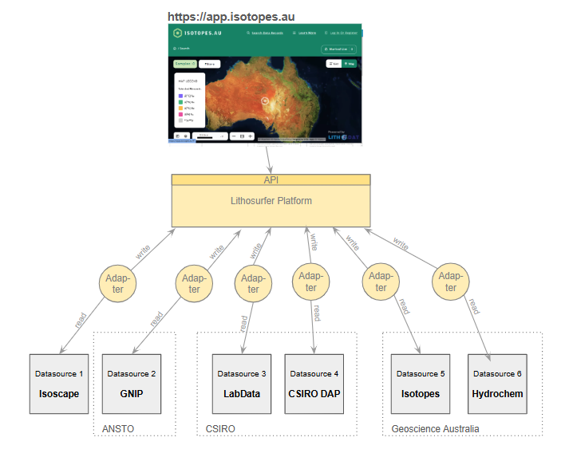
Figure 1 shows an overview of the involved components of isotopes.au and their relations.

The website https://app.isotopes.au in the top of figure 1 is the portal to the platform (see The Portal). The design in functionality and appearance in particular of the public website was mainly driven by CSIRO, Geoscience Australia, ANSTO and NMI (the founding partners). The website enables access to the data without special tools. Users can log in, browse, search and download the data. There is also an area in the portal that is only accessible for users with the CURATOR role. It provides additional functionalities to manage the data (e.g. editing, uploading, deleting).

The API is open. That means everyone can connect to it, but access to data (read & write) is strictly controlled, based on roles and data packages. The API is used by the portal (website), but it can also be used by any other kind of system (e.g. the Australian Agricultural Data Exchange system). People are free to develop additional systems, but they need to authenticate so the access control layer (ACL) can check the legitimacy of their requests.

Data is transferred via adapters from external sources. The adapters read data from the datasource of any kind, translate it to a model, in this case the isotope model, and write it to the platform. An adapter is just another system using the platform API. An adaptor can be developed by any party. In this project Lithodat was developing the adapters and is hosting them now on their AWS infrastructure. The adapters are triggered frequently to update the data on the platform on a regular basis (for more see The Adapters).

The Portal
The Portal consists of two areas, a public website and a protected area for contributors and curators. The public area opens immediately after navigating to https://app.isotopes.au. To reach the protected area the user has to log in. If the user also has the role CURATOR an additional link “Contribute” on top of the page becomes visible (see figure). A user can get the CURATER role by a request from a trusted person to Lihodat (e.g. via email to support@lithosurfer.io).

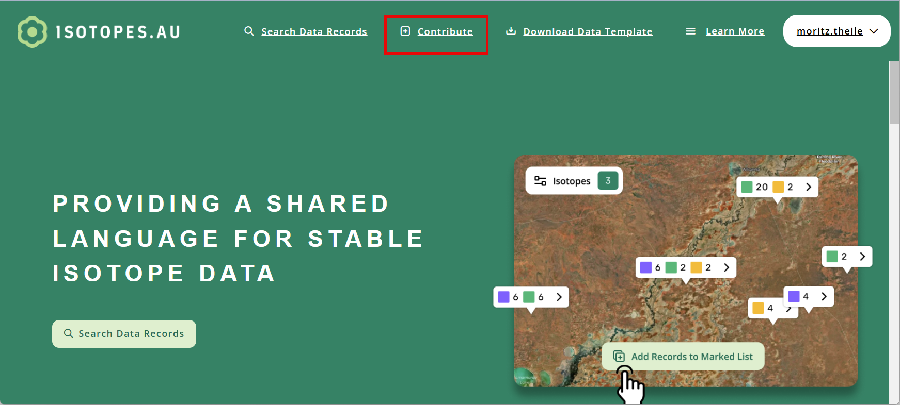

The Public Website
The public website enables the user to search and download the available isotope data. Central is a geospatial representation of the data on a map and the possibility to filter data (see figure 2).

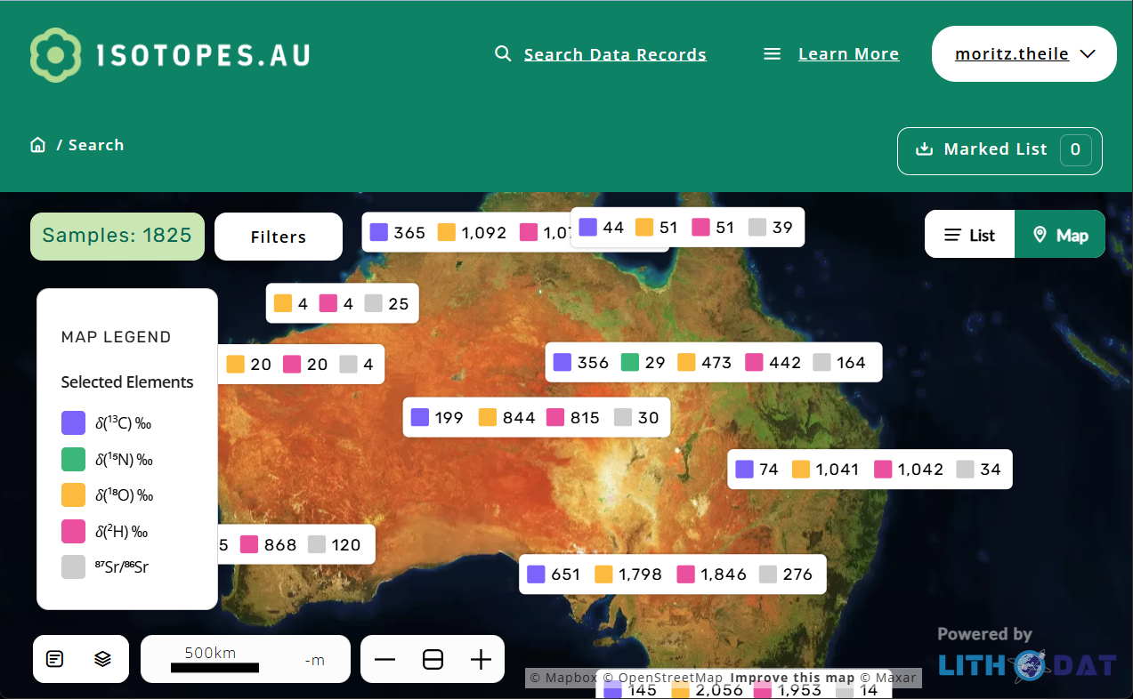

Figure 2 The isotopes.au public website (portal).

The website does not distinguish between data coming from different packages. All searches are searching across all data. The filters are using the properties defined by the stable isotope ontology.
The public website obtains the data via a series of API interfaces that return data requested. The API is used for everything from authentication to fetching isotopic data, counts and locations. The data is returned in the form of geojson / json which is then rendered using mapBox software and react /html (generic interface programming languages).

From the protected area a user can view the API documentation by navigating to https://app.isotopes.au/docs/api (this is only available to authenticated users). This documentation shows how the data can be fetched, uploaded or edited via API calls.
An example API call that fetches the Isotopes used for filtering the data https://app.isotopes.au/api/iso/IsoMeasurable
A segment of the json returned is shown below. This particular data is used to create the filters for the isotopes.
[
{
"id": 26093416,
"name": "87Sr/86Sr-Bulk",
"sortorder": 25,
"description": "87Sr/86Sr"
},
{
"id": 26093411,
"name": "δ18O-SO4 (VSMOW)",
"sortorder": 12,
"description": "𝛿(18O) ‰"
},
{
"id": 26093412,
"name": "δ18O-NO3 (VSMOW)",
"sortorder": 13,
"description": "𝛿(18O) ‰"
},
…
]

The Protected Area for Curators and Contributors

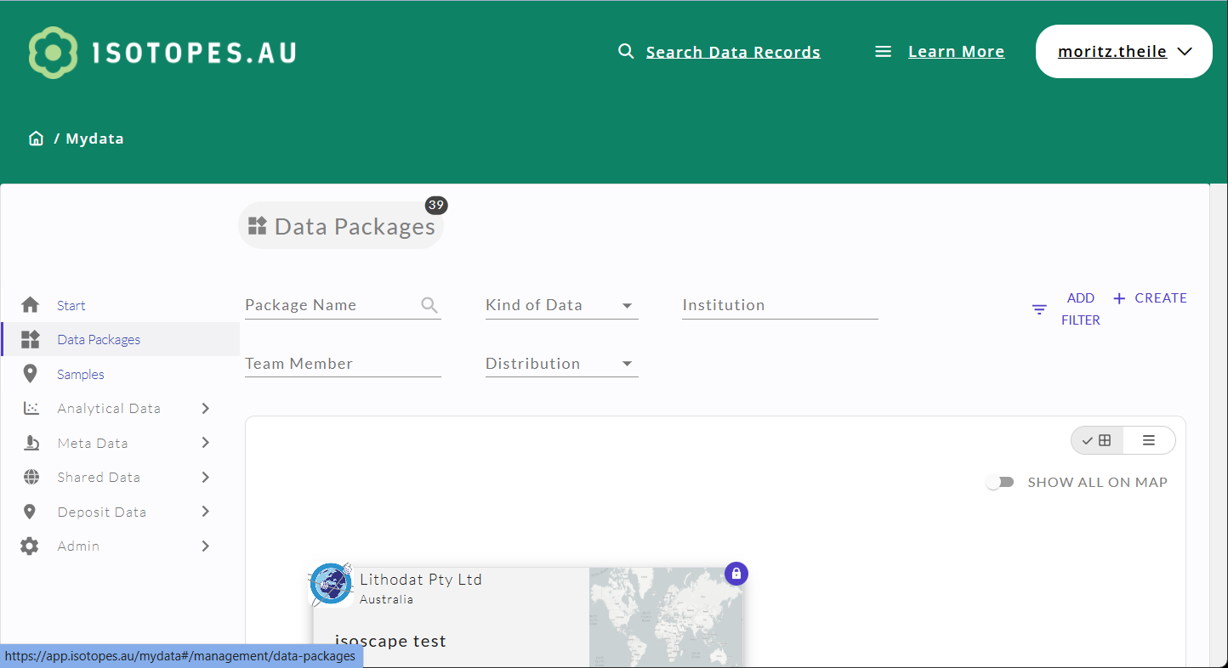

Users can log into the portal with username and password to access the data without further tools or API programming know-how.

In this proposal it is assumed that each adaptor (see figure 1) feeds its data into exactly one data package. Following this approach keeps data organized and helps to maintain full control of the data by the data providers.

Packages & Access Control
Figure 3 shows the Data package overview page of the portal. Data packages are the central concept for organizing data. There can be any number of data packages. For this project there is exactly one package for each datasource (see figure 1). This results in a total of 6 data packages.

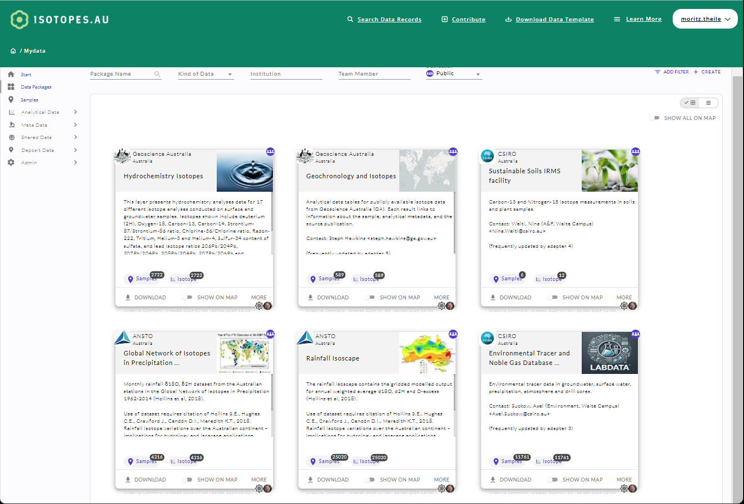
Figure 3 All available data packages are listed in an overview page.

Data packages generally belong to one institution (e.g. ANSTO, CSIRO, Geoscience Australia). That e.g. means Geoscience Australia has two packages. One for datasource 5 and one for datasource 6. On the other hand, data package 1 will contain a number of different isoscape datasets, where the datasets are owned by multiple organisations (e.g. ANSTO and CSIRO).

Setting Up New Packages
Curators or data package administrators can set up new data packages and define a team working on it. The team can work on the package by adding data. The data won’t show on app.isotopes.au for non logged in users until it is published. See Intro & Login video and Create Data Package video.

The Portal URL
The portal url isotopes.au is owned and managed by CSIRO. The subdomain
- app.isotopes.au
is pointing to the AWS service with the CNAME entry
- lithosurfer-prod-env.ap-southeast-2.elasticbeanstalk.com.

The Adapters
Adapters connect arbitrary data sources with the platform (see figure 4). Adapter development can be done by any party. The main challenge is that each adapter is different. Careful analysis needs to be done in advance. In particular the technical connection to the datasource and the data mapping needs to be specified. Sometimes this can be very easy, sometimes it can be very difficult. Sometimes it even requires changes to the datasource.

Adapters are reading from the datasource and writing to the platform. In order to function in a real world scenario adapters must provide some features. These are discussed in the following paragraphs. The rest of this chapter explains the 6 adapters already developed.

Adapters can be developed using almost any available programming language (Python, C#, Java, JavaScript etc.). The basic capability is to be able to connect to the interface offered by the datasource, translate the data and write it to the Lithosurfer API (REST web service).

Adapters need a mapping algorithm in order to map from the arbitrary datasource model to the consolidated Lithosurfer model (aka. ontology).

Adapters mirror the data from the datasource into the platform. Different strategies can be applied to do so. The simplest is to first delete all data in the data package and then transmit all the data again, including the latest changes. Another strategy is to find the difference and only transmit this difference. Which one to apply depends on different factors such as data volume and availability of last changed or last edited timestamps.
The amount of data in this project (<100k) speaks for the delete-and-transmit-all strategy.

Adapters need a trigger mechanism to start the process. This could either be a timer (daily, weekly, monthly) or a push notification from the data source.

Adapters need a way to be configurable e.g. the credentials for API access or the time intervals to run the mirroring. Also each execution should output a log file that is viewable by the maintainers.

Adapters need to be able to be updated in a quick and simple way if e.g. the datasource interface changes.

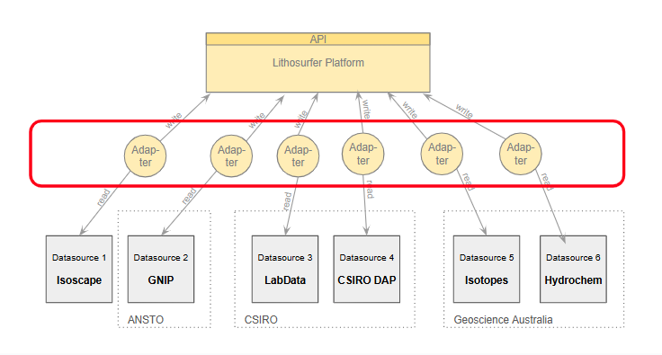
Figure 4 Adapters connecting data sources of different kinds with the platform.

Adapter Mapping in General
Adapters can be seen as mini programs which contain the code to translate from one data format into the Lithosurfer data model (aka. Ontology). Translation means to find a mapping from one or multiple datasource attributes to one attribute of the ontology.
Often these mappings are very simple, e.g. take the text from the attribute “documentation” and write it to the attribute “description” in the target ontology. But in many cases there is more logic needed, e.g. unit conversion or vocabulary mapping. It also can get a lot more difficult if the data needs to be calculated from multiple input fields, e.g. for creating a unique id.
Furthermore there can be data sources that provide relational data. In this case not only the attribute mapping, but also an entity mapping has to be implemented (Adapter 3, LabData was such a case).
Last but not least the adapters have the potential to enrich the incoming data with information from other data sources, e.g. adding elevation data that is not available in the data source.
The exact way of the mapping implementation can be found in the source code (see Adapter Source Code).

Lithodat’s Jobserver as Adapter Runtime Environment
Lithodat runs a jobserver (jobserver.lithosurfer.io) as an Elastic Beanstalk application in the AWS cloud. The jobserver is designed to run jobs in a scheduled and robust manner. The jobs are closely monitored. In case errors occur emails will be sent to a defined list of recipients.
All 6 adapters developed in the scope of this project are implemented as a jobserver module. Some are run automatically, others are triggered manually. The next chapters will elaborate on such adapter specific details.

Adapter 1: Isoscape
This adapter follows the delete-and-transmit-all strategy (see The Adapters).
It is run manually when a new data source file is provided via email.
In case of complications an email is sent to:

- HUGHES, Cath <ceh@ansto.gov.au>

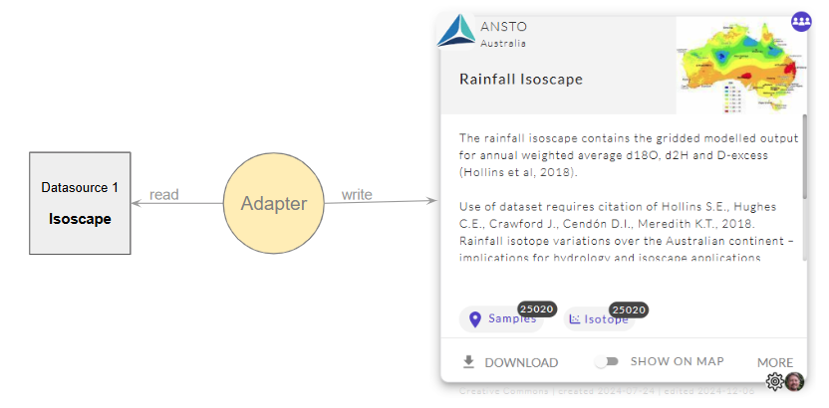
For further information on the environment and mapping specification please have a look into this Google Drive folder or the appendix of this document..

Mapping Details
The table below describes which input data is used from the data source to calculate the attribute or measurable of the Lithosurfer data model (aka. Ontology). For the exact way of how these inputs were used to calculate the result please have a look at the mapping code (see Adapter Source Code).

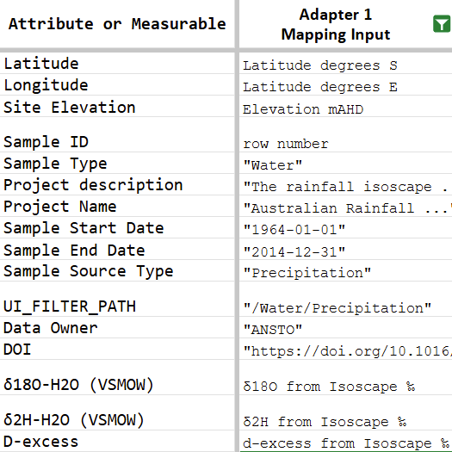
see ontology sheet

Adapter 2: GNIP
This adapter follows the delete-and-transmit-all strategy (see The Adapters).
It is run manually when a new data source file is provided via email.
In case of complications an email is sent to:

- HUGHES, Cath <ceh@ansto.gov.au>

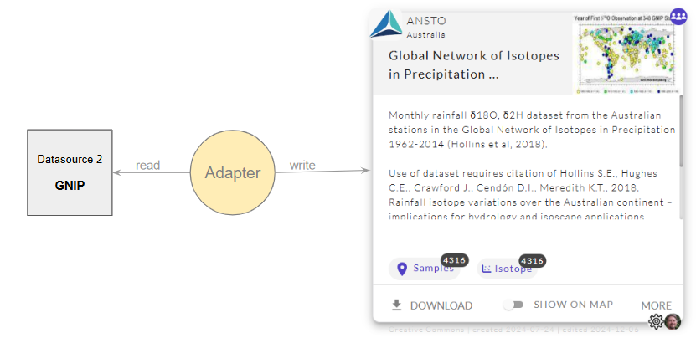
For further information on the environment and mapping specification please have a look into this Google Drive folder or the appendix of this document..

Mapping Details
The table below describes which input data is used from the data source to calculate the attribute or measurable of the Lithosurfer data model (aka. Ontology). For the exact way of how these inputs were used to calculate the result please have a look at the mapping code (see Adapter Source Code).

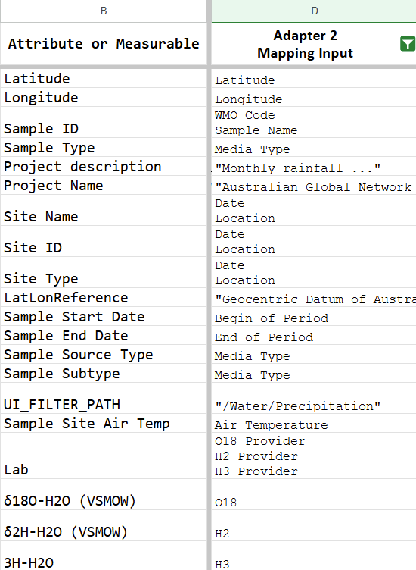
see ontology sheet

Adapter 3: CSIRO LabData
This adapter follows the delete-and-transmit-all strategy (see The Adapters).
It is run automatically every day. It will update the data when a new file is detected.
In case of complications an email is sent to:

- Suckow, Axel (Environment, Waite Campus) <Axel.Suckow@csiro.au>

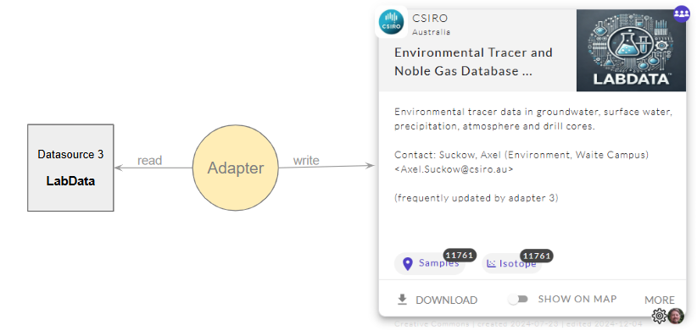
For further information on the environment and mapping specification please have a look into this Google Drive folder or the appendix of this document.

Mapping Details
The table below describes which input data is used from the data source to calculate the attribute or measurable of the Lithosurfer data model (aka. Ontology). For the exact way of how these inputs were used to calculate the result please have a look at the mapping code (see Adapter Source Code).

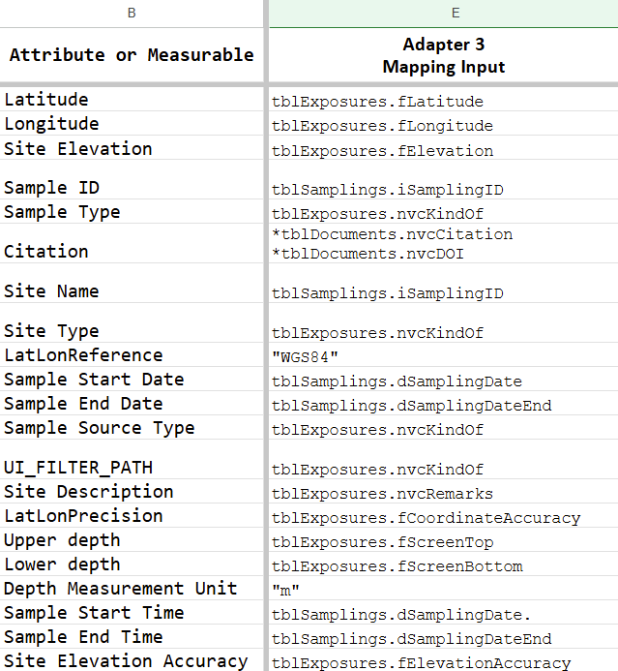
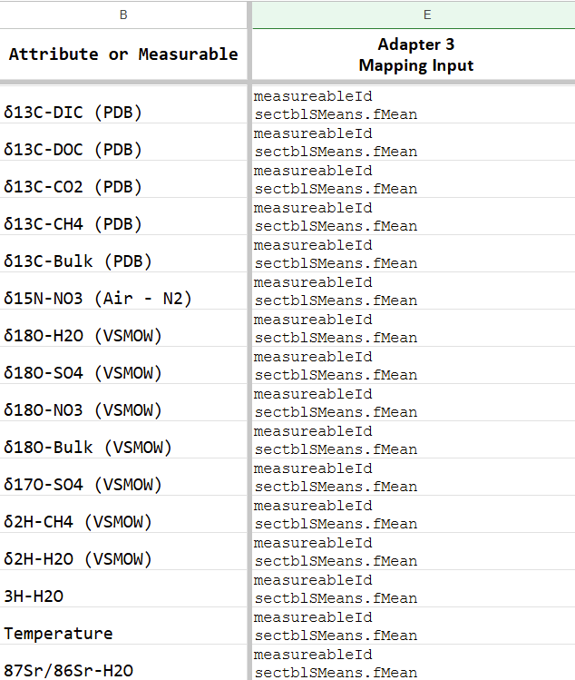
see ontology sheet

Adapter 4: CSIRO DAP
This adapter follows the delete-and-transmit-all strategy (see The Adapters).
In version 0.5.5 this adapter is triggered automatically once a week. In a future version it will trigger every two weeks to check the DAP for data and transmit it all.
In case of complications an email is sent to:

- Welti, Nina (A&F, Waite Campus) <Nina.Welti@csiro.au>

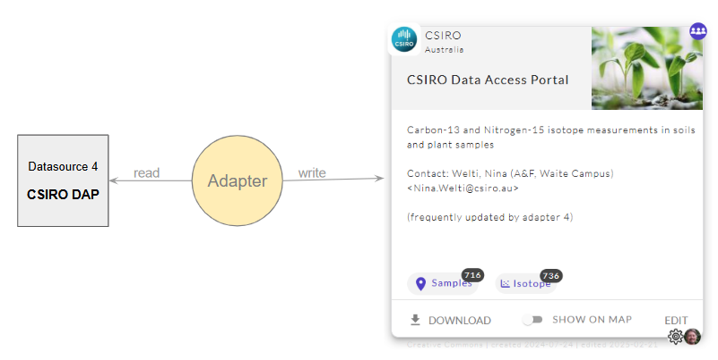
For further information on the environment and mapping specification please have a look into this Google Drive folder or the appendix of this document.

Mapping Details
The table below describes which input data is used from the data source to calculate the attribute or measurable of the Lithosurfer data model (aka. Ontology). For the exact way of how these inputs were used to calculate the result please have a look at the mapping code (see Adapter Source Code).

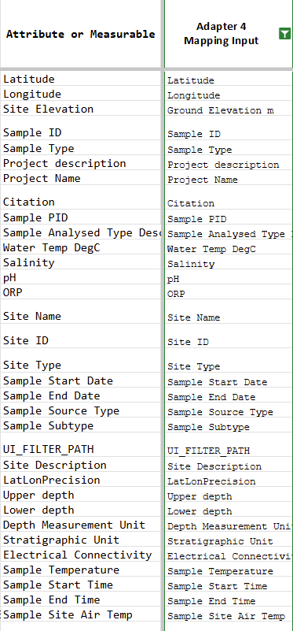
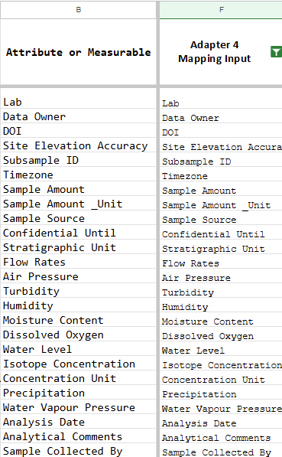

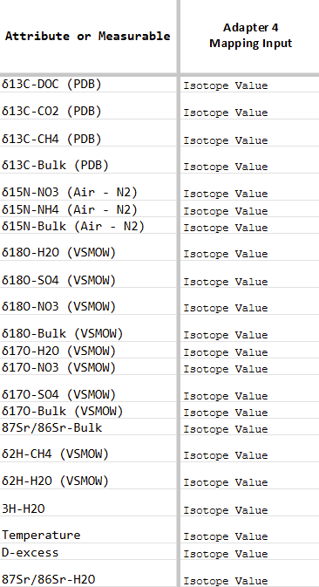
see ontology sheet

The measurable mapping of adapter 4 is implemented as this code fragment shows:
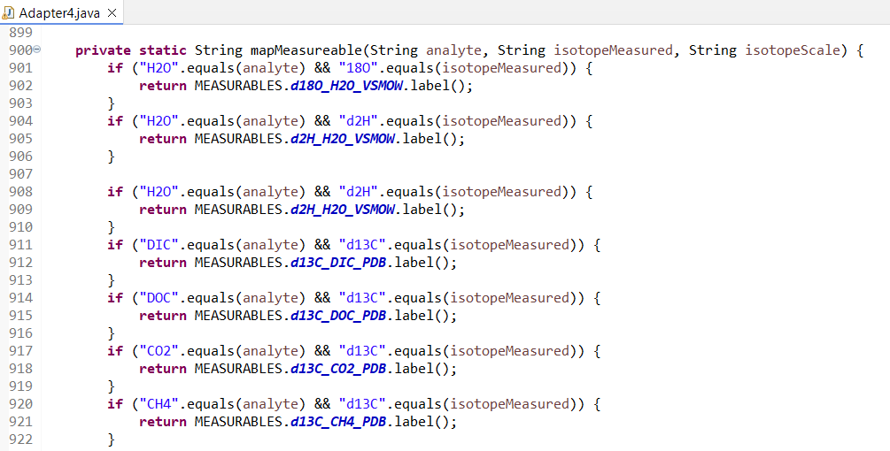

Adapter 5: GA Isotopes
This adapter follows the delete-and-transmit-all strategy (see The Adapters).
It is triggered manually in version 0.5.2 but will be started every two weeks in future versions.
In case of complications an email is sent to:

- Steph Hawkins <steph.hawkins@ga.gov.au>

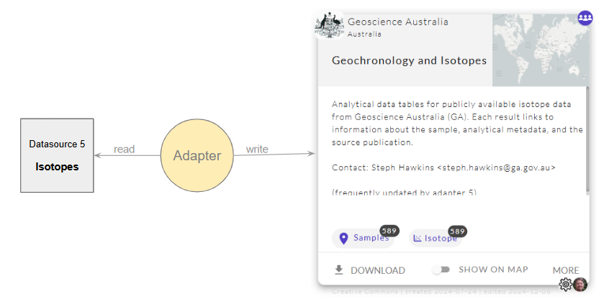
For further information on the environment and mapping specification please have a look into this Google Drive folder or the appendix of this document..

Mapping Details
The table below describes which input data is used from the data source to calculate the attribute or measurable of the Lithosurfer data model (aka. Ontology). For the exact way of how these inputs were used to calculate the result please have a look at the mapping code (see Adapter Source Code).

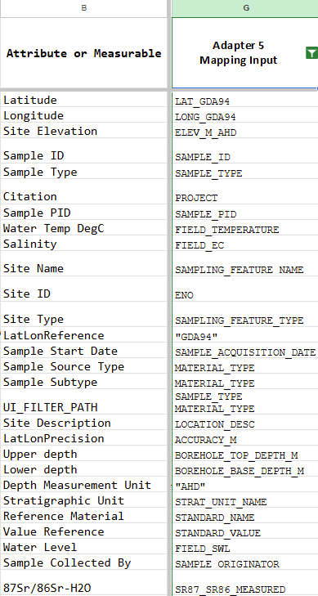
see ontology sheet

Adapter 6: GA Hydrochemistry
This adapter follows the delete-and-transmit-all strategy (see The Adapters).
It is triggered manually in version 0.5.2 but will be started every two weeks in future versions.
In case of complications an email is sent to:

- Steph Hawkins <steph.hawkins@ga.gov.au>

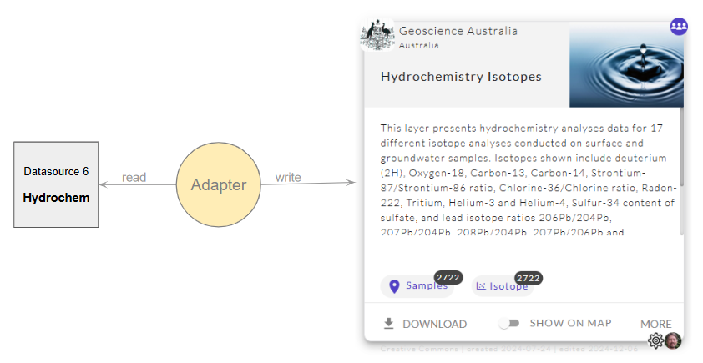
For further information on the environment and mapping specification please have a look into this Google Drive folder or the appendix of this document..

Mapping Details
The table below describes which input data is used from the data source to calculate the attribute or measurable of the Lithosurfer data model (aka. Ontology). For the exact way of how these inputs were used to calculate the result please have a look at the mapping code (see Adapter Source Code).

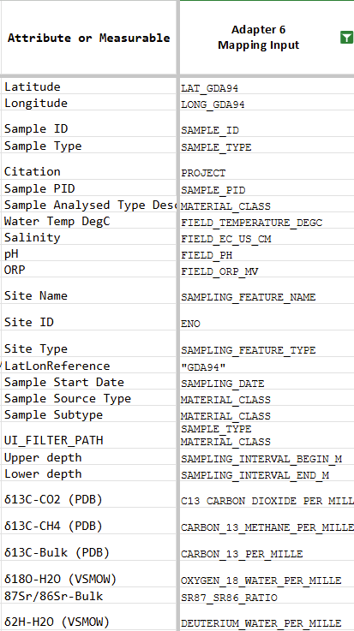

see ontology sheet

Adapter Source Code
The adapter source code is accessible via GitHub or as a ZIP file:

- Source viaGitHub Project GitHub Project
- Source Code via ZIP file jobserver.v0x5x2.zip

The GitHub project is not public. Please send an email to support@lithosurfer.io with a list of GitHub ids to get access granted. The ZIP file is hosted on Google Drive and can be downloaded.
The adapter code is embedded in a ready to run Java Spring Boot application. It can serve as a basis to start new adapters or as a source of truth to check current mappings. The individual adapter logic can be found in the 6 AdapterN.java classes (see figure).

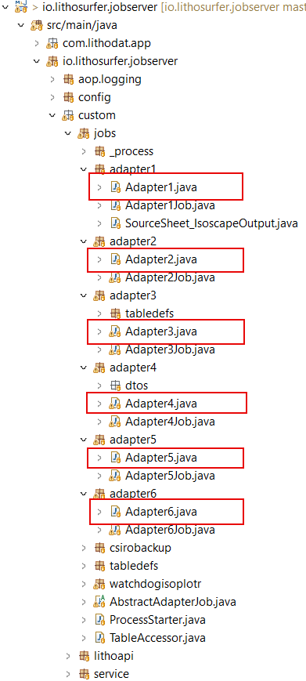

Adapter Hosting and Maintenance
As with the development, the hosting can be done by any party. However, in this project Lithodat is hosting the 6 developed adapters on their AWS infrastructure.

Updating the adapter is not part of hosting or maintaining. Lithodat can implement and roll out updates at a fixed hourly rate.

Data Import Wizard
Adapters are great for importing machine generated data. Unfortunately there is a lot of data that is created with human interaction (cut & paste, typing, formulas and other spreadsheet work). This data is not suitable for adapters since the adapters are not smart enough to fix the errors humans tend to introduce.

To import non perfectly clean data the import mechanism has to cooperate with the user in a feedback loop. We call such an importer a ‘Wizard’. The wizard tells the user when something is wrong (e.g. “there is column x missing” or “the key column contains non unique values” or “the column z contains text but there should only be numbers” etc.).
So as a rule of thumb: If the data is not machine generated, use a wizard instead of an adapter.

When the project was started it was decided all data sources are to be connected via adapters. This has been done. However, some of the data sources seem to be files that are manually created (e.g. Adapter 4 via DAP). This approach is working as long as the file is error free. If it turns out over time that this approach is problematic we recommend switching to a wizard for uploading data.

Datasets in the IsotopesAU standard template format can be checked and issues fixed prior to making them available to the isotopes.au platform via the Wizard. See Upload Samples video and Upload Measurements, Filtering Data, What it means for Adapter 4 video.

Platform Metrics

The performance of a web application like the isotopes.au portal can be evaluated through various metrics. Typically, the aim is to gain a deeper understanding of user behavior, which can drive improvements to the system or help assess the effectiveness of marketing campaigns.

Very common is Google Analytics for measuring indicators like Users/Visitors, sessions, pageviews, bounce rate, average session duration, behaviour metrics, conversion metrics.

Isotopes.au uses Google Analytics and some basic information can be derived from it. For deeper analysis the site is not set up accordingly.

Besides Google Analytics isotopes.au records certain key events with timestamps e.g. “Application was loaded”, “Click on menu link x” or “Download started”. These records can be used to visualise the activity over the time.

Lithodat is using Metabase for the visualisation. Lithodat shared a link to a Metabase dashboard with some KPIs.

- https://metabase.lithosurfer.io/public/dashboard/0793edf0-9675-41e5-b338-7d0668e1f384?tab=1-per-day

Below is a screenshot of this dashboard. The time period is very short since the data was only recorded for a week, but it will grow continuously. All KPIs can be visualised in the granularity of either days or months.

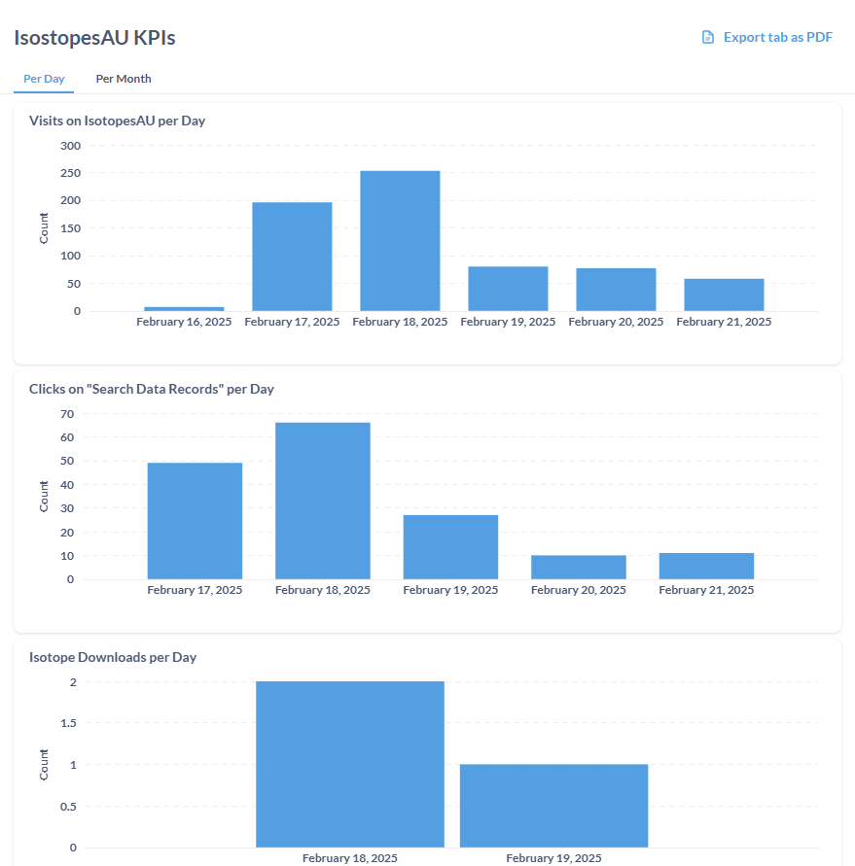

KPI: Visits on IsotopesAU
This KPI measures how often the application gets loaded into the browser. Normally this should happen once per visit. However, if the user reloads the page there will be an extra count.

KPI: Clicks on “Search Data Records”
This KPI measures how often the menu item “Search Data Records” was clicked.

KPI: Isotope Downloads
This KPI measures how many times isotope data was downloaded.

FAIRness
The platform integrates the FAIR data principles as outlined below.

# | FAIR ACTION | REQUIRED / RECOMMENDED | DETAILS OF IMPLEMENTATION | ACTUAL COMPLETION DATE OR EXPECTED COMPLETION DATE | STATUS
1 | All data outputs are assigned appropriate PIDs, preferably a DOI | Required | Each data record has a DOI (required field in ontology) that stays with the record. The DOIs are passed through the adapters from the datasource to the platform outputs. | November 2024 (platform launch) | DONE
2 | All data outputs have metadata to enable discovery | Required | Each data record includes metadata (defined by the ontology) that is passed through the adapters from the data source to the platform outputs. | November 2024 (platform launch) | DONE
3 | All data outputs have a record in Research Data Australia | Required | CSIRO has published a platform as a service record for IsotopesAU on the DAP, which Research Data Australia will link to. | March 2025 | DONE
4 | All data outputs are registered with relevant discipline-specific discovery aggregators (if they exist) | Recommended | There isn’t currently an aggregator for isotopes data. The platform acts as an aggregator of sorts for the data contributors. | N/A | N/A
5 | The persistent identifier for the data output being described is included in the metadata | Required | Each data record has a DOI (required field in ontology) that stays with the record. The DOIs are passed through the adapters from the data source to the platform outputs. | November 2024 (platform launch) | DONE
6 | All data outputs are made as openly available as possible; they are only closed where necessary | Required | The platform currently contains only open data (no private or embargoed data is included at present) | November 2024 (platform launch) | DONE
7 | All data outputs are made available through a repository | Required | Data outputs are available through IsotopesAU and via the datasource repositories such as the CSIRO DAP and the GA portal | November 2024 (platform launch) | DONE
8 | All data outputs are available as a download and/or accessible through an open, documented API (where data is not closed) | Required where data is not closed | Data is downloadable from IsotopesAU in as CSV and shapefile and via an open, documented API | November 2024 (platform launch) | DONE
9 | If the data outputs are not openly available, there is a clear description on the landing page on how to request access to the data outputs and the conditions that need to be met | Required where relevant | Not currently applicable as all data outputs are openly available. | N/A | N/A
10 | The persistent identifier for the data output points to a landing page about the data output, even if the data output is not public (open). | Required | In the current model, as the data is held by the data sources and not the IsotopesAU platform, the landing pages are managed by the data sources where the data source has a landing page (e.g. CSIRO DAP, Geoscience Australia Portal). | N/A | N/A
11 | If the data output is not openly available there is an authorisation and authentication procedure to provide access to the data | Required where relevant | This functionality is available in the LithoSurfer platform but is not currently used for IsotopesAU as the data output is openly available. | November 2024 (platform launch) | DONE
 |  |  |  |  | (but not used)
12 | The persistent identifier for the data output continues to point to a landing page, even if the data output is no longer available, and there is a policy to maintain these landing pages | Required | This functionality is available in the LithoSurfer platform, where the link to the landing page is managed by the handle.net system and independent from the data output. For IsotopesAU, this is currently managed at the datasource. | November 2024 (platform launch) | DONE
 |  |  |  |  | (but not used)
13 | Data outputs use community-agreed standard data formats (where such agreed formats exist) | Required where research community agreed standards exist | Detailed in the ontology and the paper | November 2024 (platform launch) | DONE
14 | Metadata for the data output uses community-agreed standards (where such agreed standards exist) | Required where research community agreed standards exist | Detailed in the ontology and the paper | November 2024 (platform launch) | DONE
15 | Data and metadata use community-agreed vocabularies, data models and ontologies (preferably internationally agreed ones where they exist) | Recommended | Detailed in the ontology and the paper | November 2024 (platform launch) | DONE
16 | Metadata contains persistent identifiers for research objects and entities (people, organisations) linked to the data outputs (including ORCIDs, grantIDs, RAIDs, DOIs, IGSNs) | Required | ORCIDs, referenced articles, funding information are available metadata fields in the LithoSurfer platform. Currently in IsotopesAU, entity names and DOIs are included in the outputs. | November 2024 (platform launch) | DONE
17 | All data outputs are assigned a machine readable licence (preferably CC-BY 4.0) | Required | The licence information and citation information is included at the file level in the zip file from the platform that contains the exported data. | November 2024 (platform launch) | DONE
18 | The licence information is available in a machine readable form on the landing page that the persistent identifier (for the data output) refers to | Required | For IsotopesAU, this is currently managed at the datasource. | November 2024 (platform launch) | DONE at datasources not on platform
19 | There is a citation statement for the data output on the landing page that the persistent identifier refers to | Required | For IsotopesAU, this is currently managed at the datasource. | November 2024 (platform launch) | DONE at datasources not on platform
20 | Provenance information on the data output is attached alongside the data | Recommended | DOI and project title and description included with every record (required fields in ontology) | November 2024 (platform launch) | DONE
21 | Relevant discipline-specific metadata to enable reuse is captured and presented alongside the data output following research community best practice | Recommended | Detailed in the ontology and paper | November 2024 (platform launch) | DONE
Source: FAIR implementation on CSIRO Sharepoint

Security
The Ausgeochem Portal, which is a portal based on the same platform as the isotopes.au portal (see The Portal), is Core Trust Seal certified (see figure). This means the Lithosurfer platform, on which isotopes.au is built has fulfilled all Core Trust Seal Requirements. These requirements validate that the platform (aka. archive) will be operable and secure for decades to come. Core Trust Seal is checking on aspects like:

 | - Continuity of access  - Organizational infrastructure  - Expert guidance  - Data integrity and authenticity  - Documented storage procedures  - Preservation plan  - Data quality  - Workflows  - Data discovery and identification  - Data reuse  - Technical infrastructure  - Security

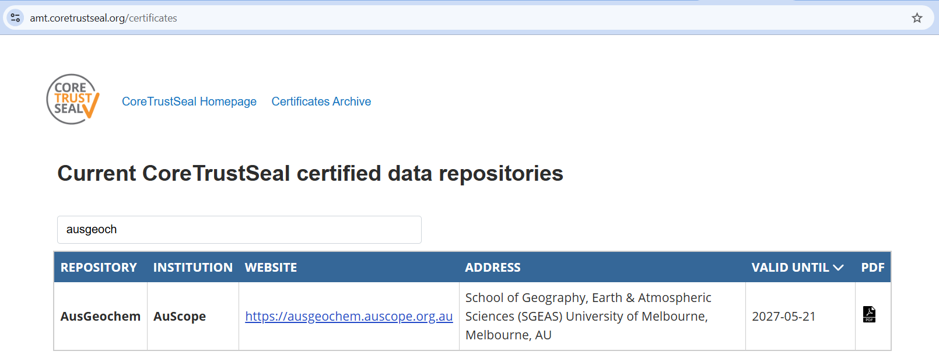

Detailed information, in particular on the security, is available in the Core Trust Seal Certification document.

API
The Application Programming Interface (API) is publicly available. Any developer can build clients to interact with the platform (e.g. uploading or visualising data).
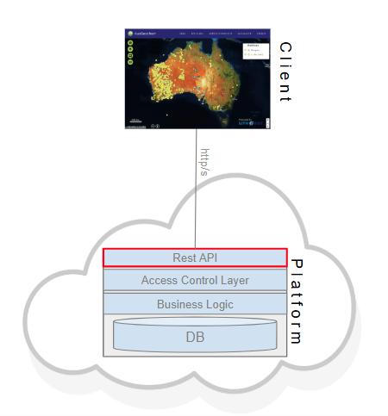

The API documentation will be updated and published continuously with the use of Swagger.

The Lithosurfer API is a RESTful service. It can be accessed via all common languages. The developers can choose the language that he/she is most comfortable with. E.g.:


Please follow these links for understanding access control and learning about recommended first steps.

- Link to Swagger documentation
- Link to Instructions
- Link to Video
- Link to example Code

Of course the Lithodat team is happy to answer questions. Don’t hesitate to ask! Happy coding!

APPENDIX

Adapter 1

Adapter 1 Specification
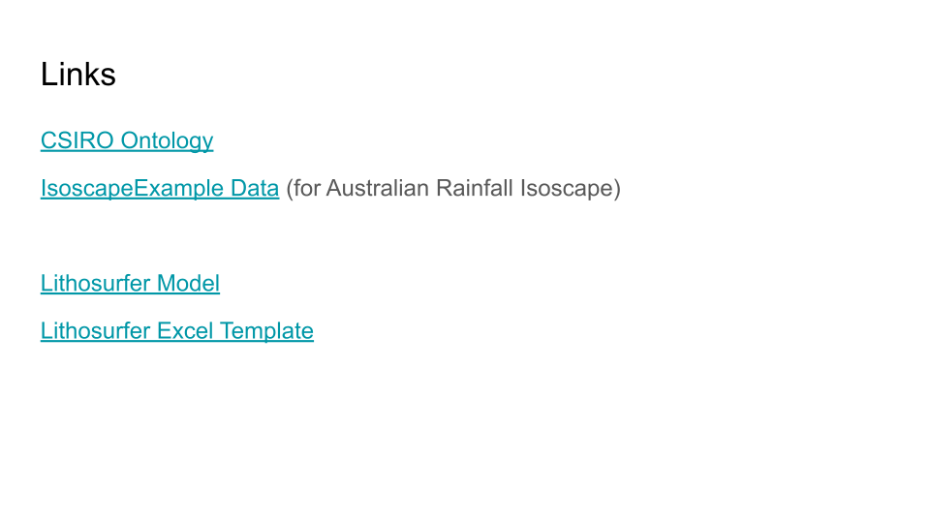
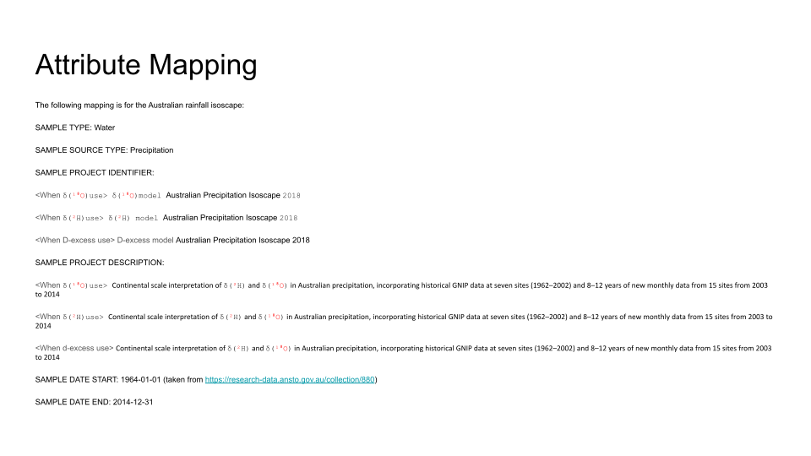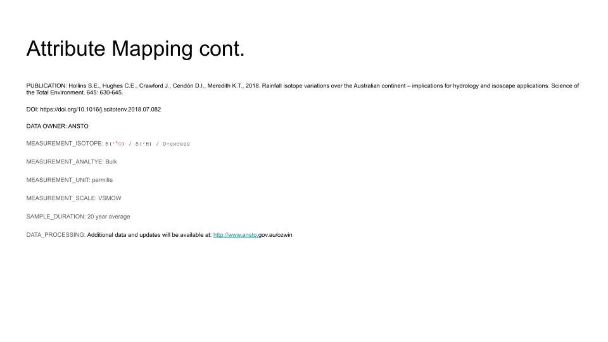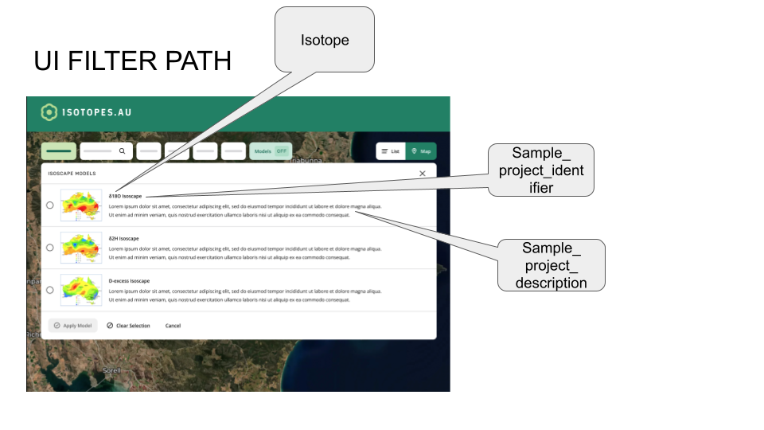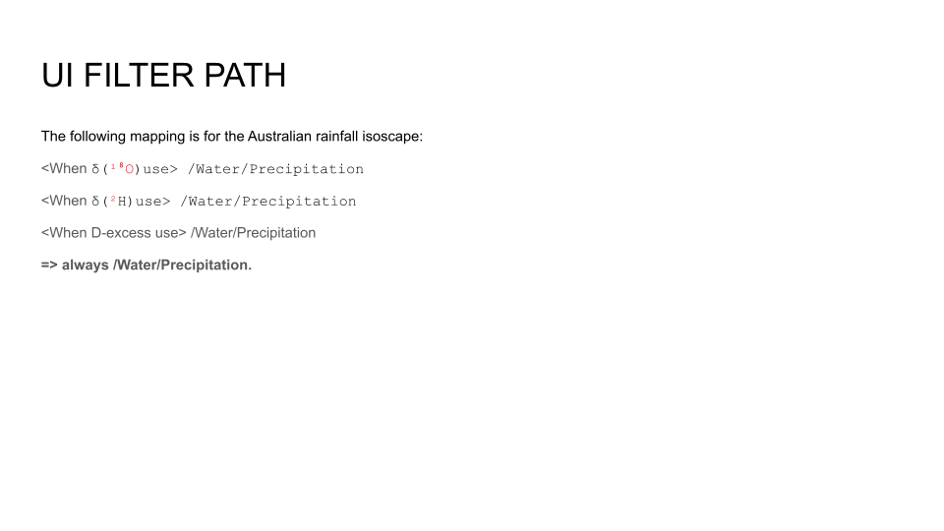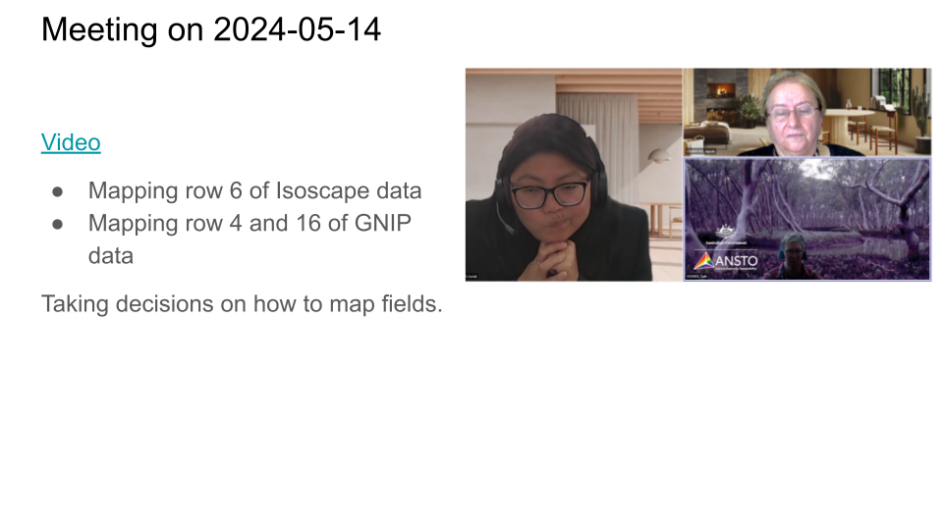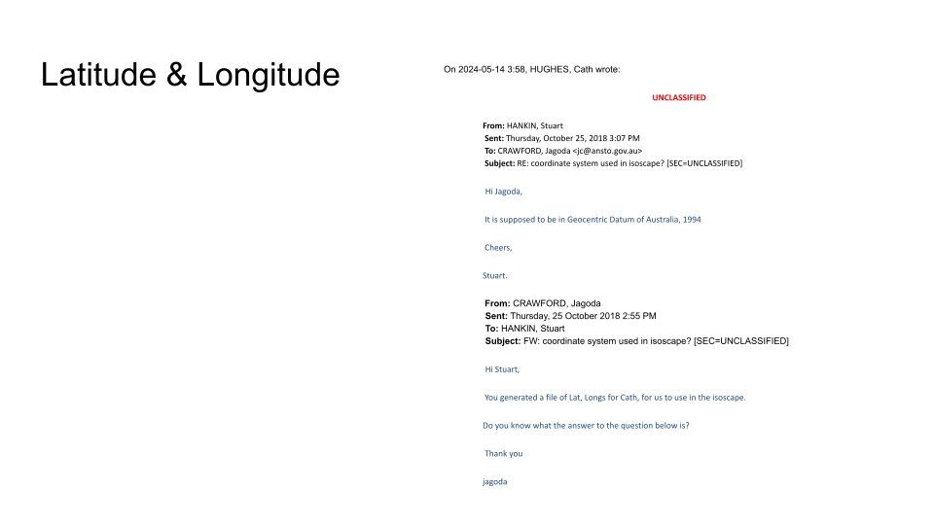

Adapter 1 Environment
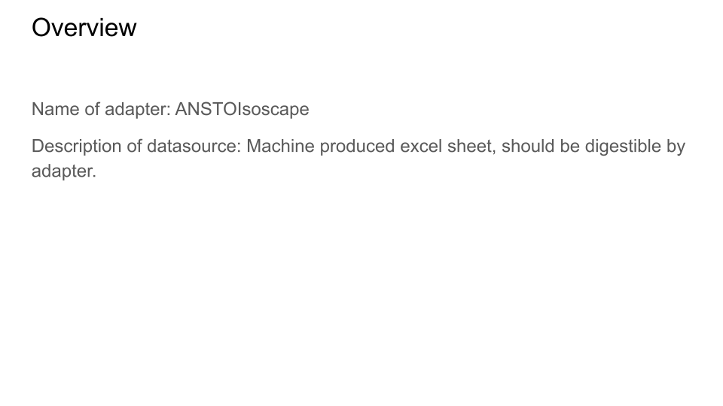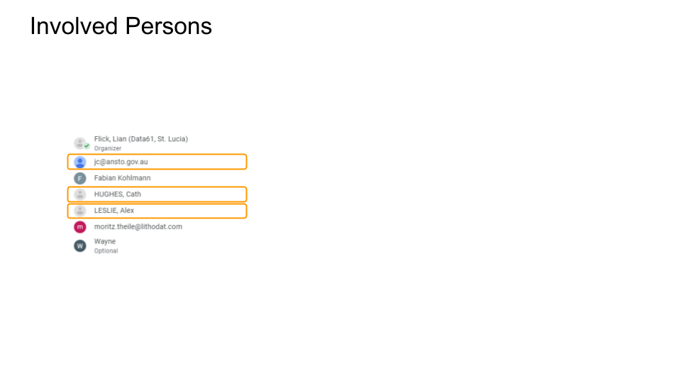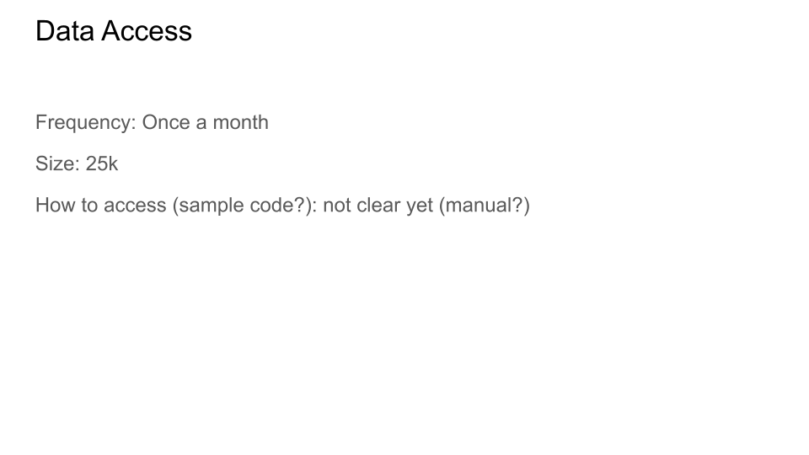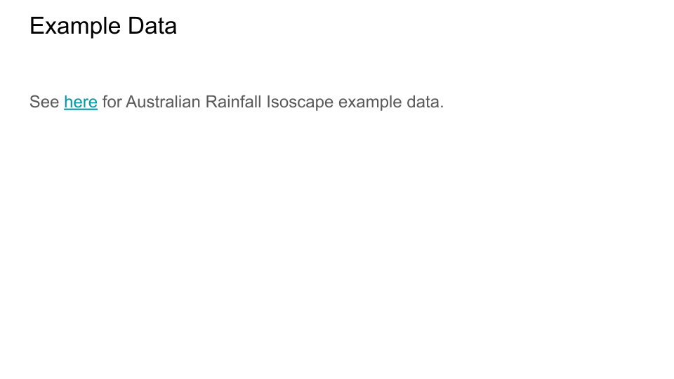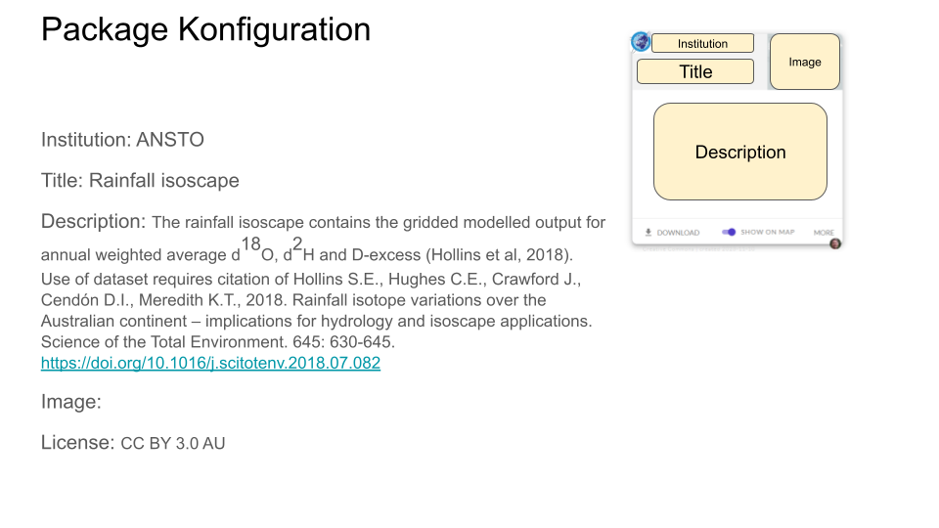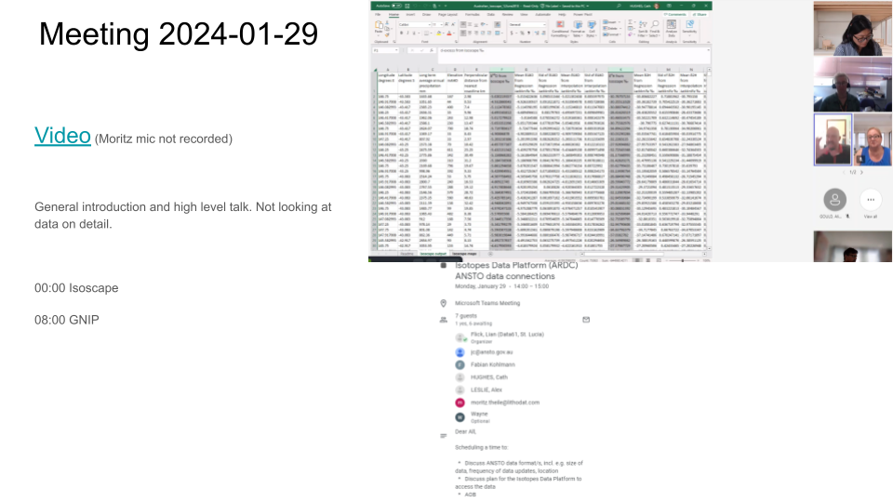

Adapter 1 Mapping

Sample
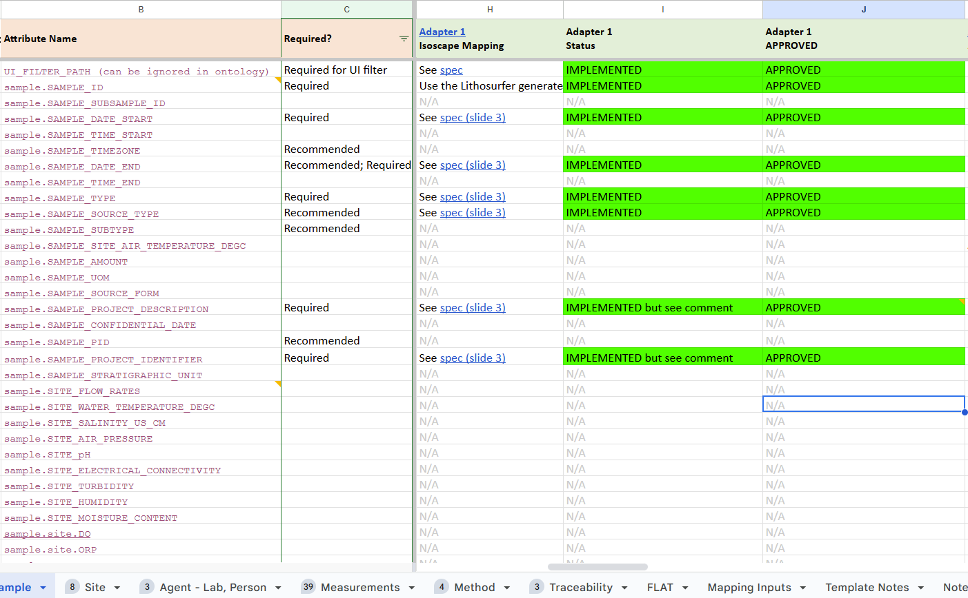

Site
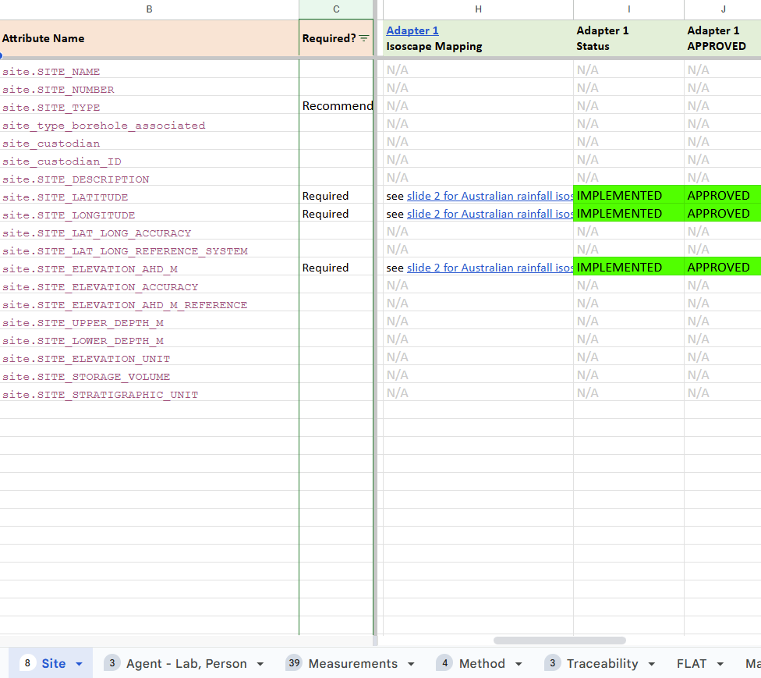

Agent - Lab, Person
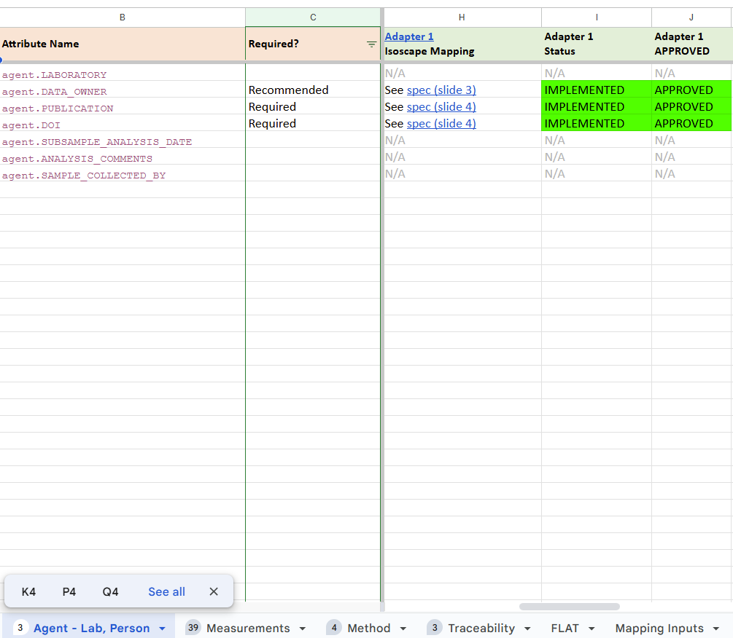

Measurements
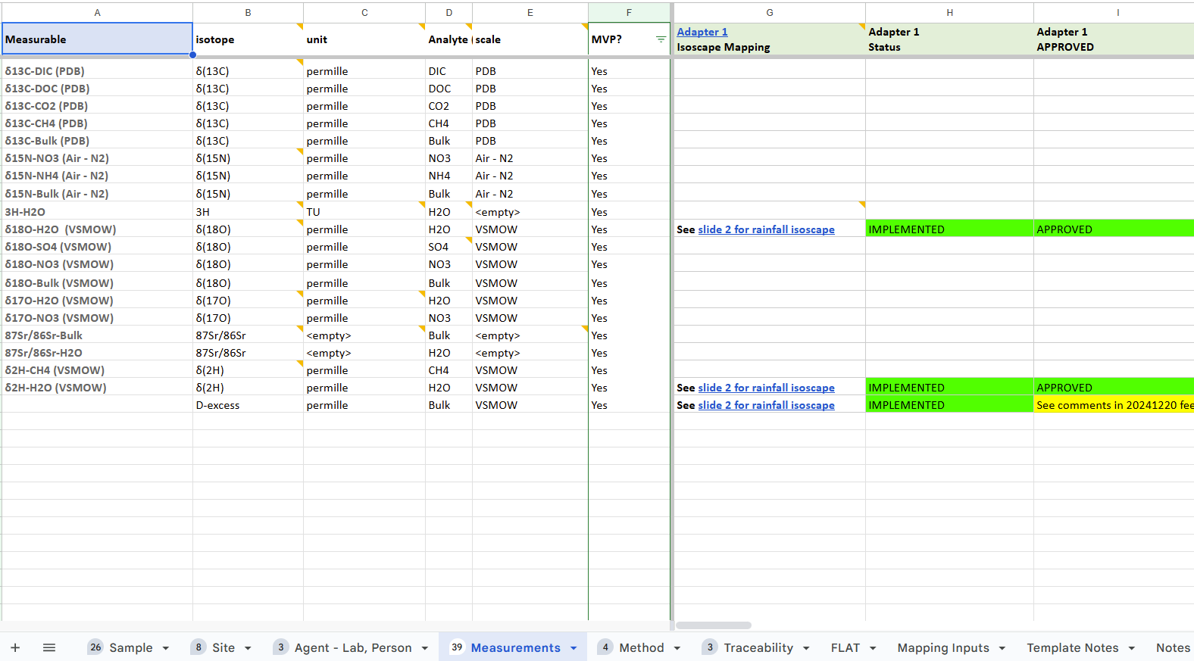

Method
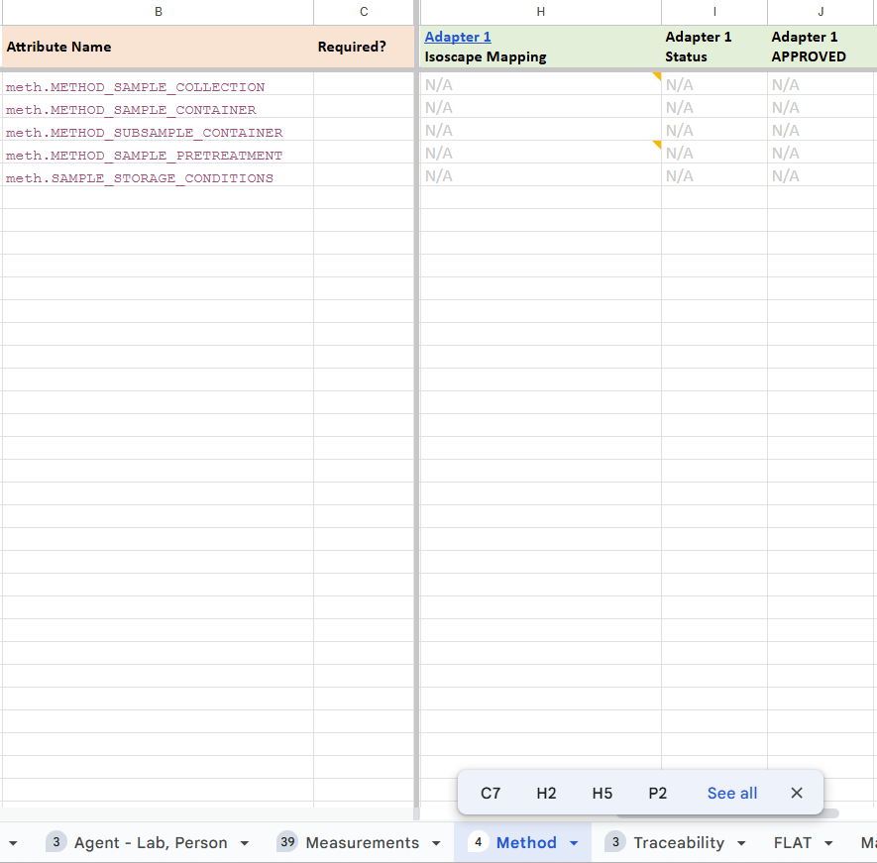

Adapter 2

Adapter 2 Specification
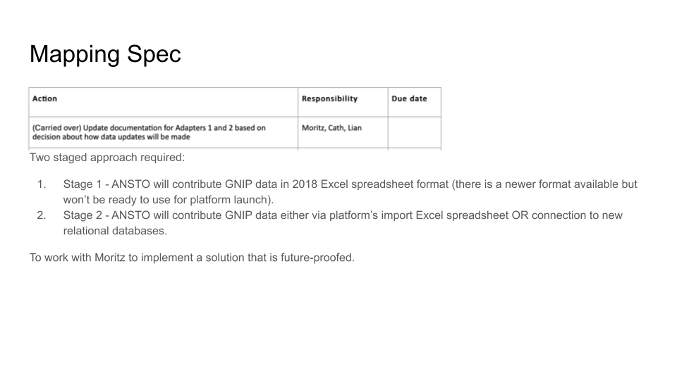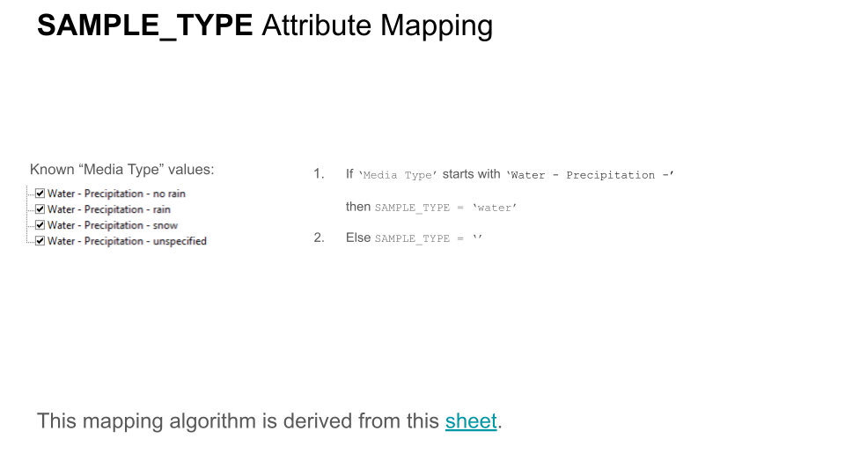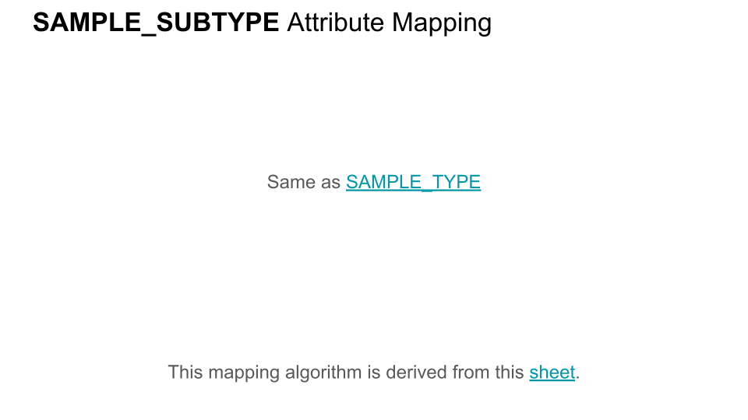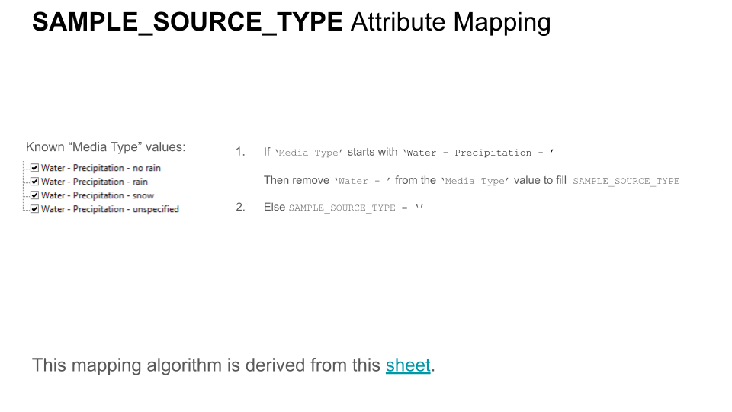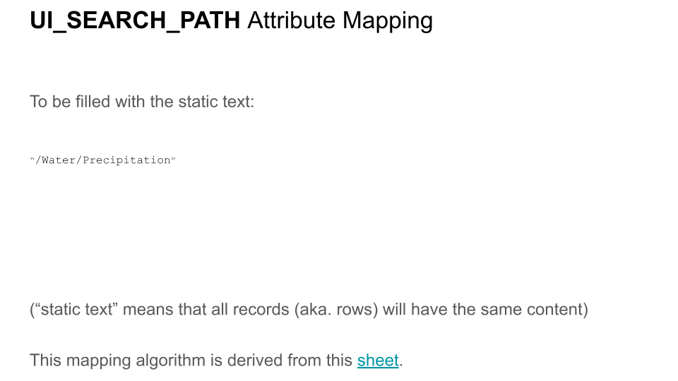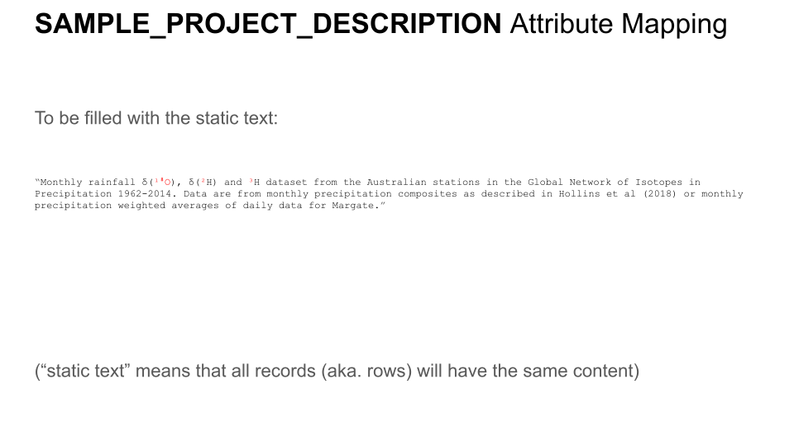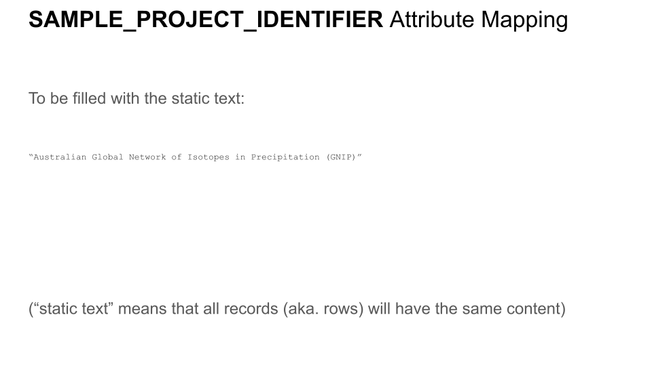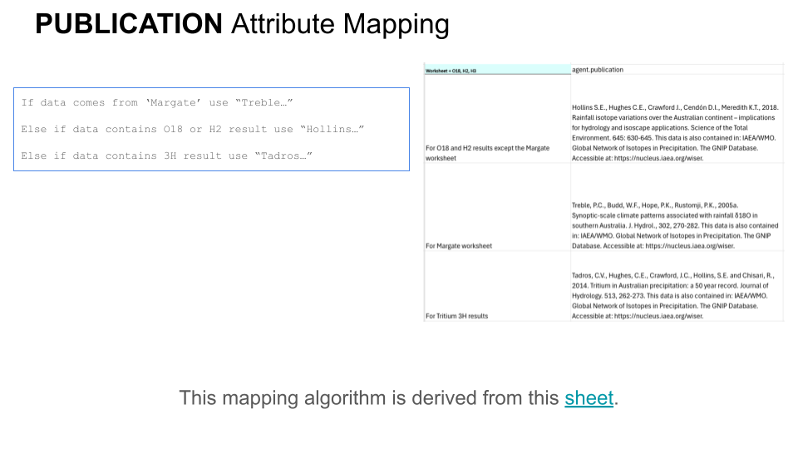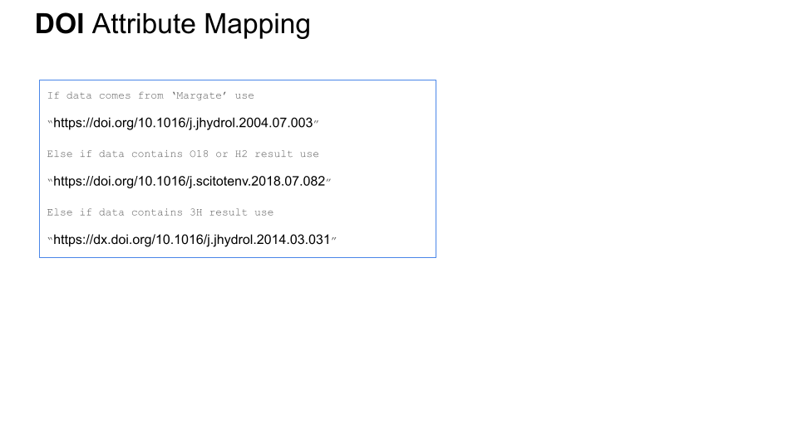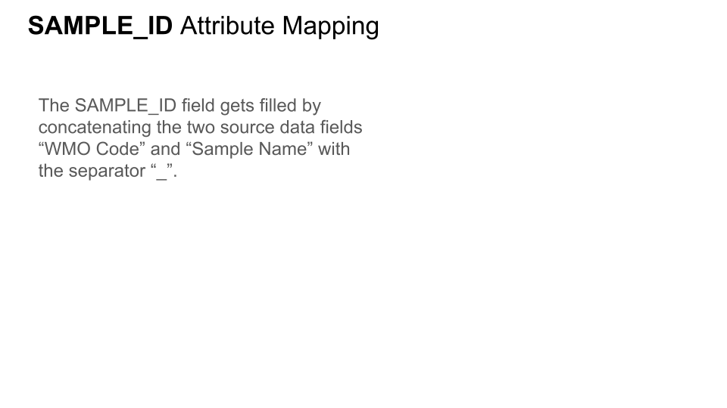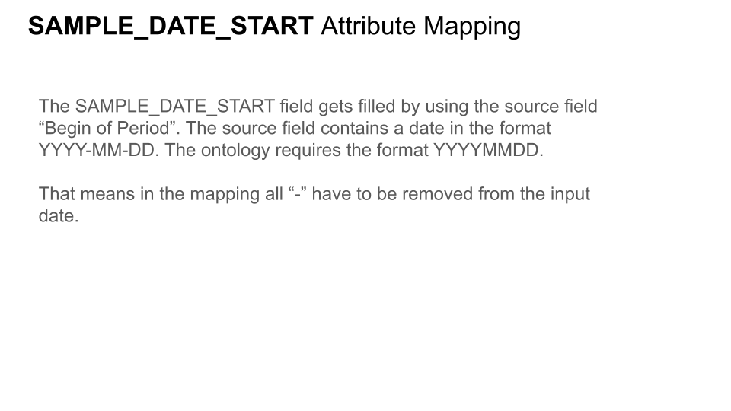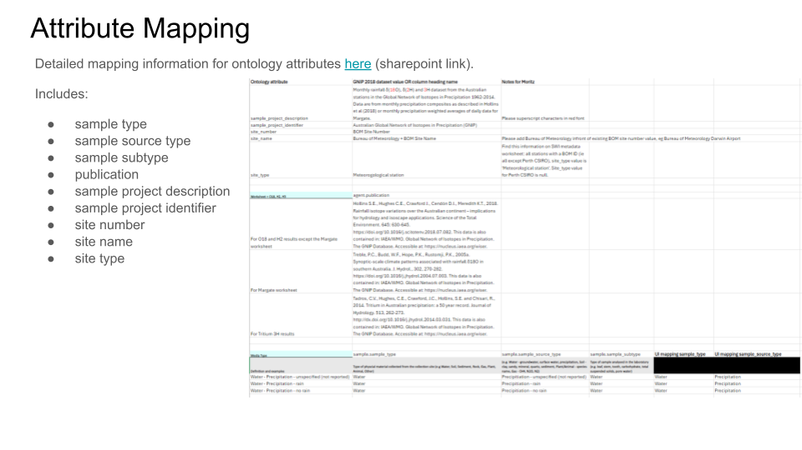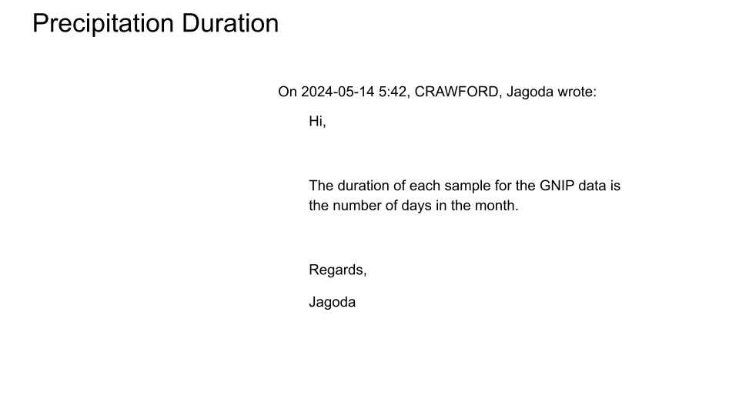

Adapter 2 Environment
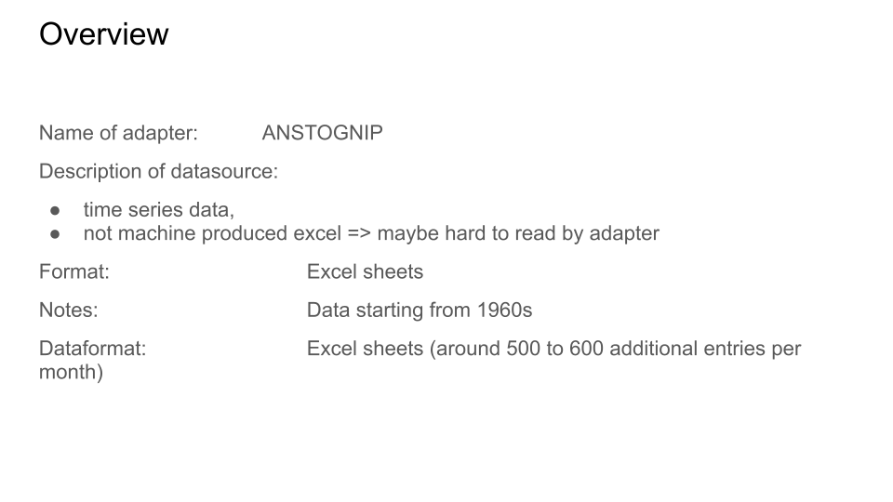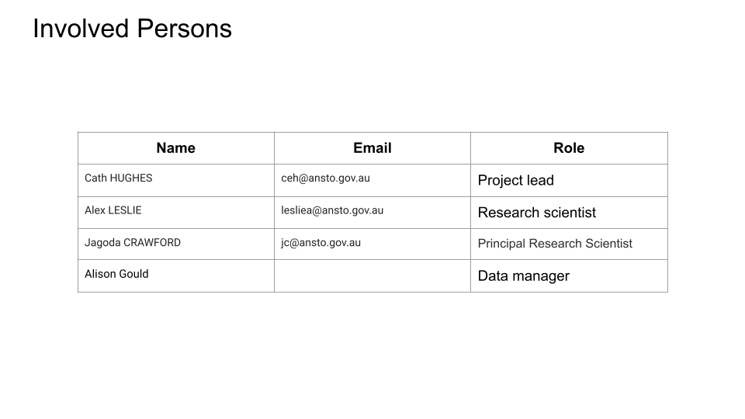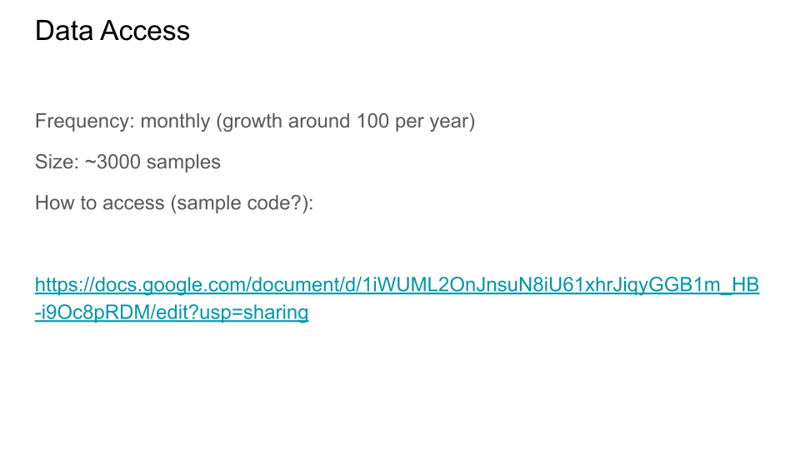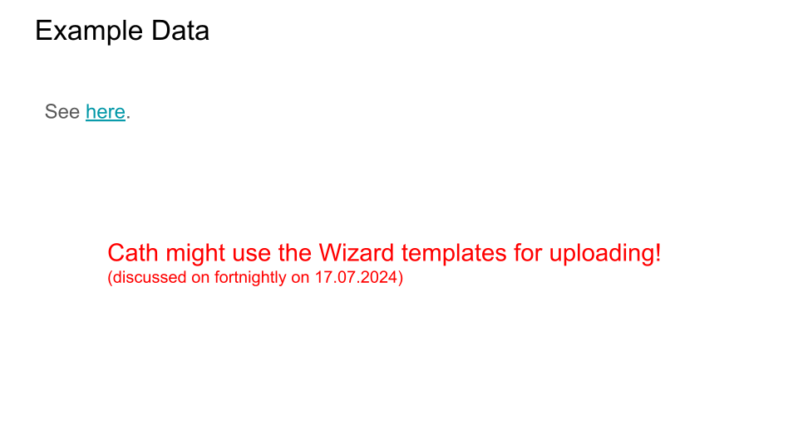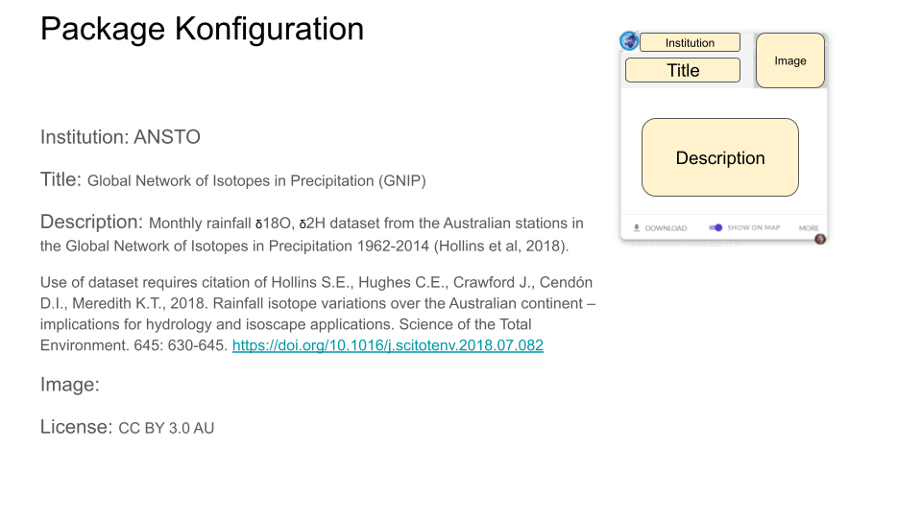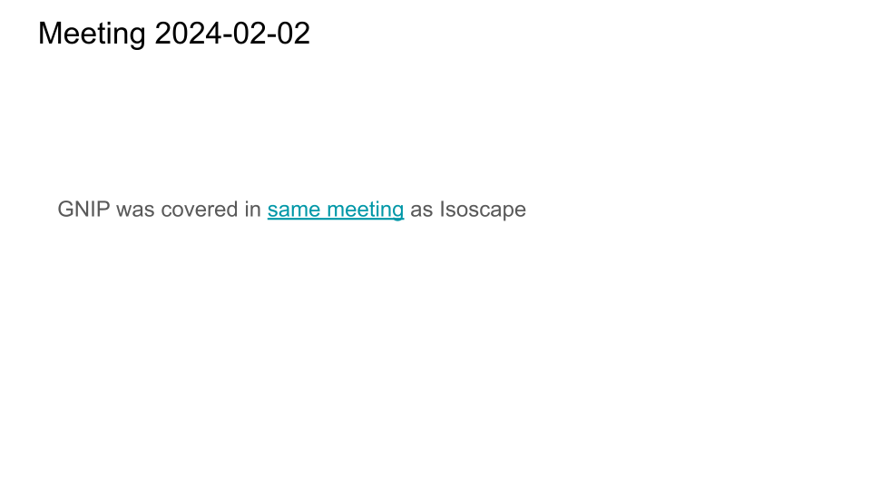

Adapter 2 Mapping

Sample
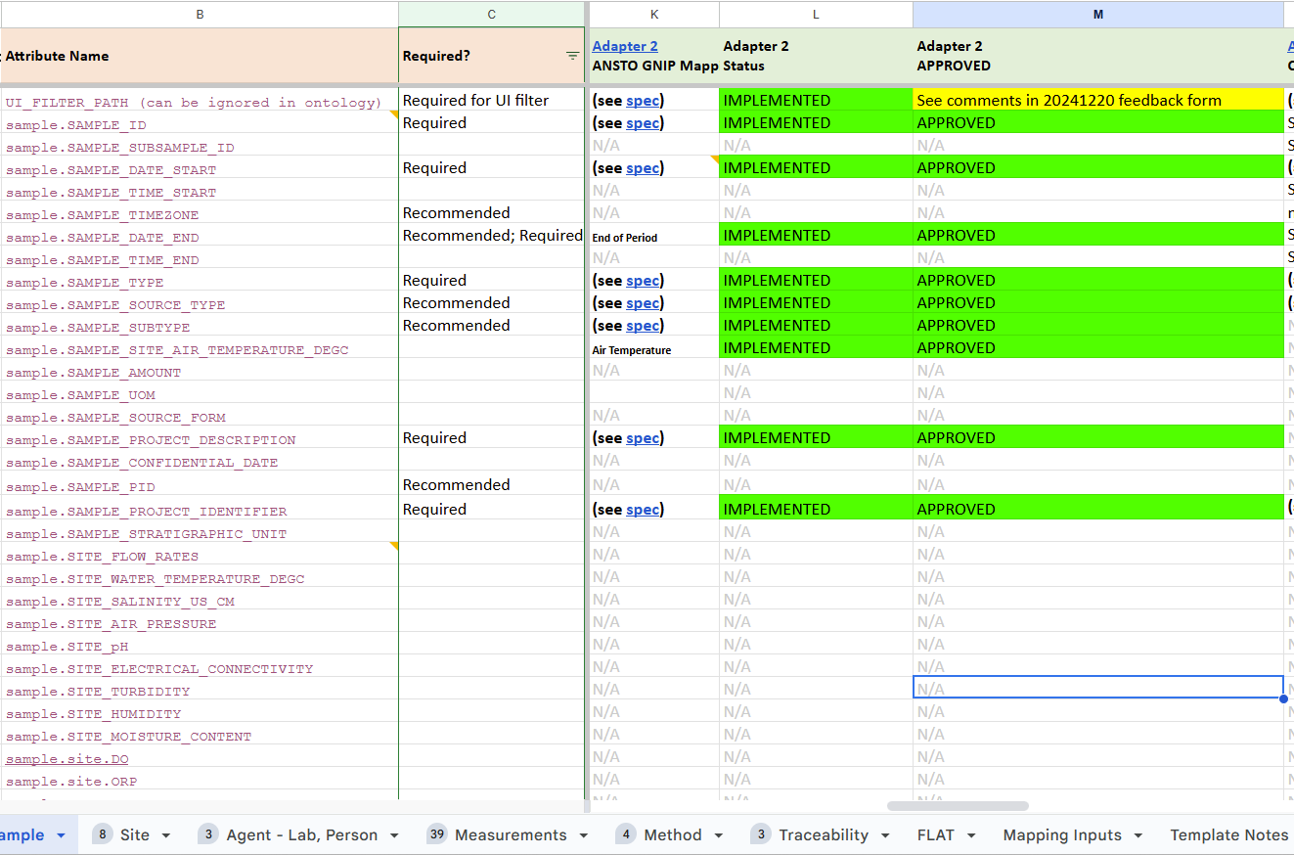

Site
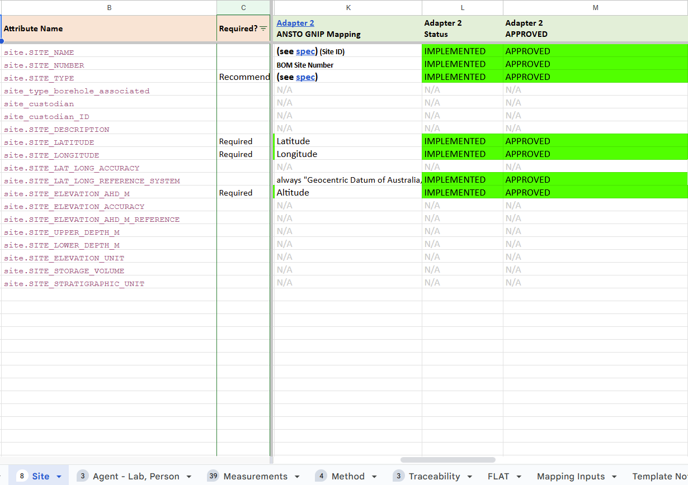

Agent - Lab, Person
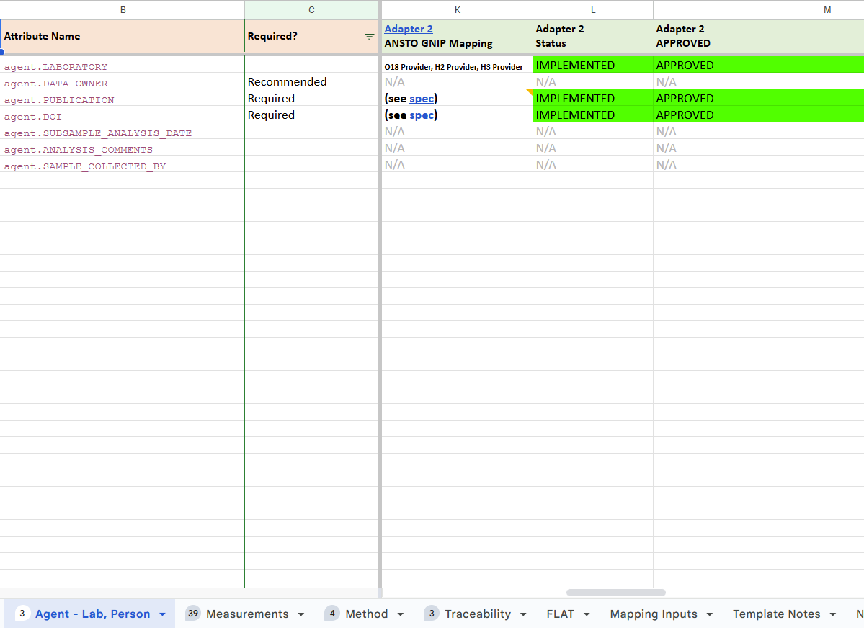

Measurement
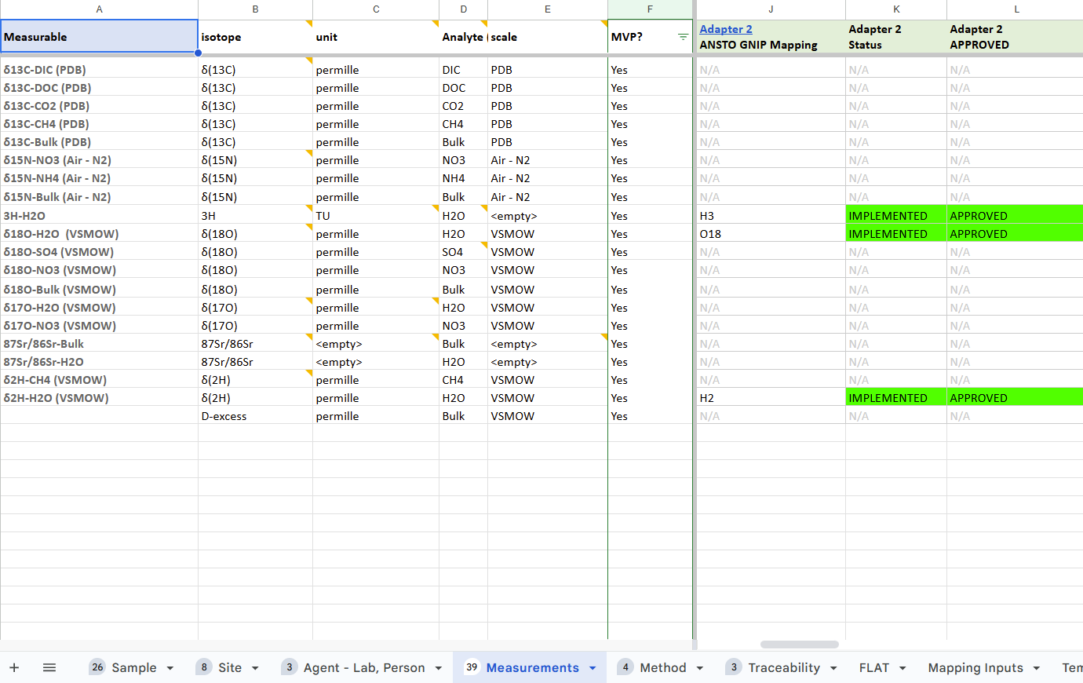

Method
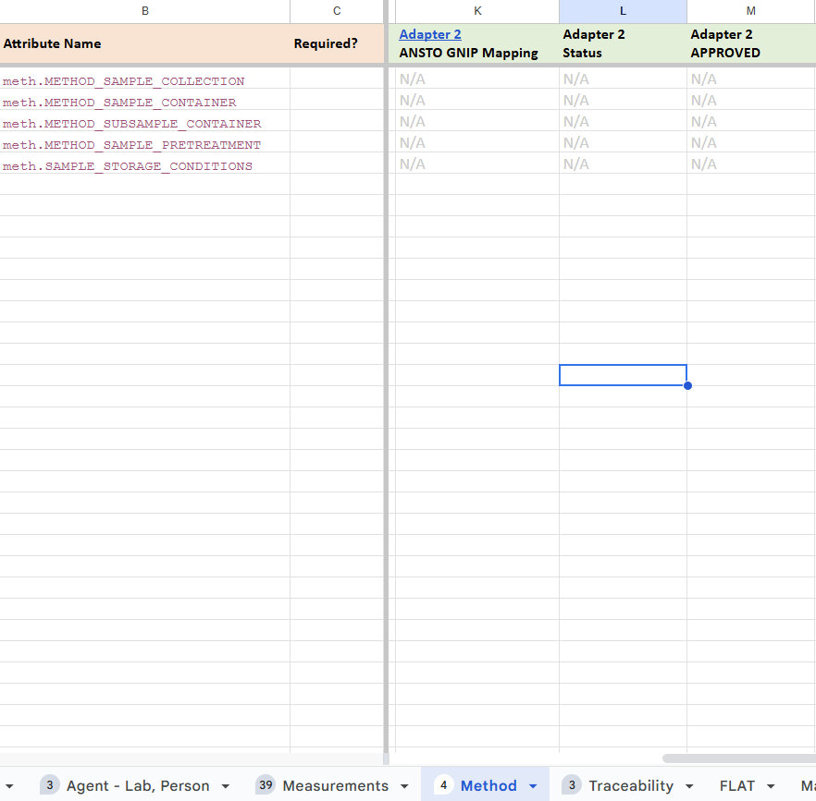

Adapter 3

Adapter 3 Specification
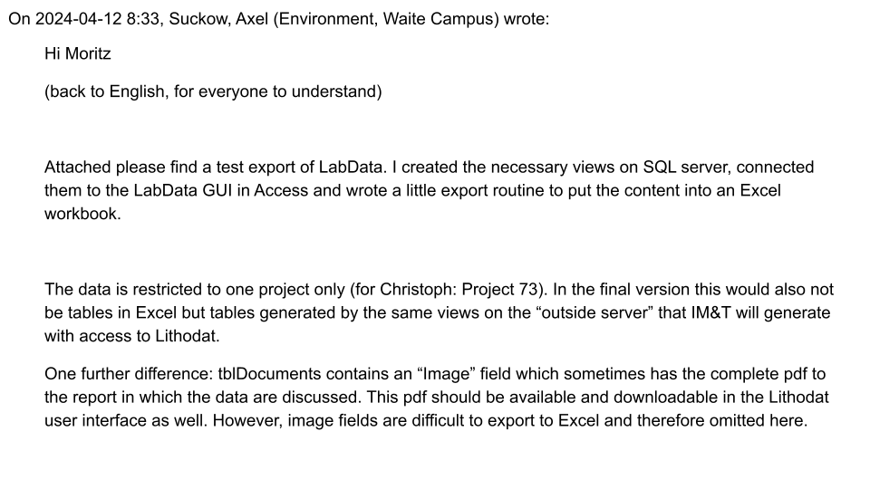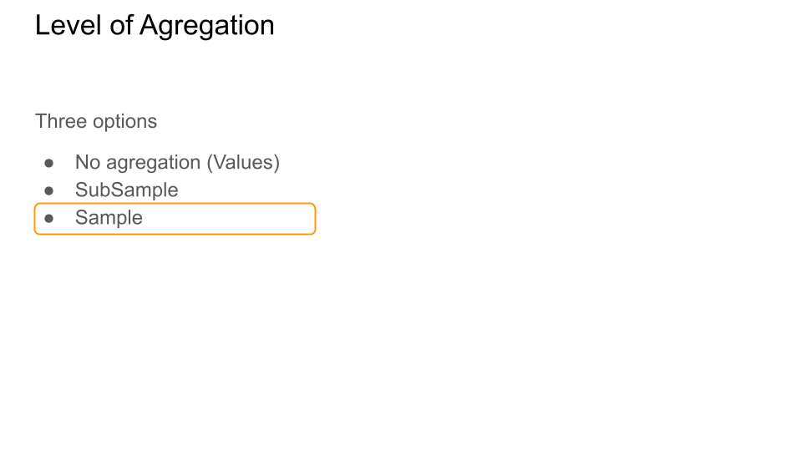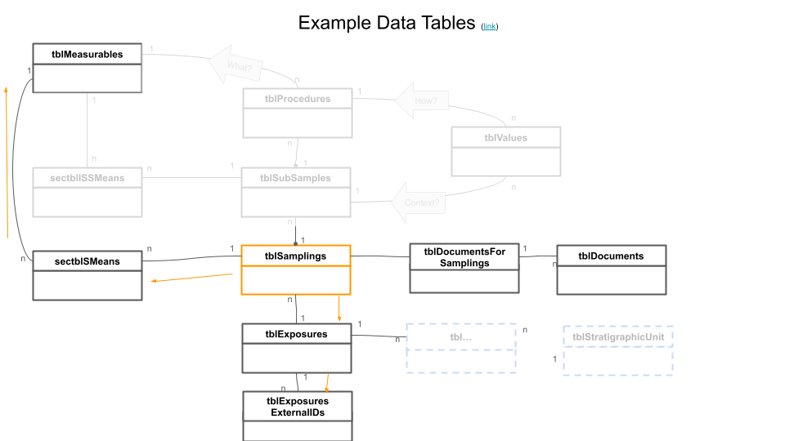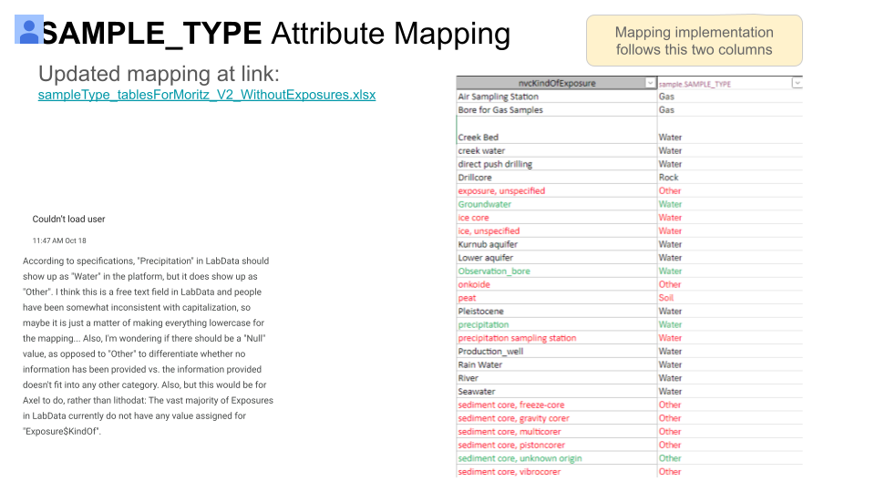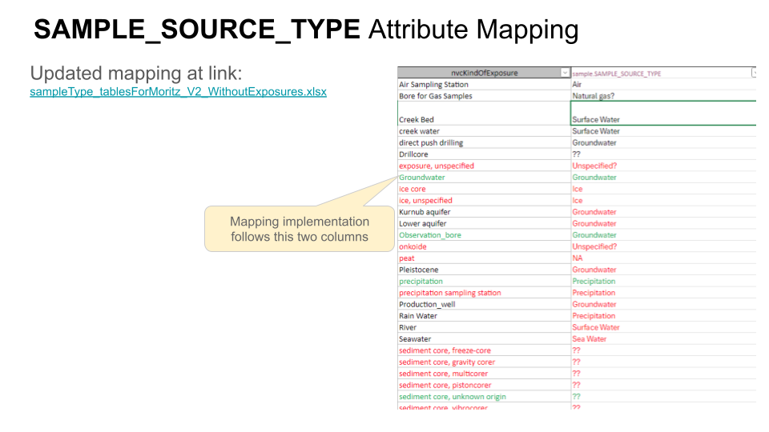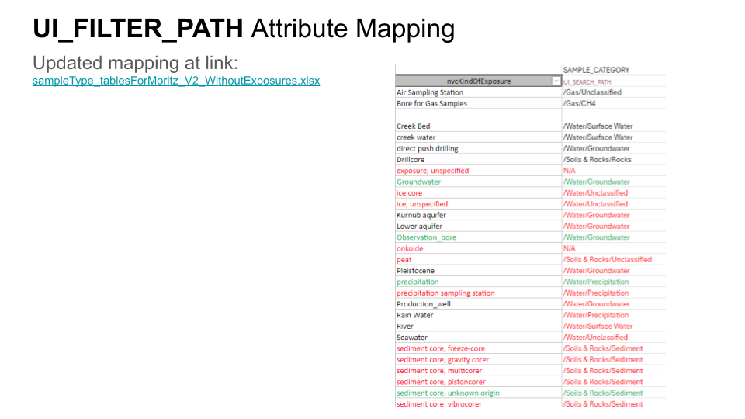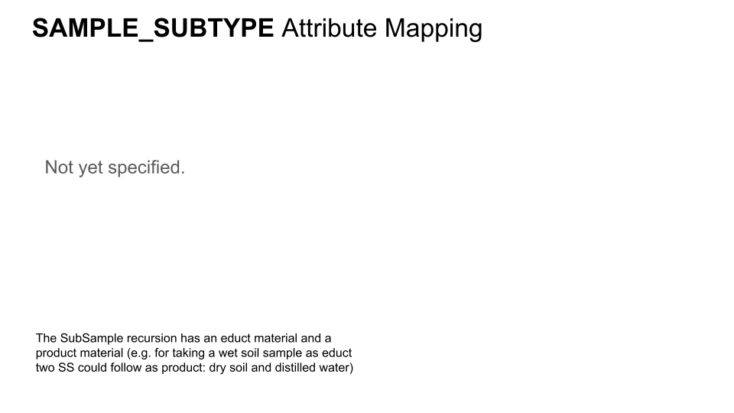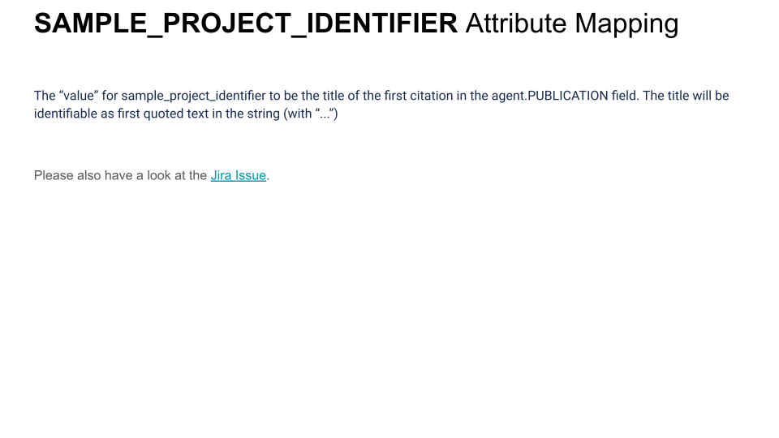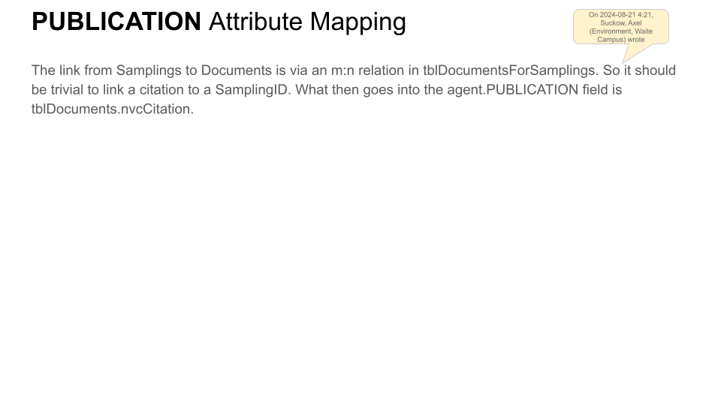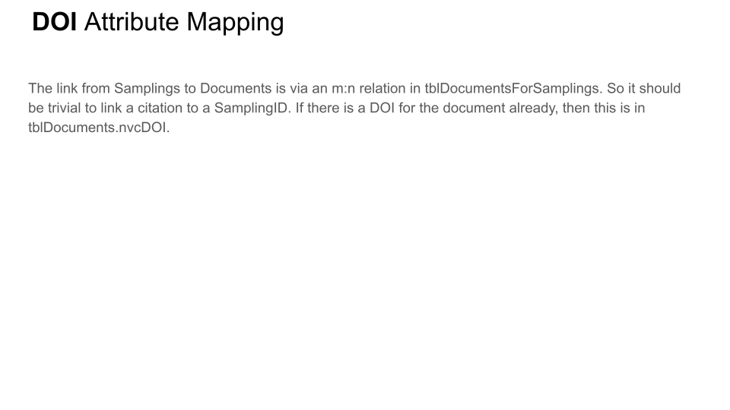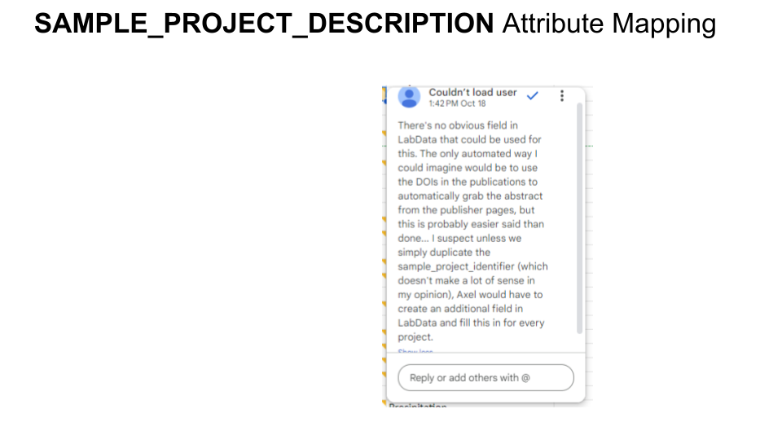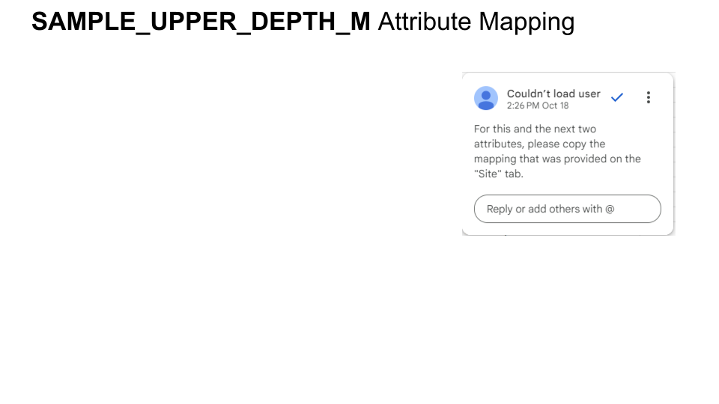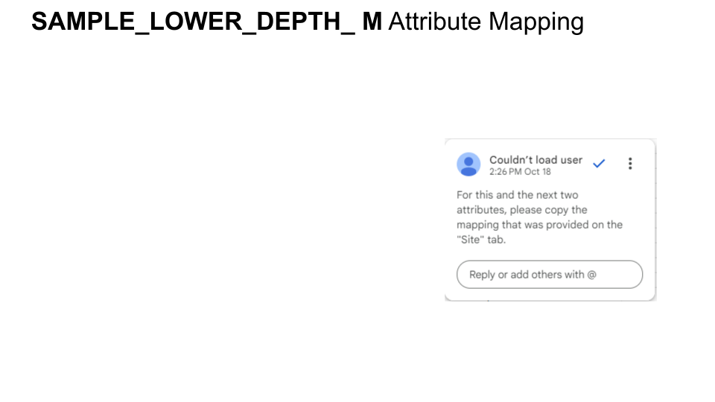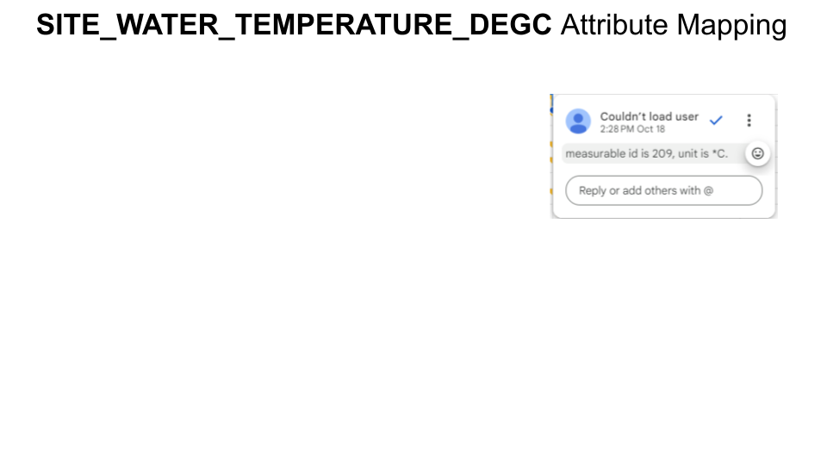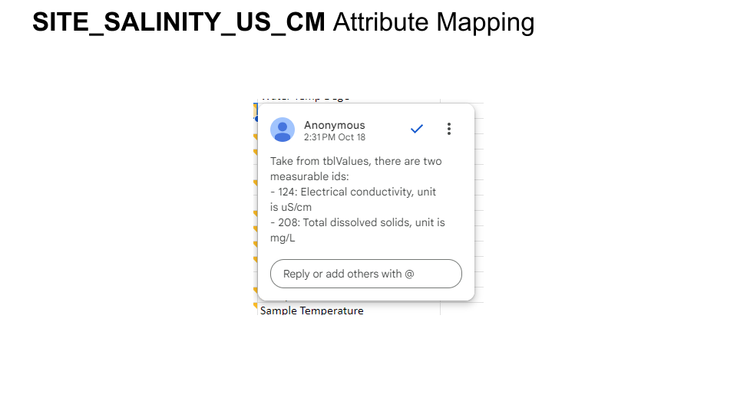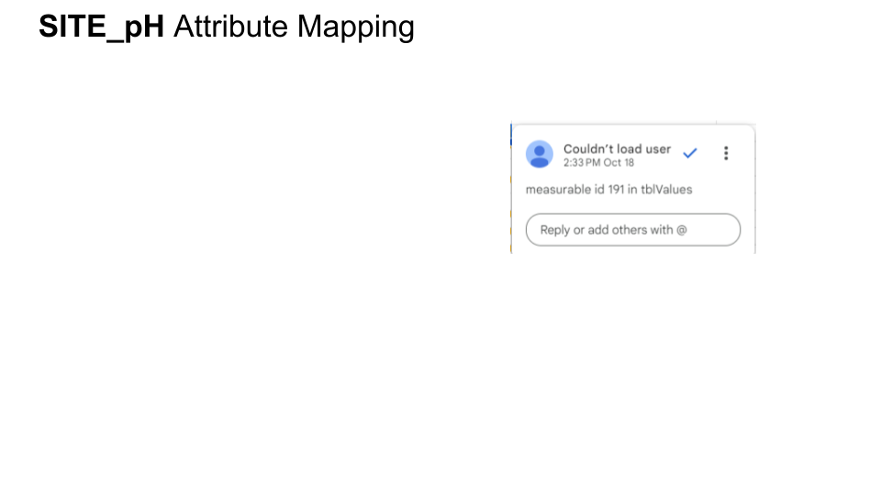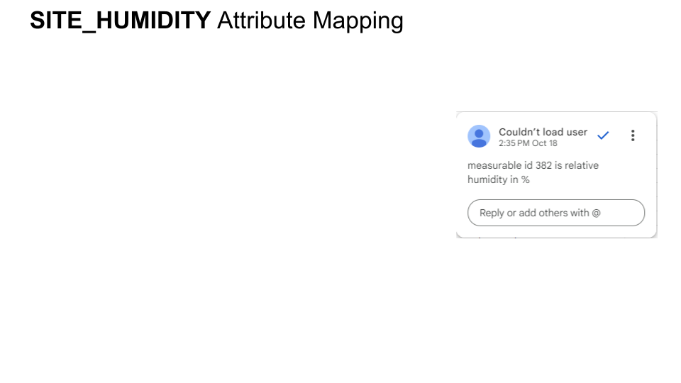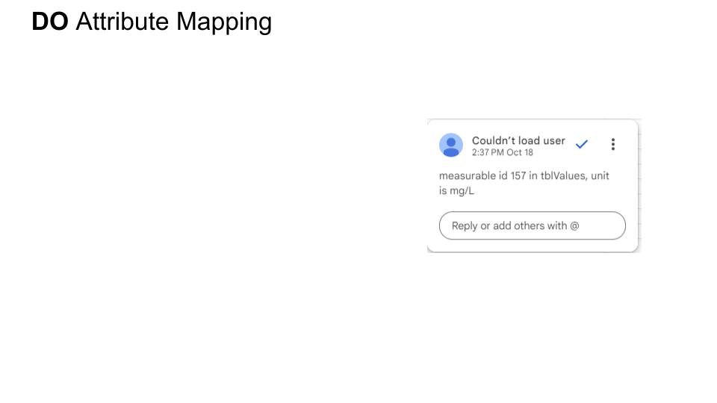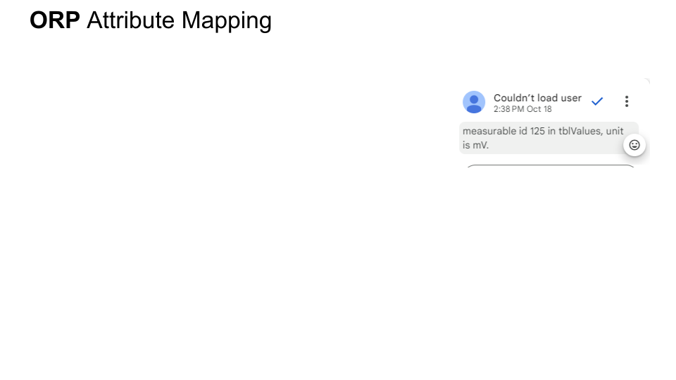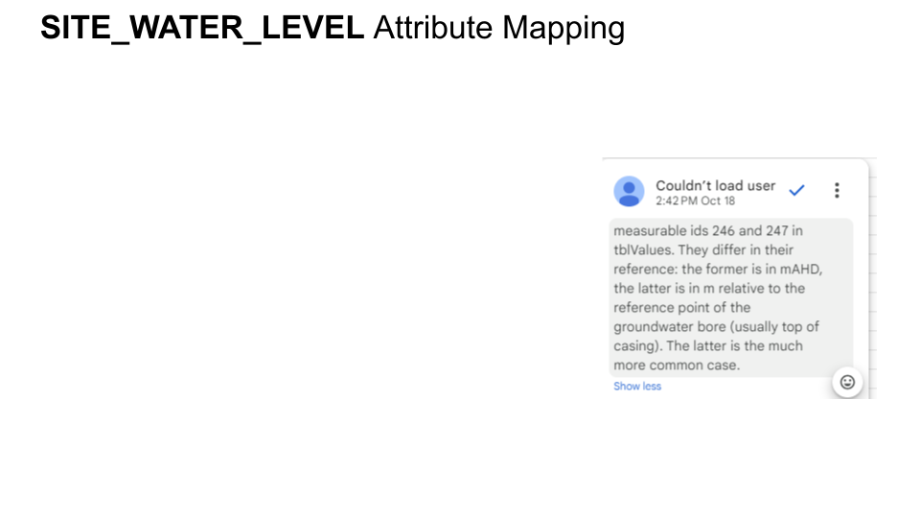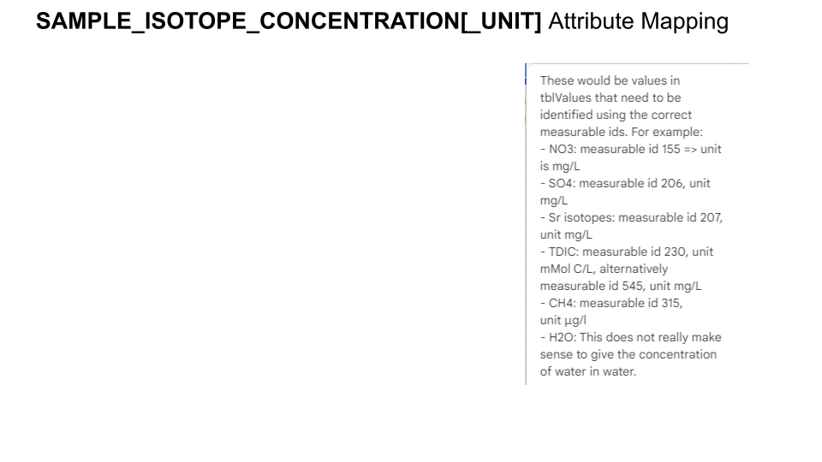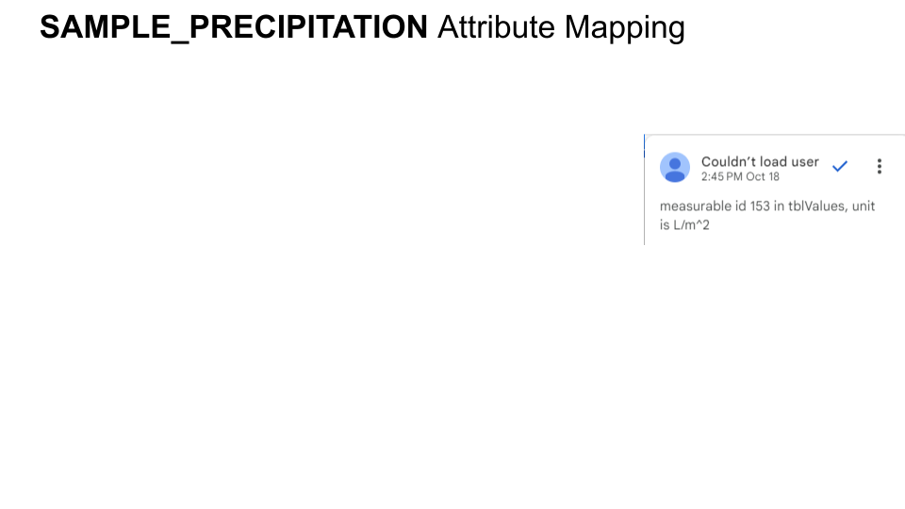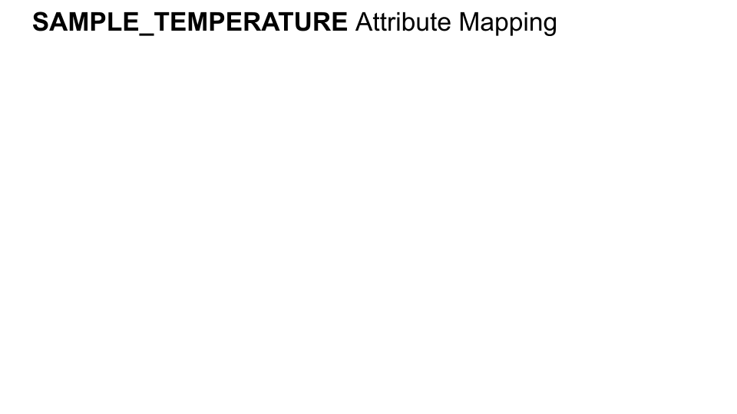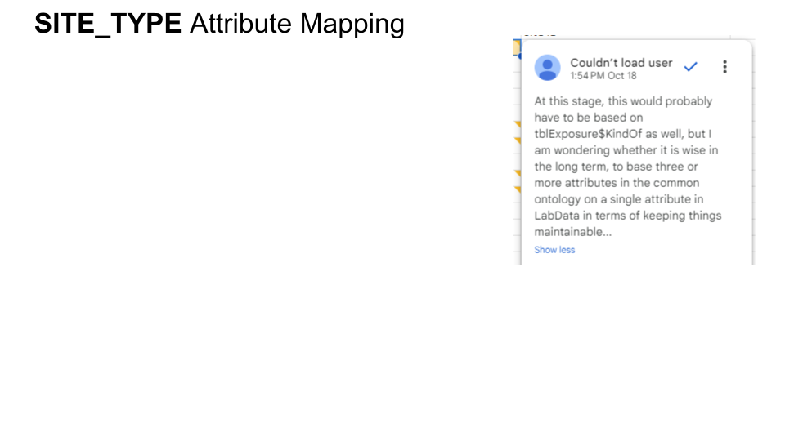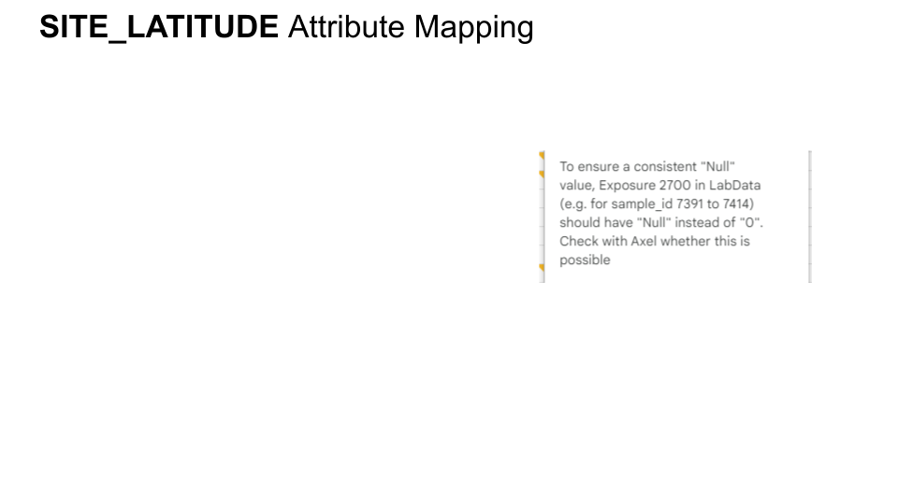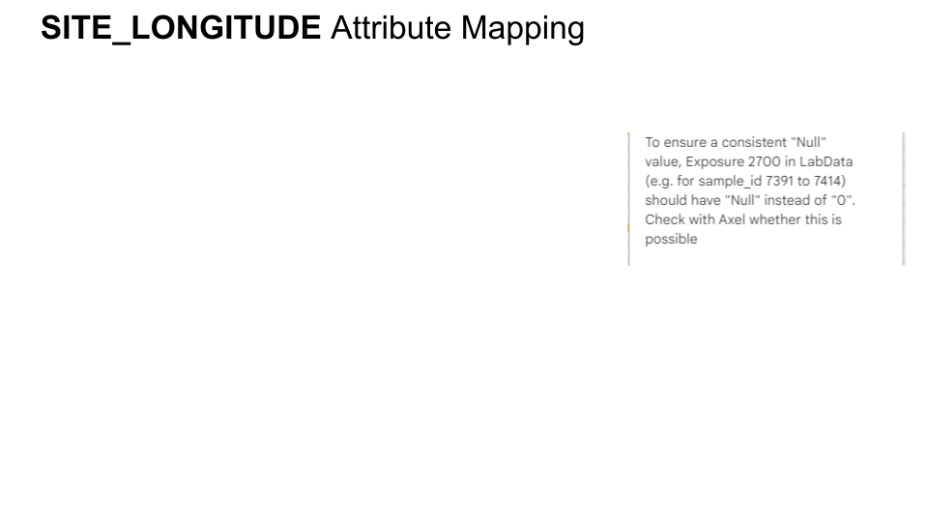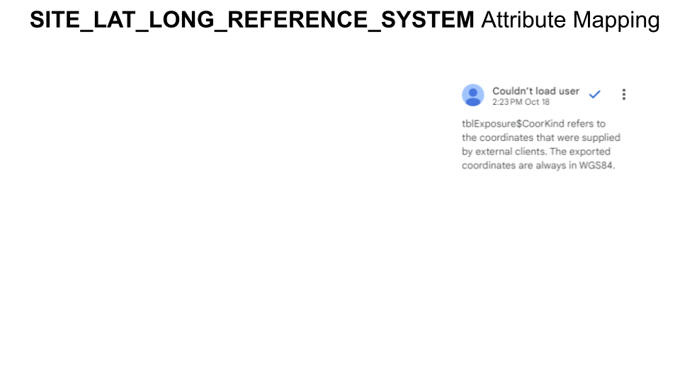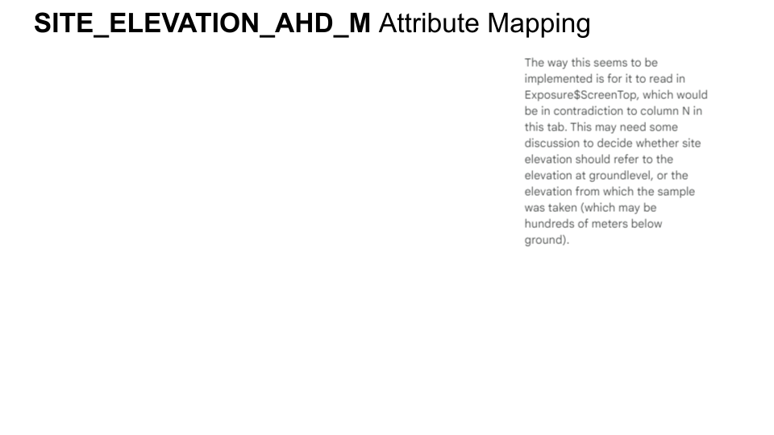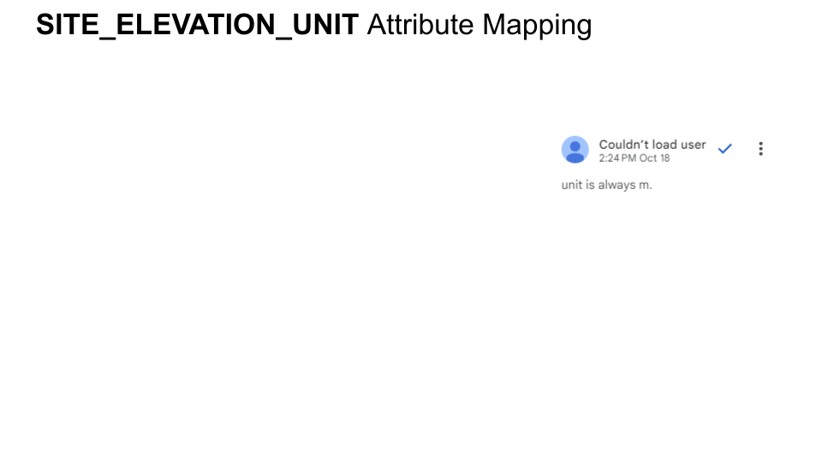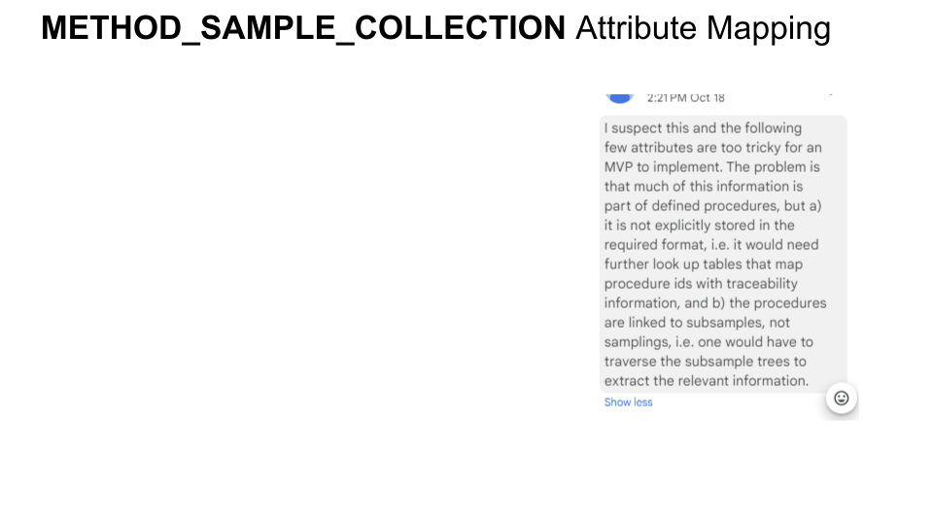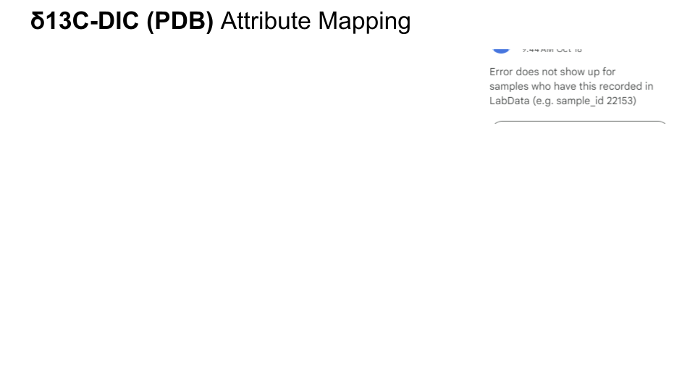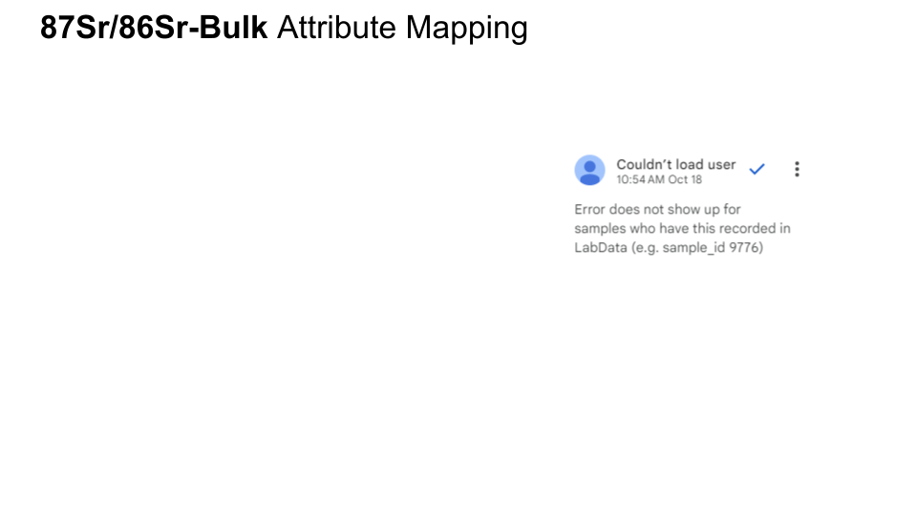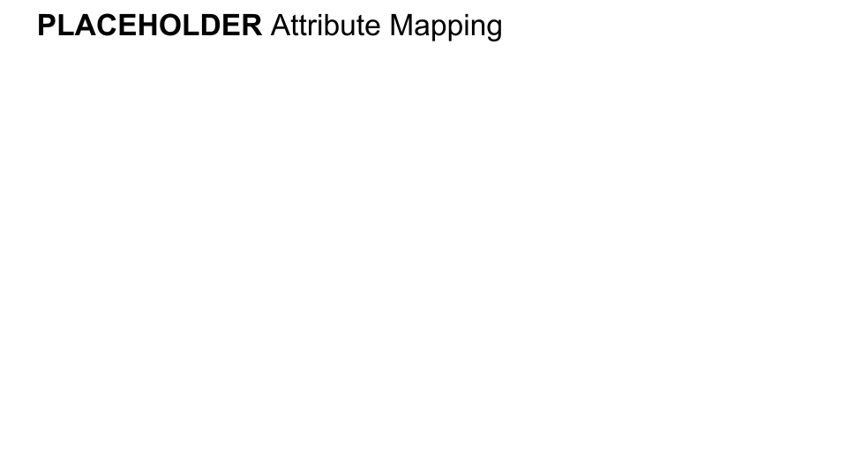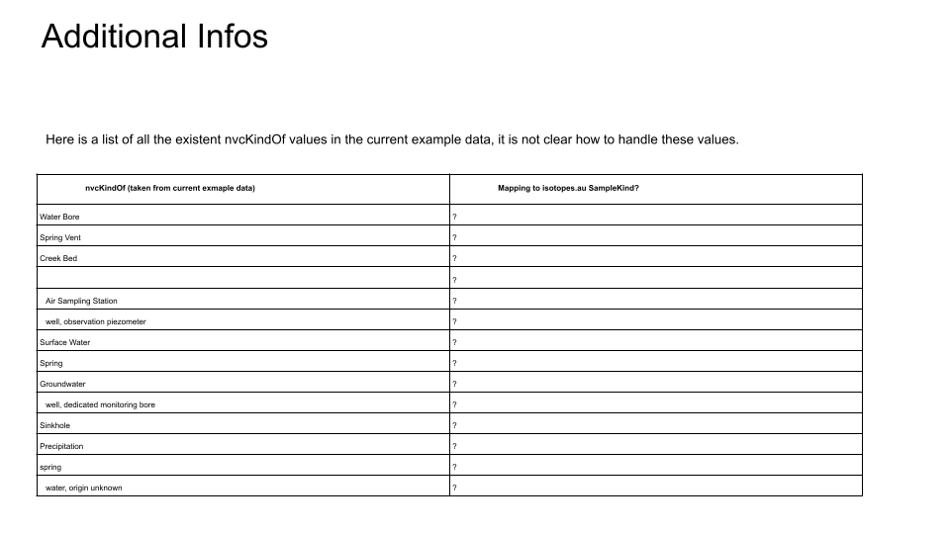

Adapter 3 Environment
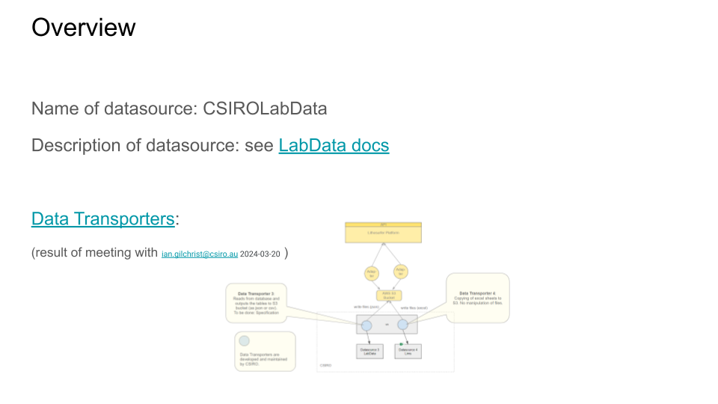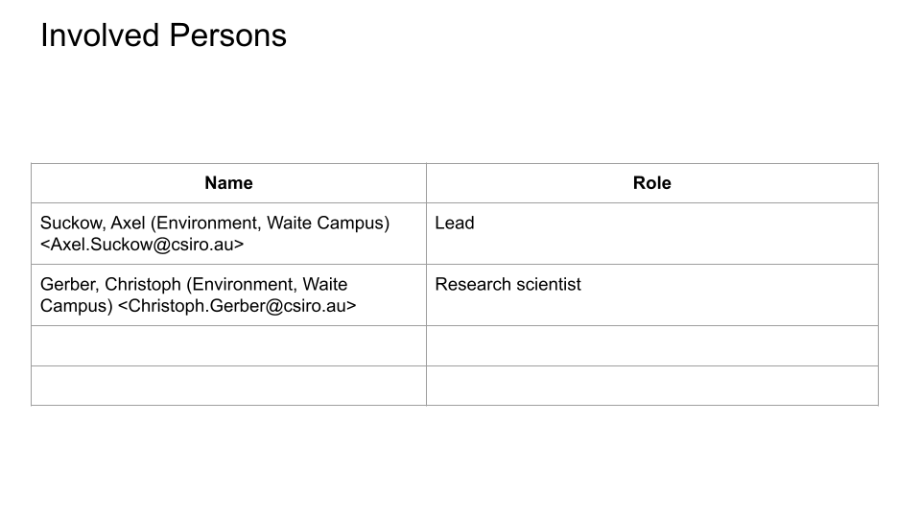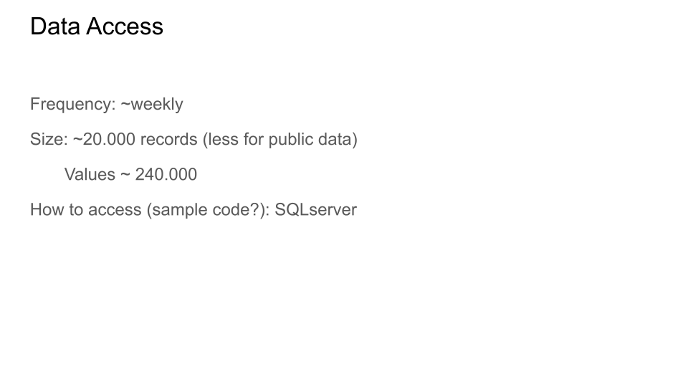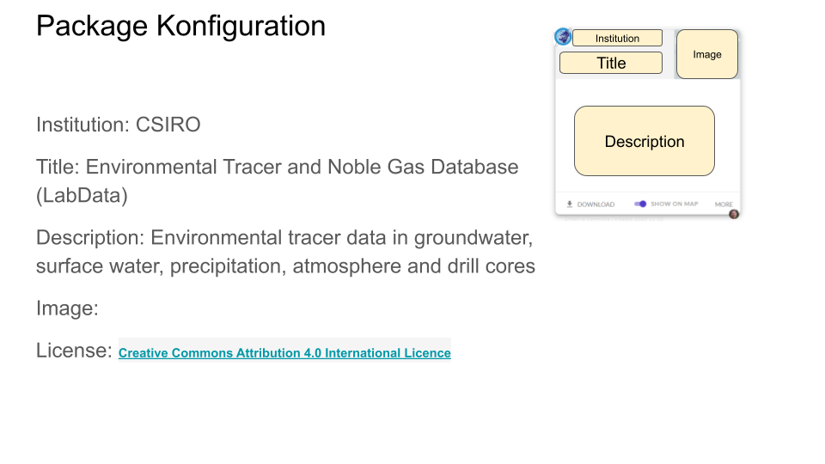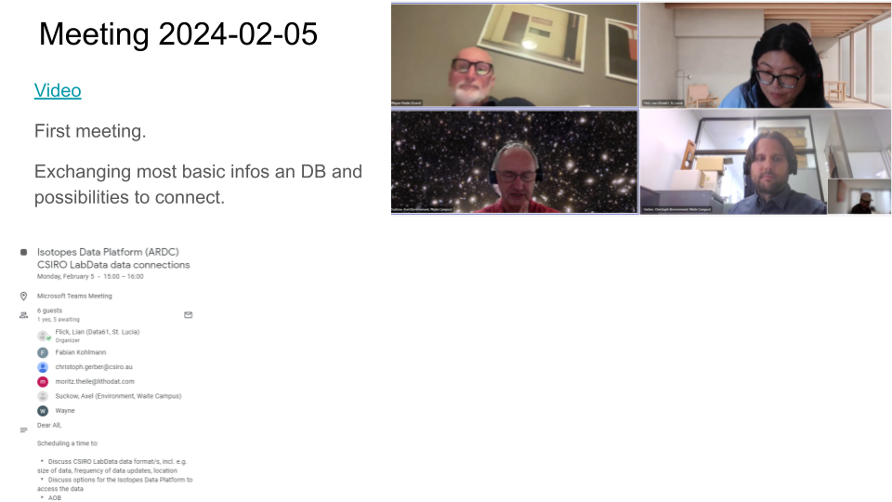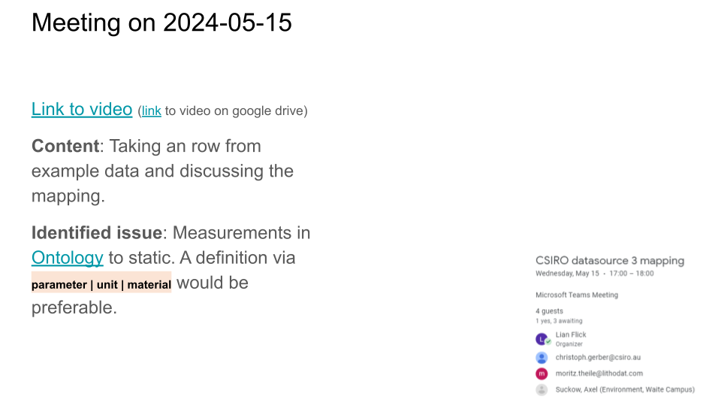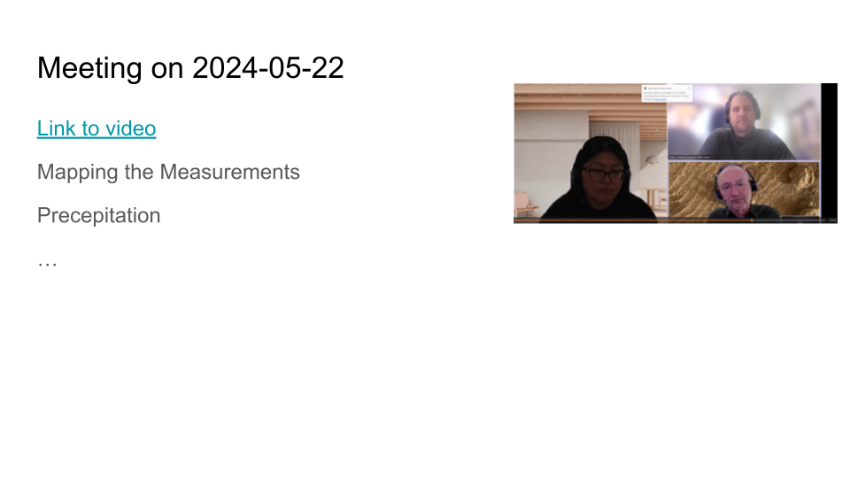

Adapter 3 Mapping

Sample

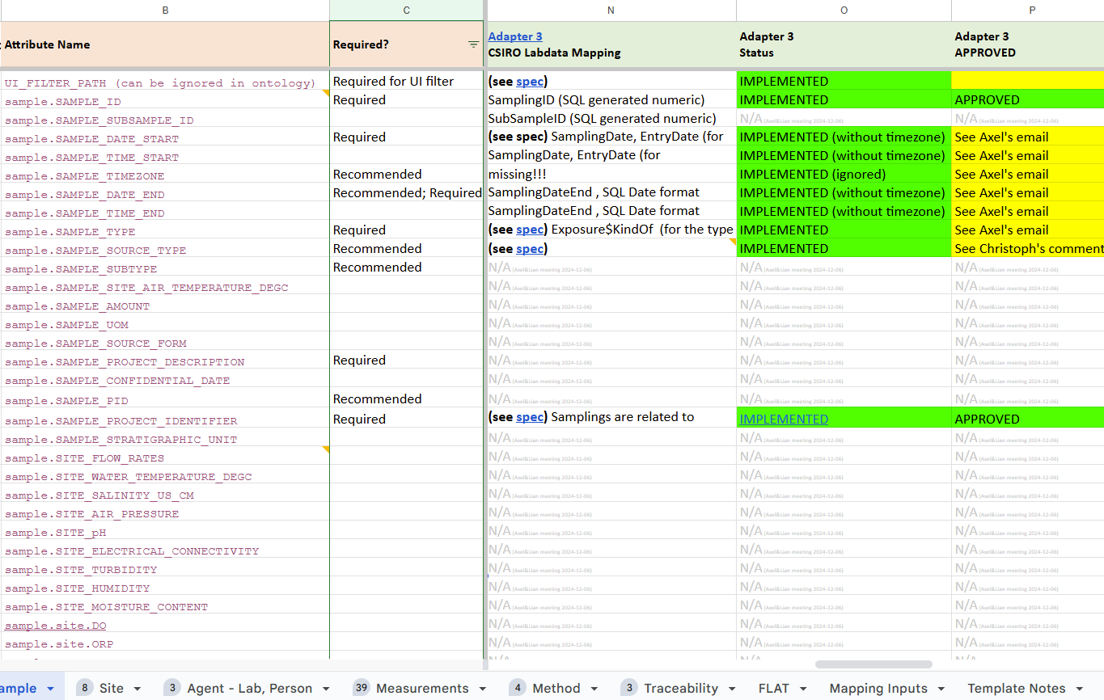

Site
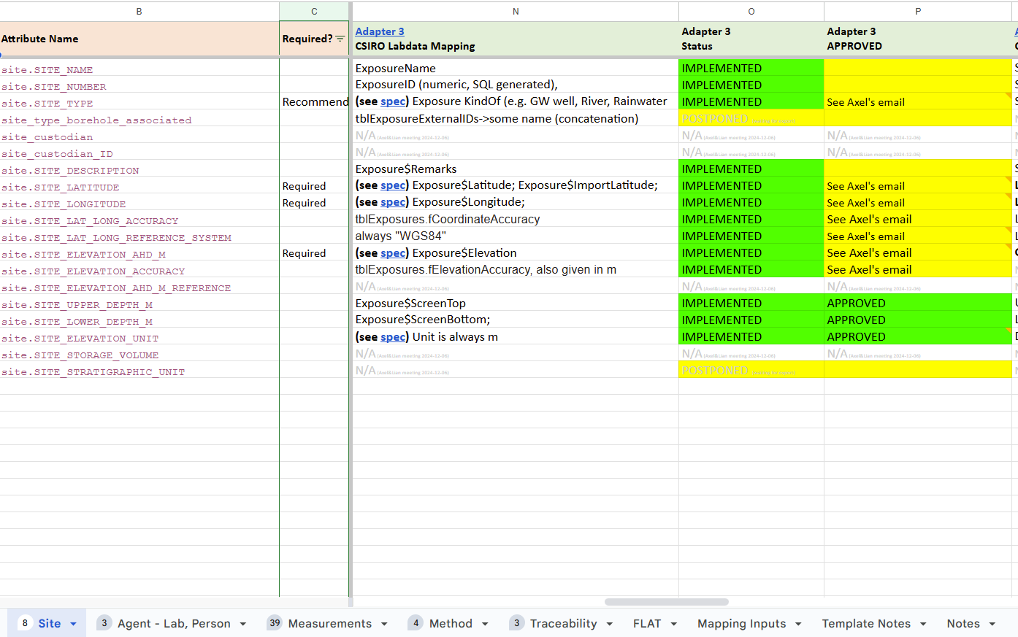

Agent - Lab, Person
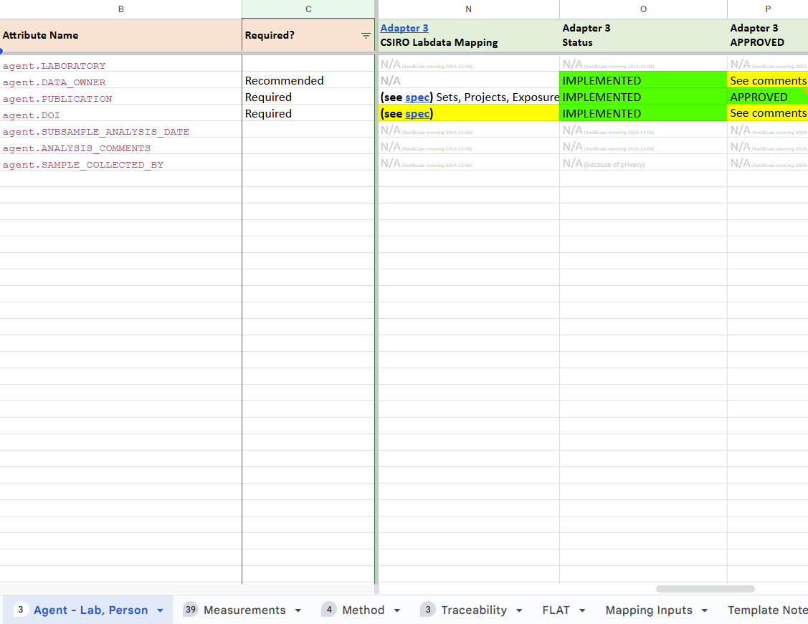

Measurements
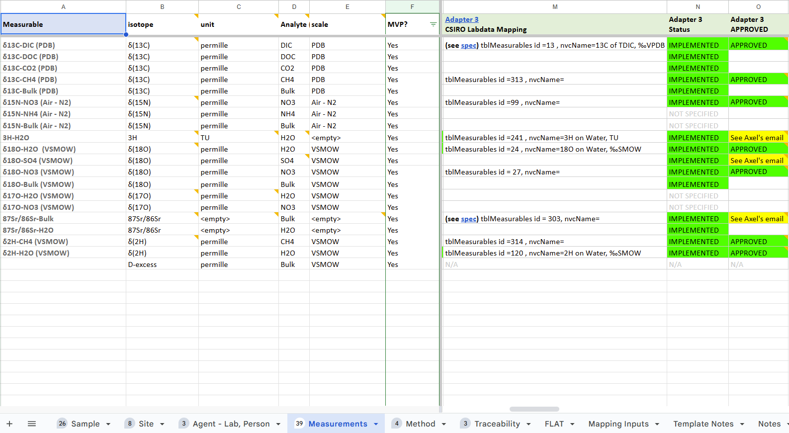

Method
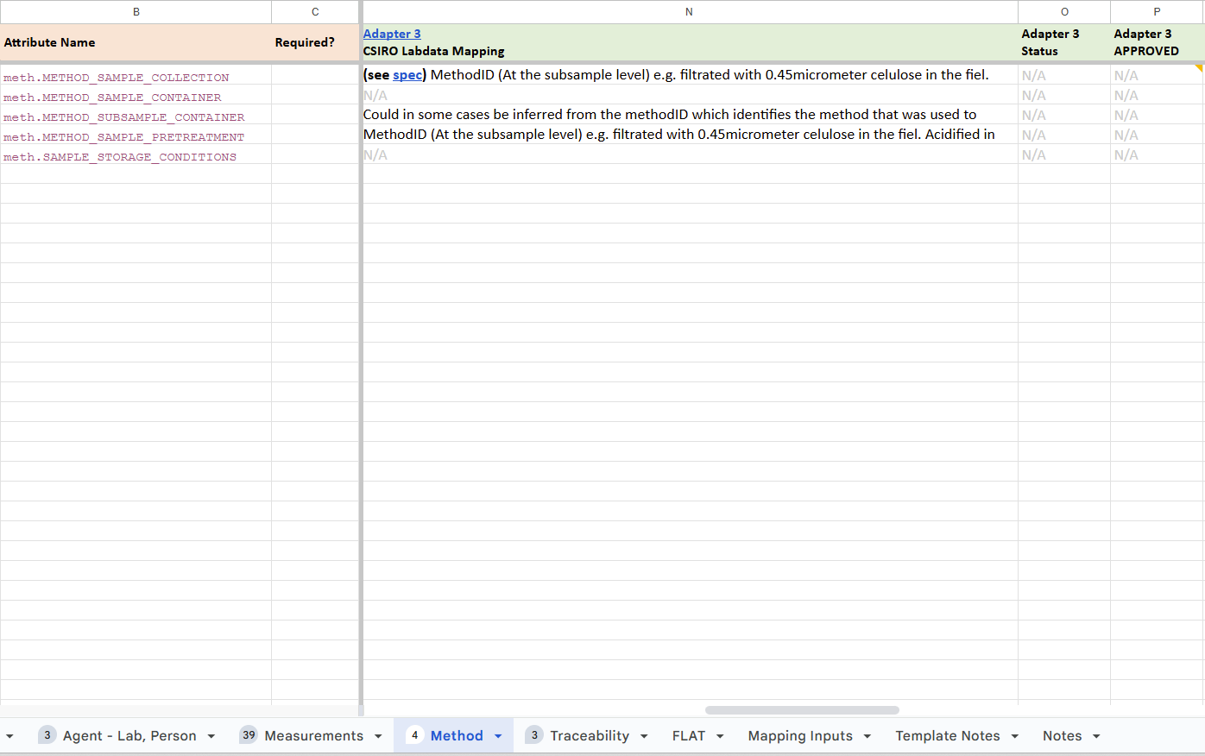

Adapter 4

Adapter 4 Specification
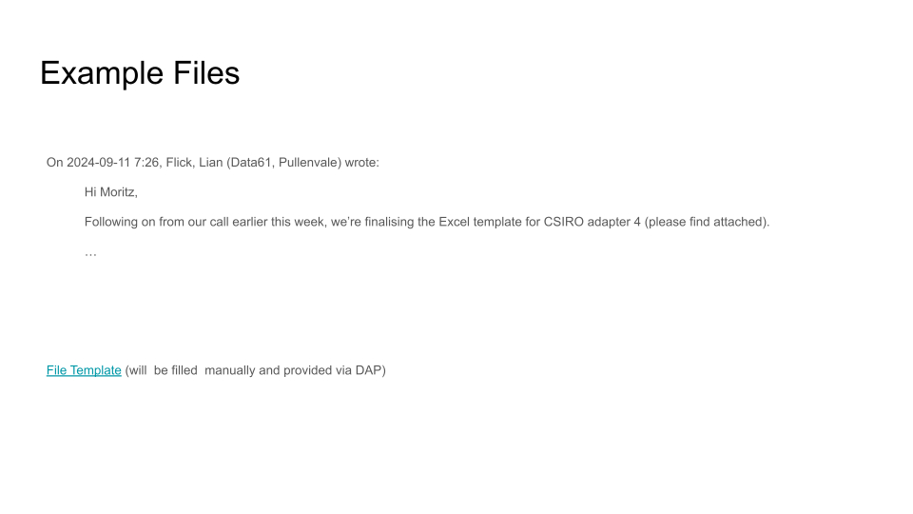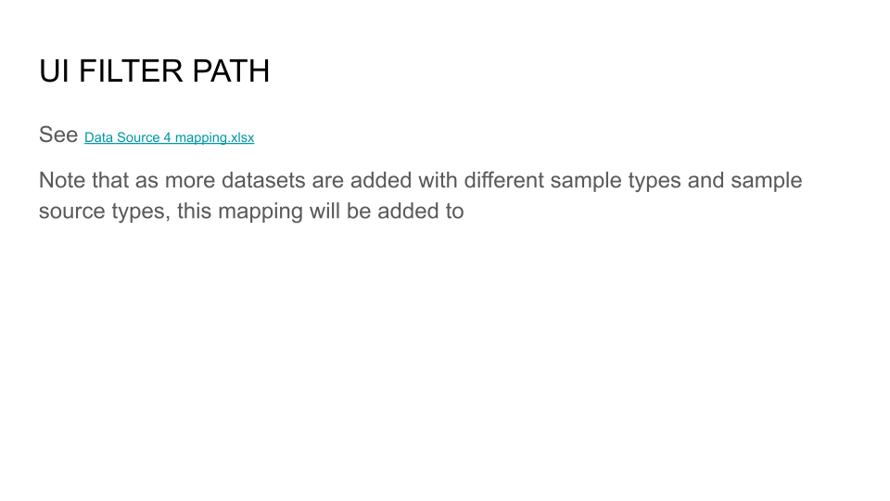

Adapter 4 Environment
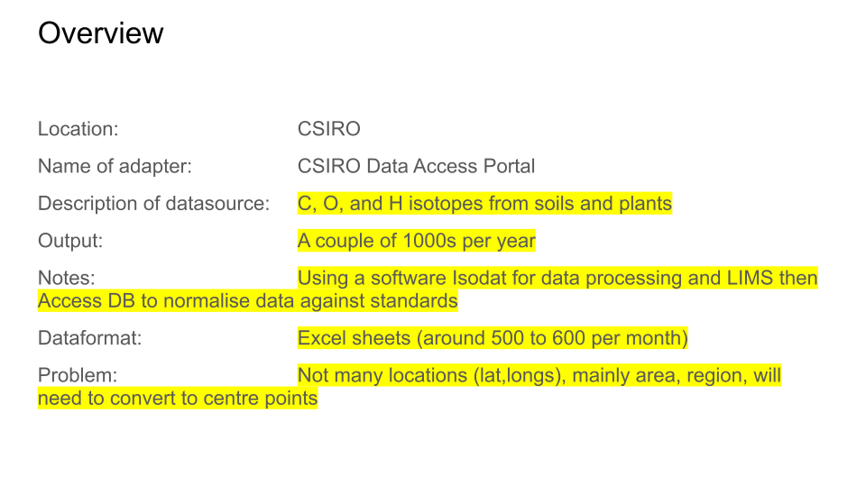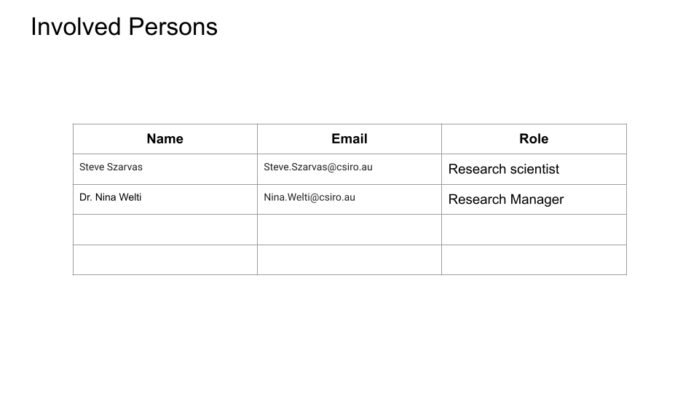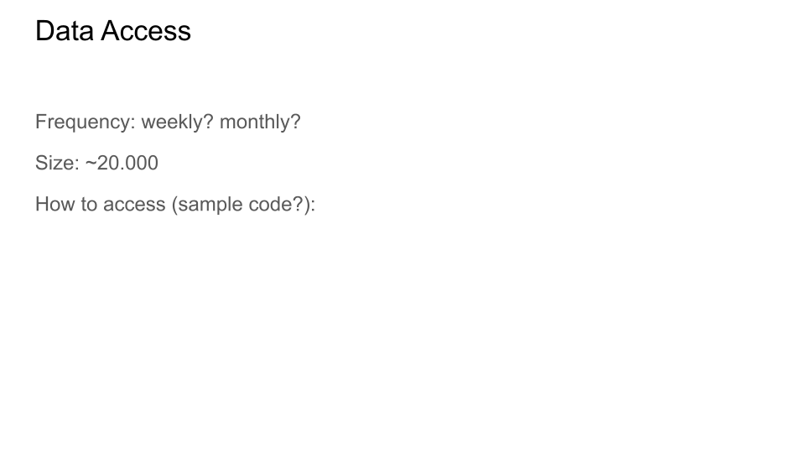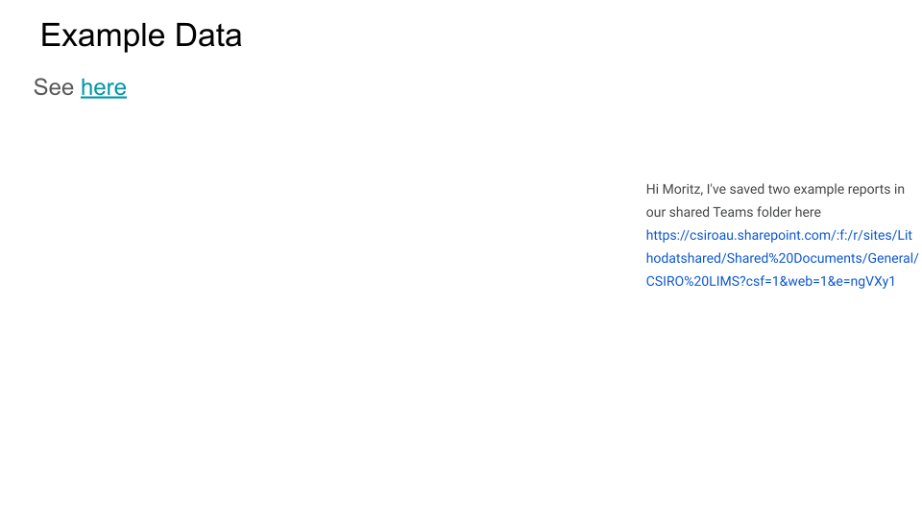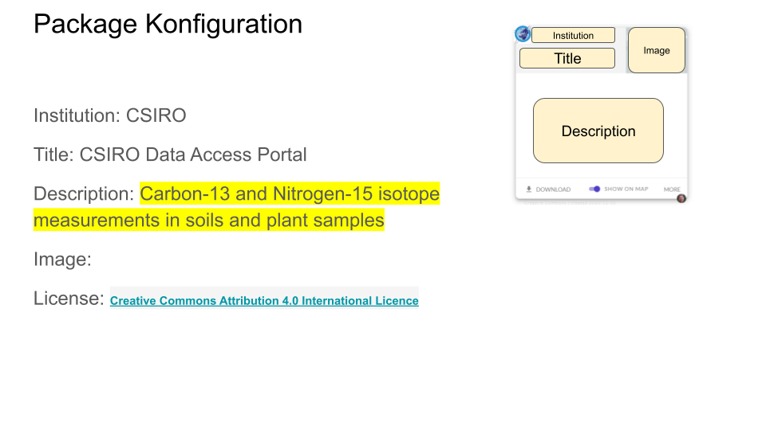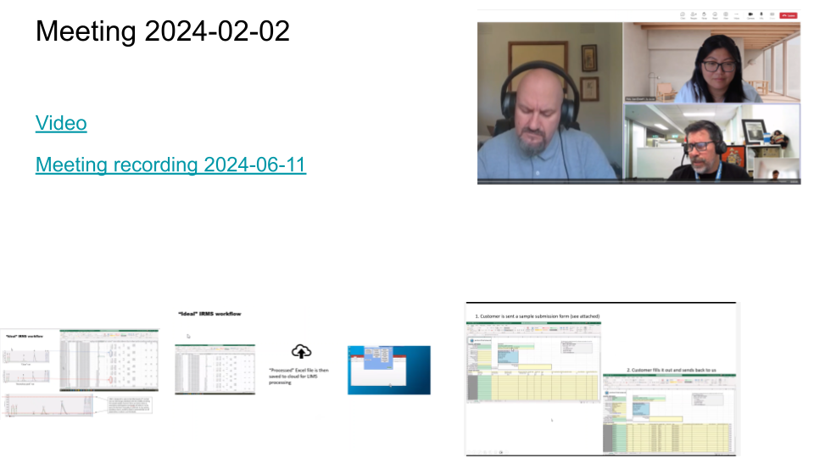

Adapter 4 Mapping

Sample
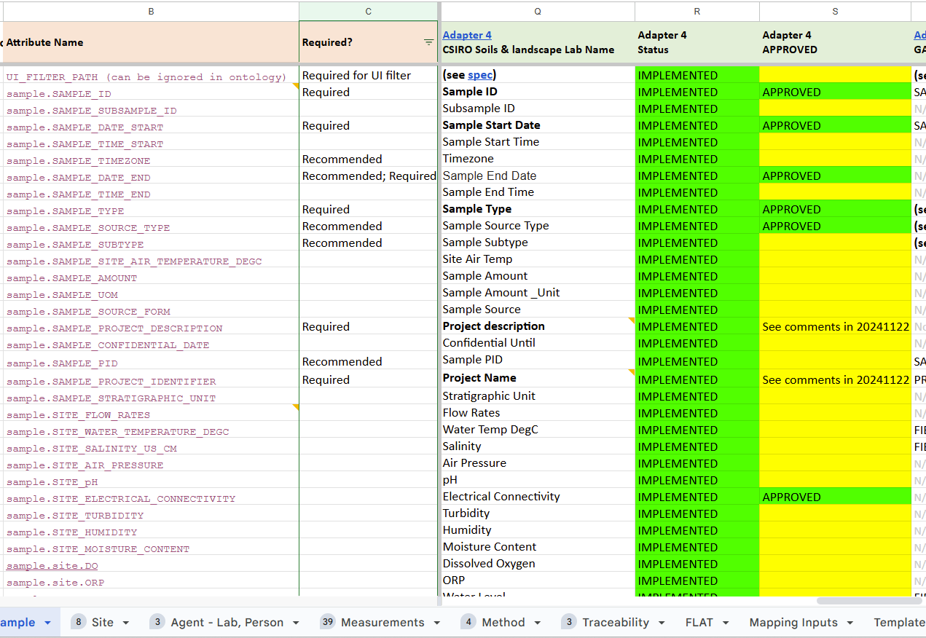

Site
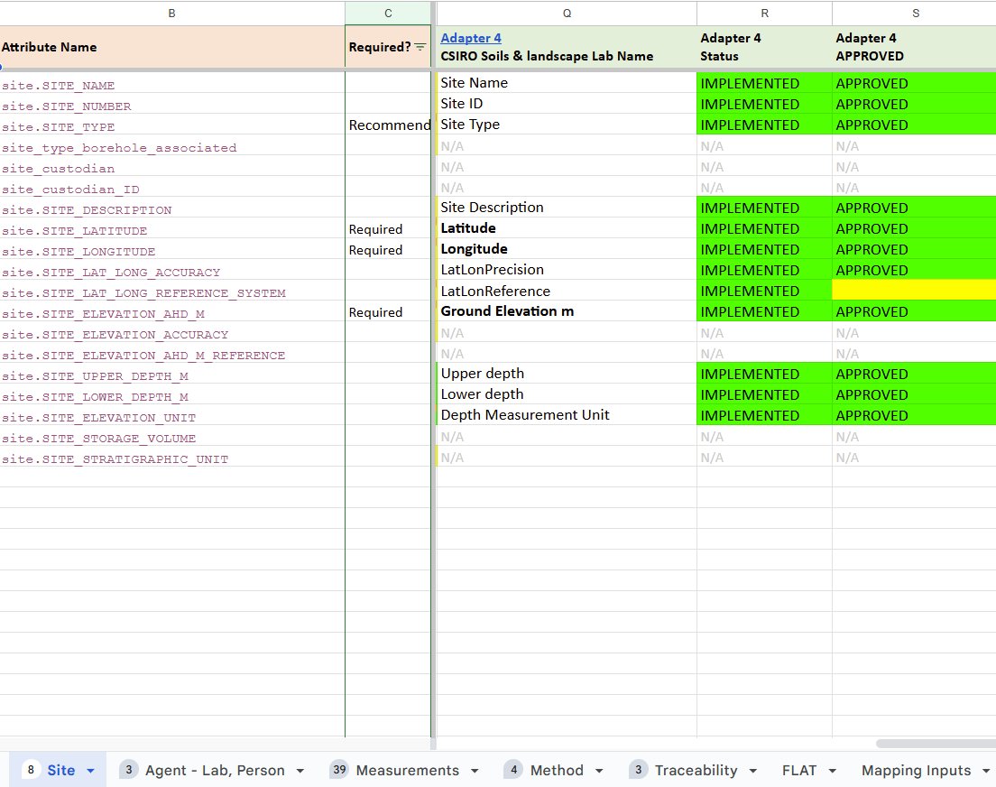

Agent - Lab, Person
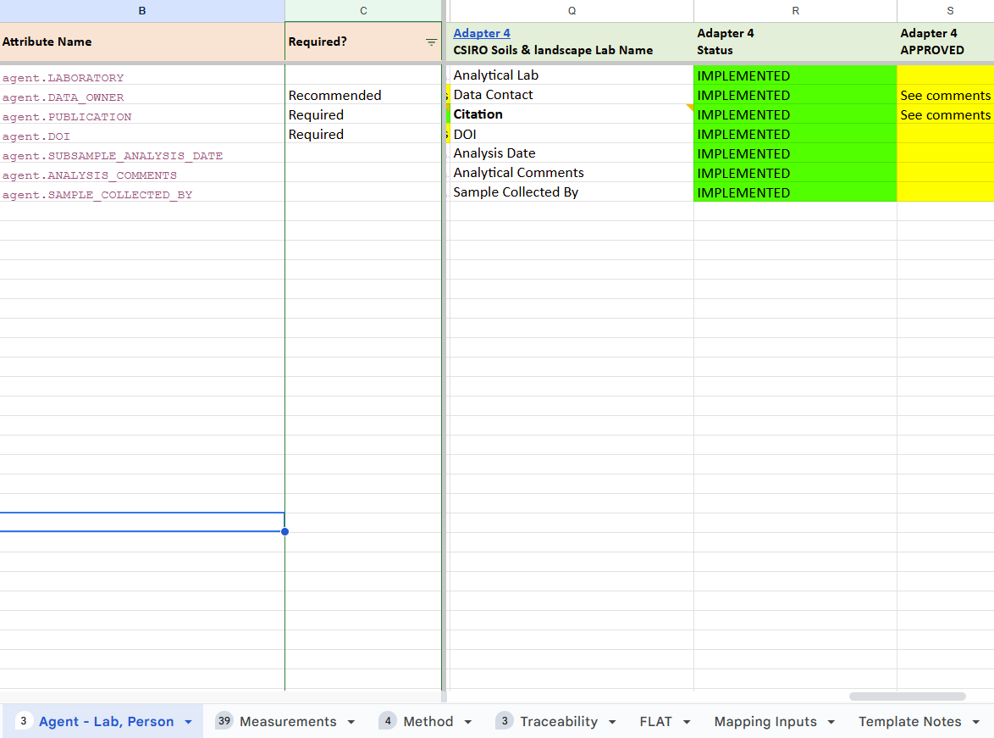

Measurements
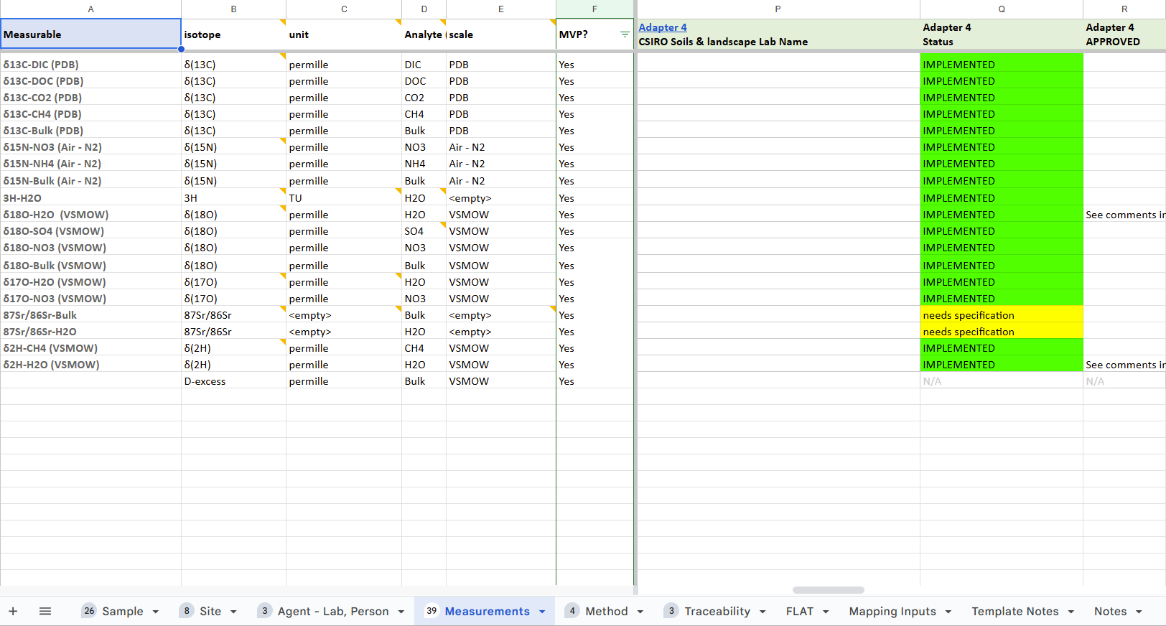

Method
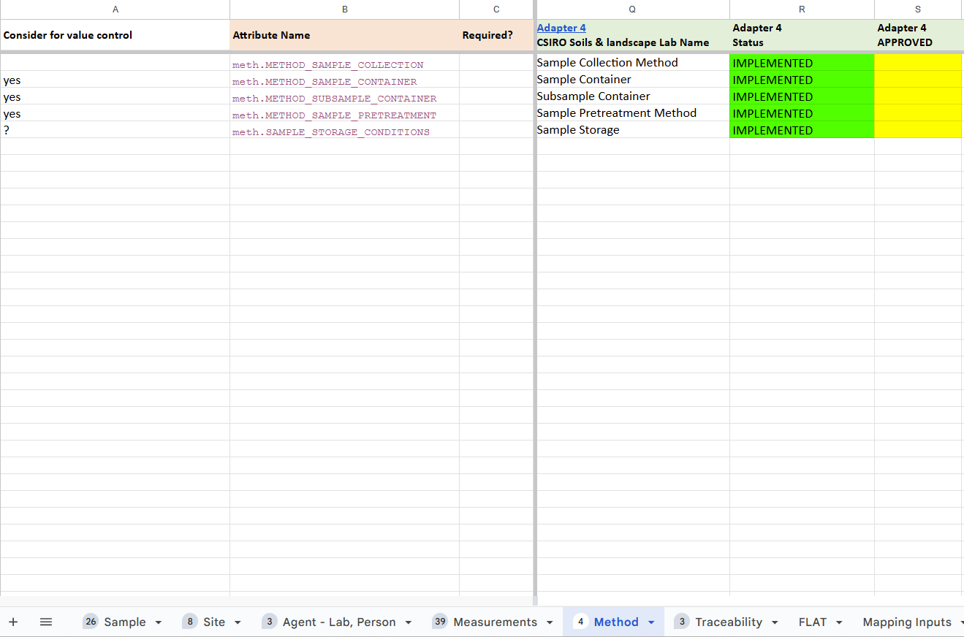

Adapter 5

Adapter 5 Specification
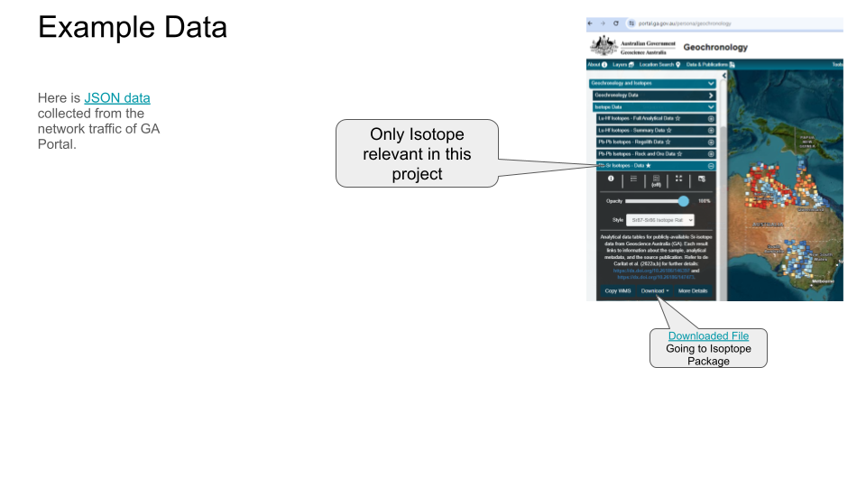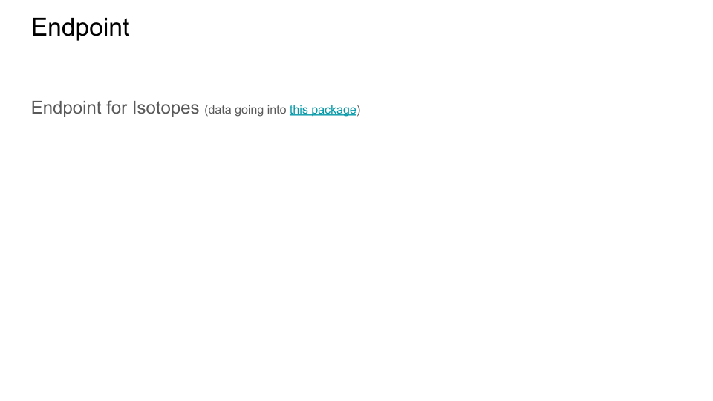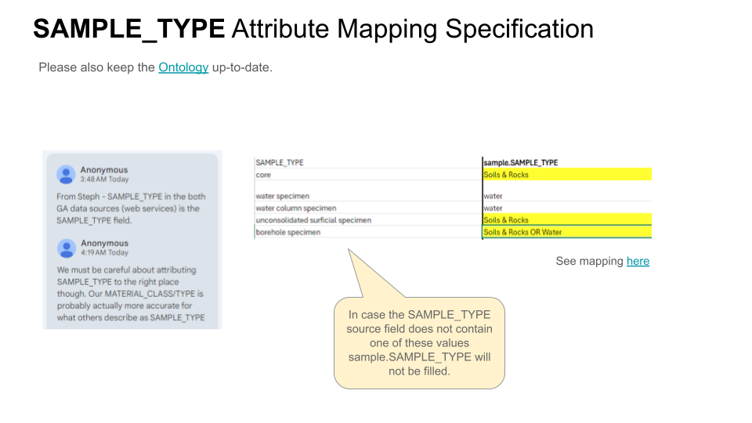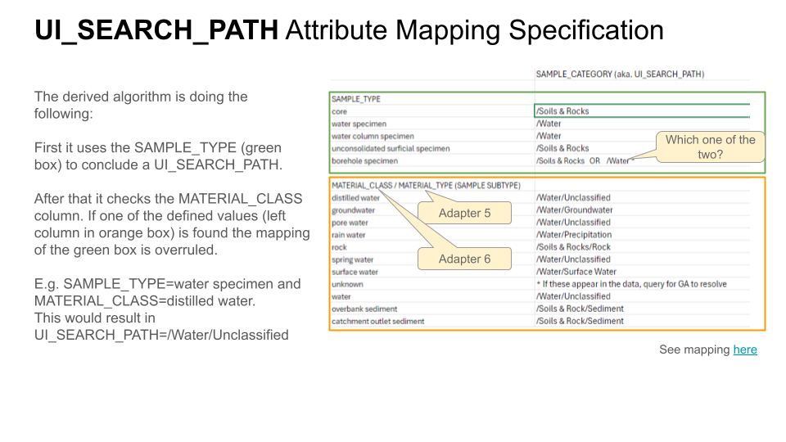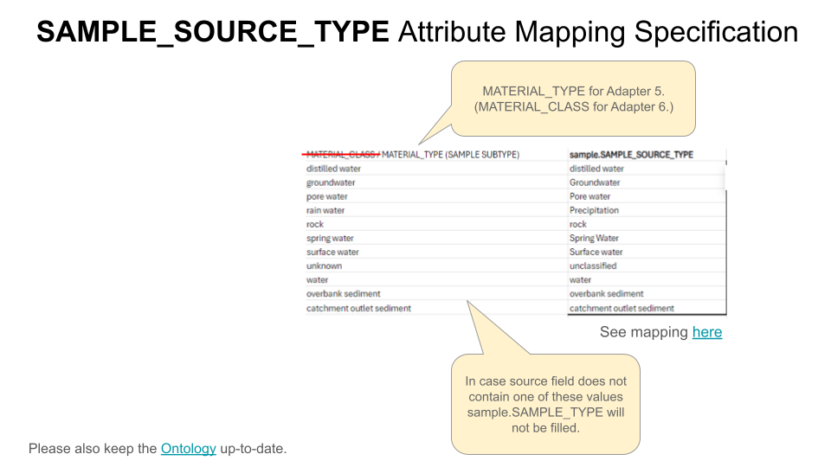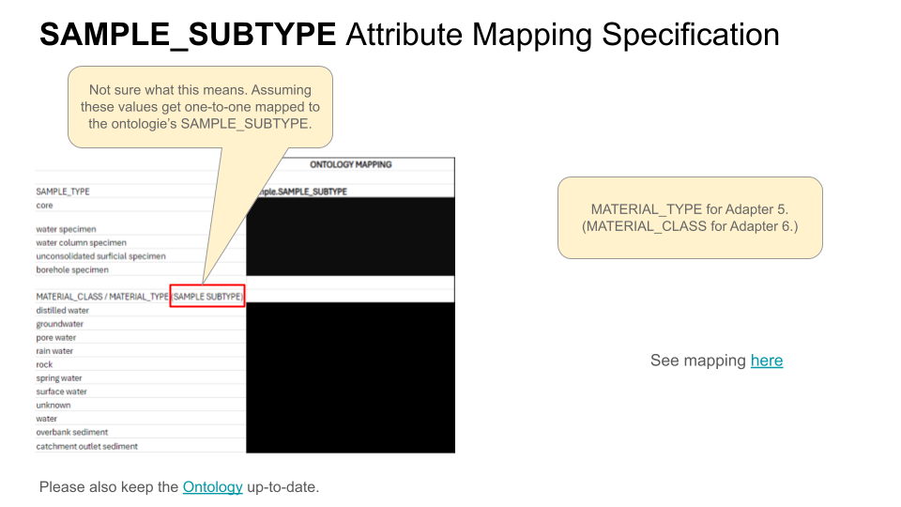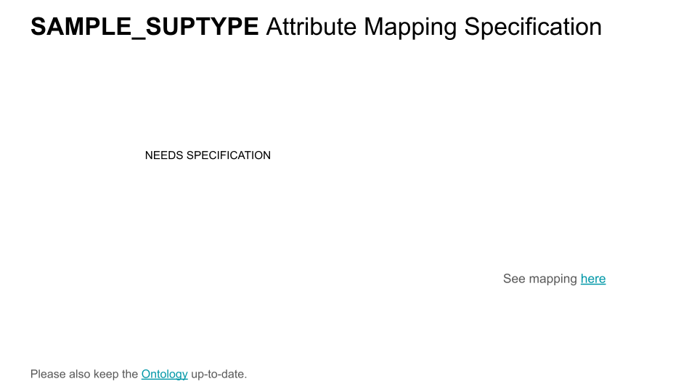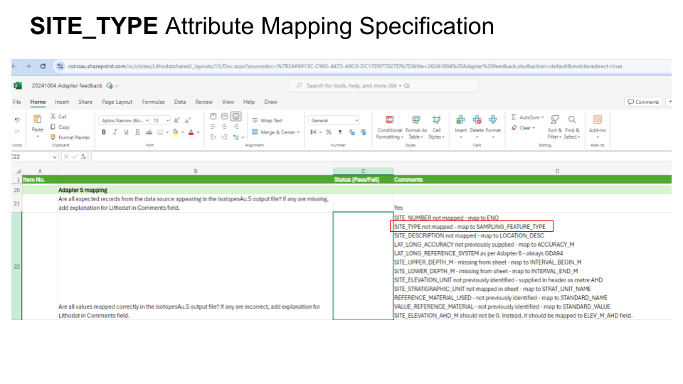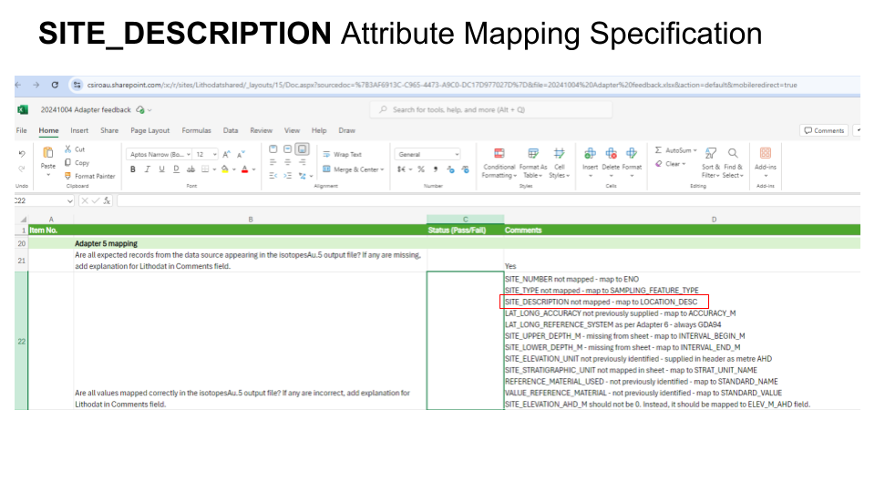

Adapter 5 Environment
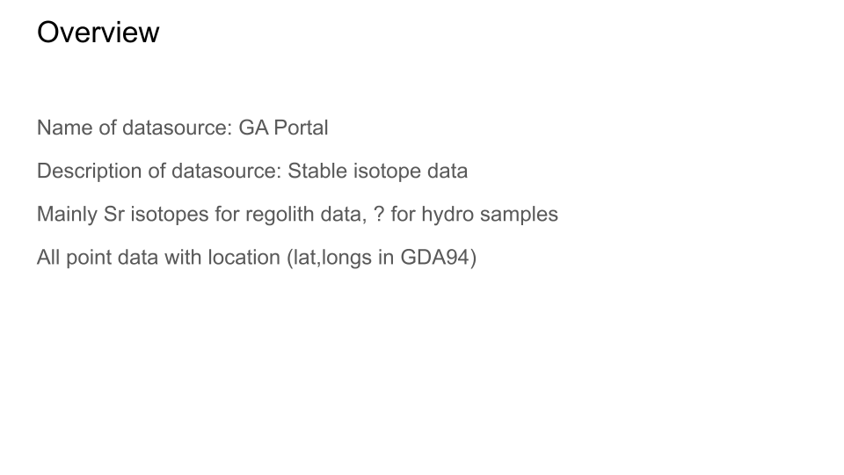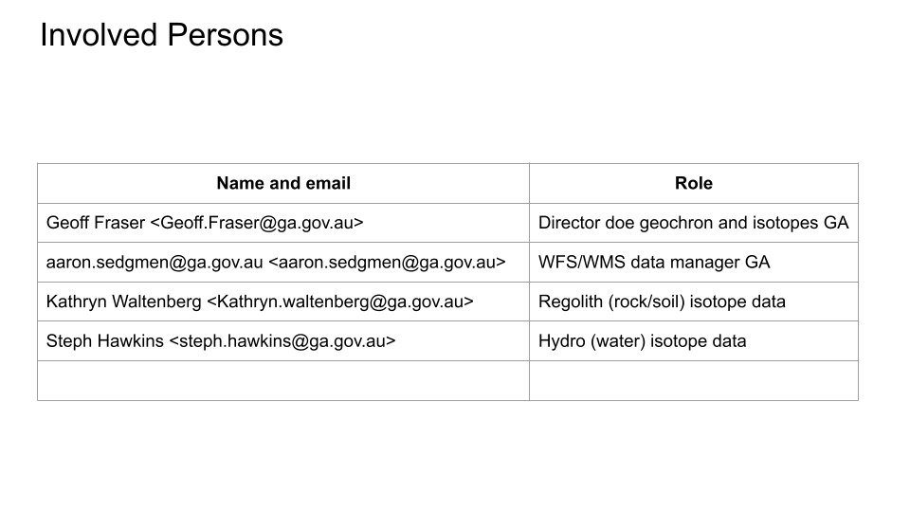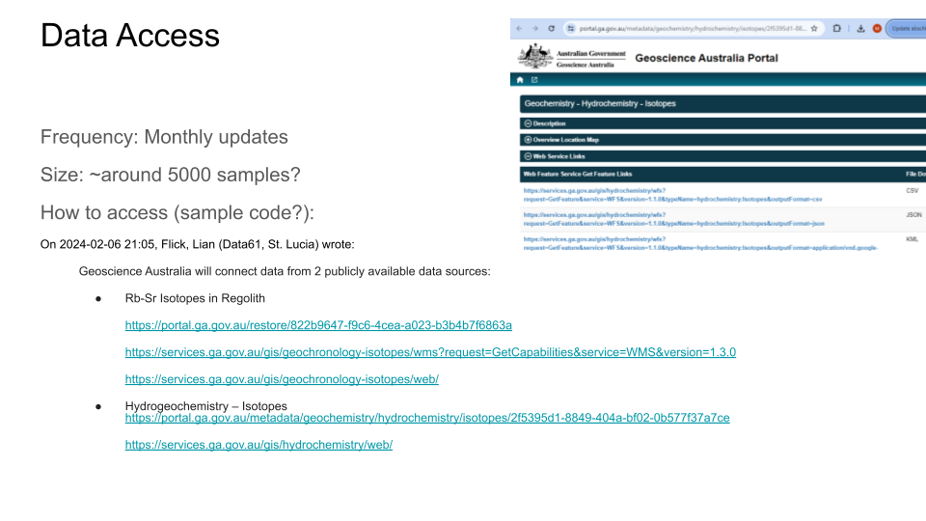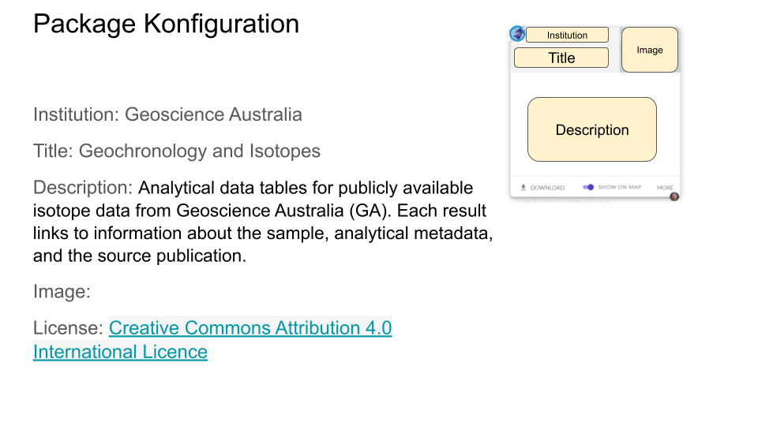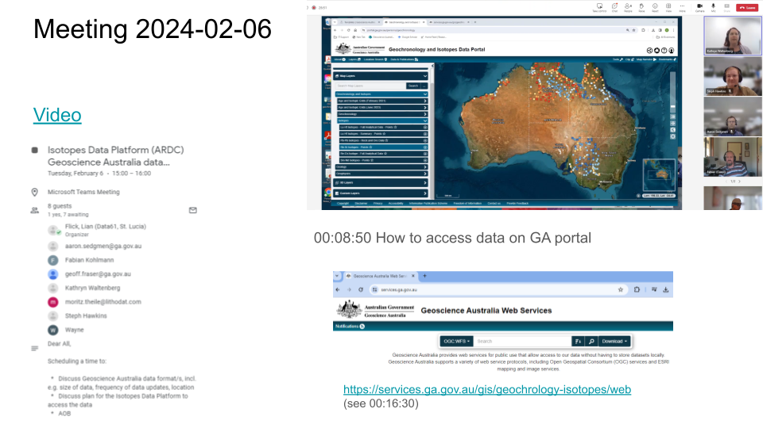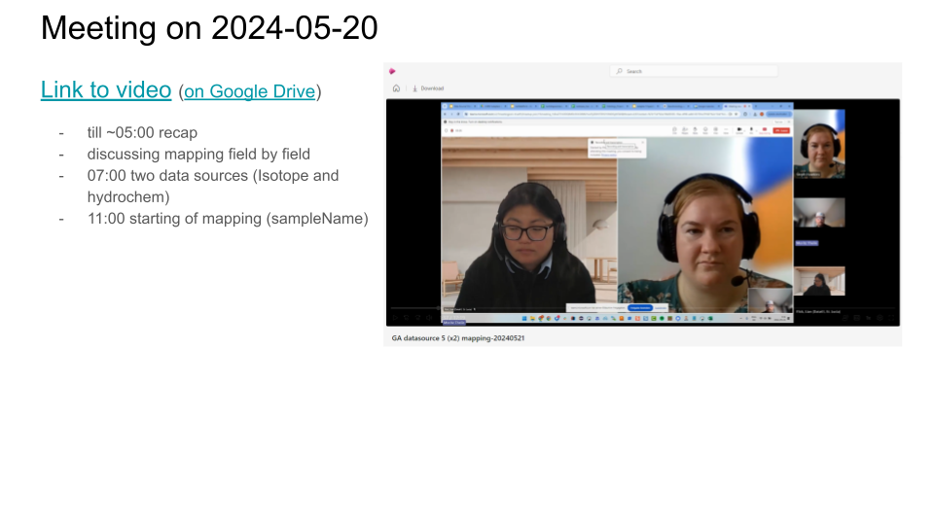

Adapter 5 Mappings

Samples
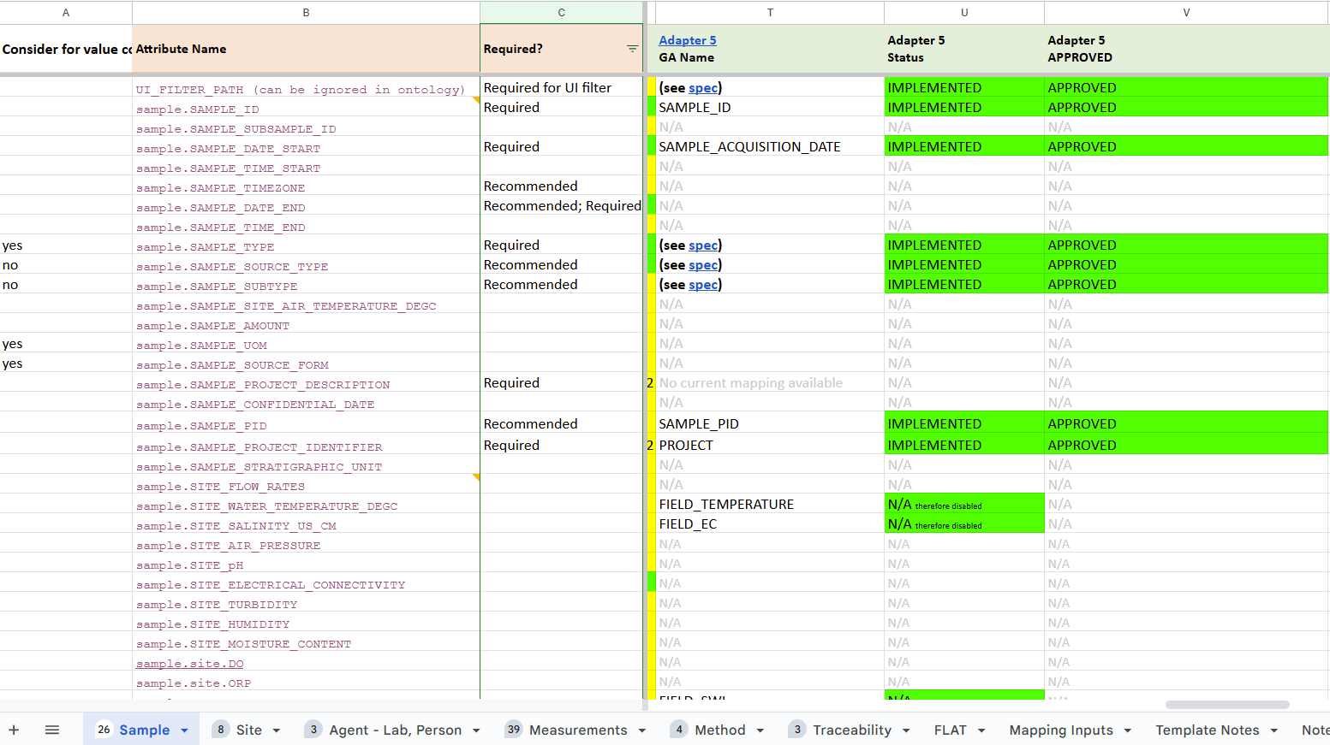

Site
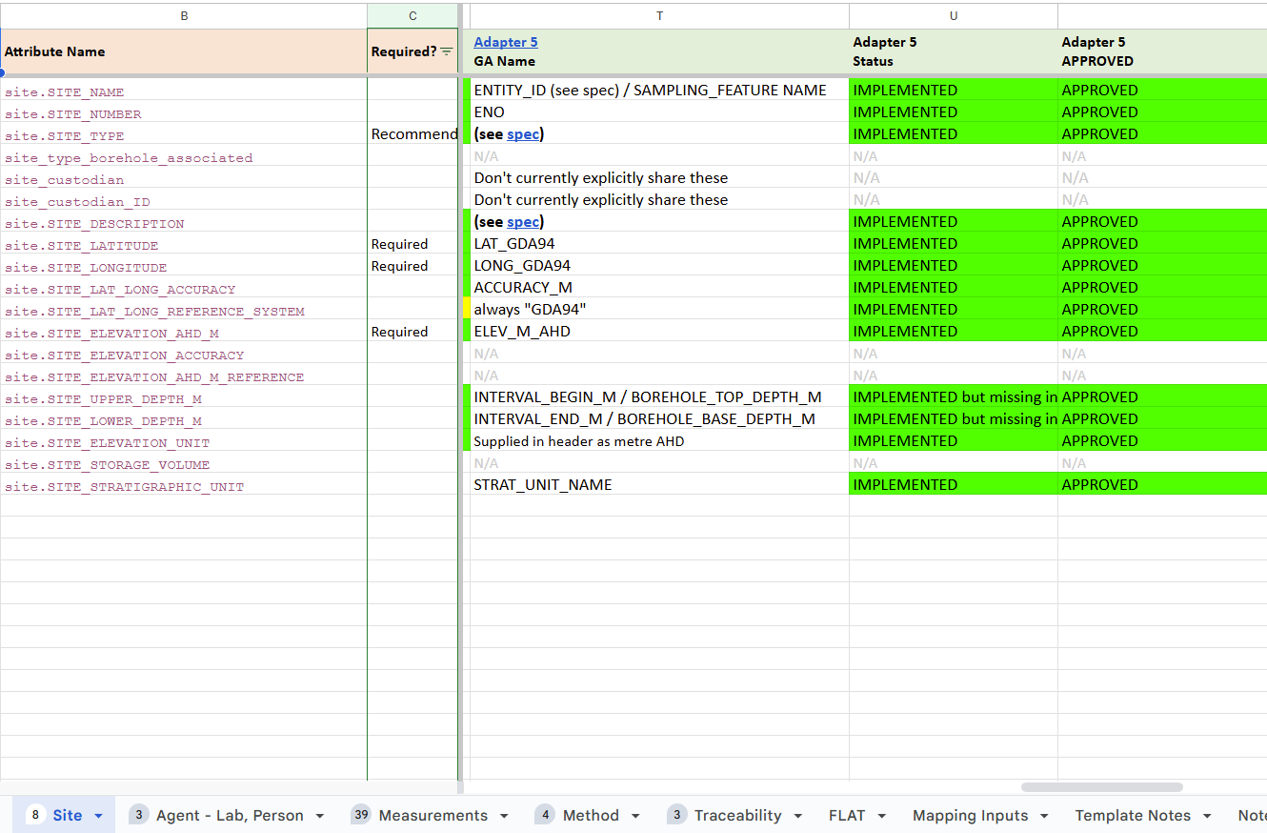

Agent - Lab, Person
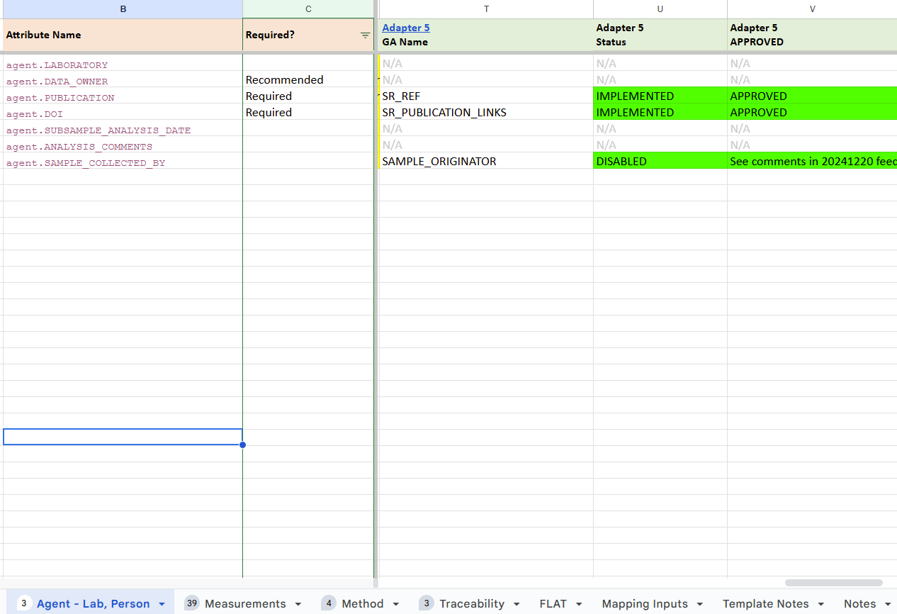

Measurement
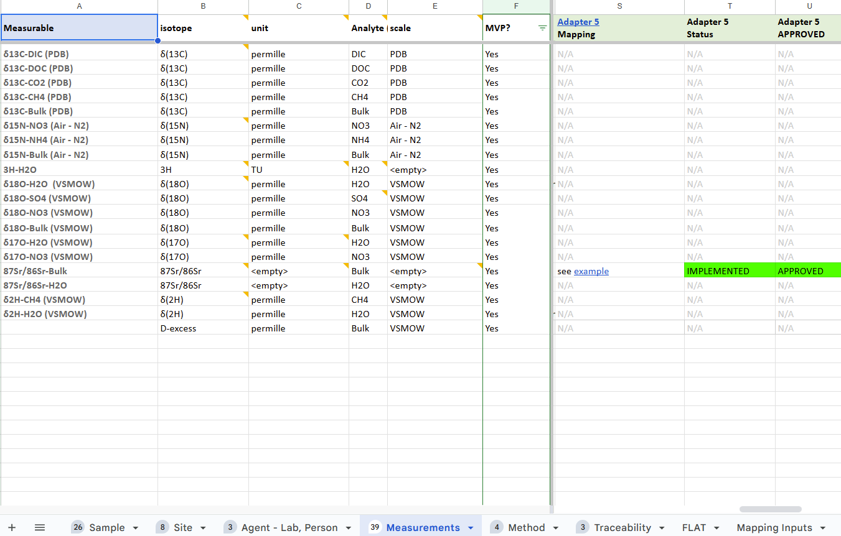

Method
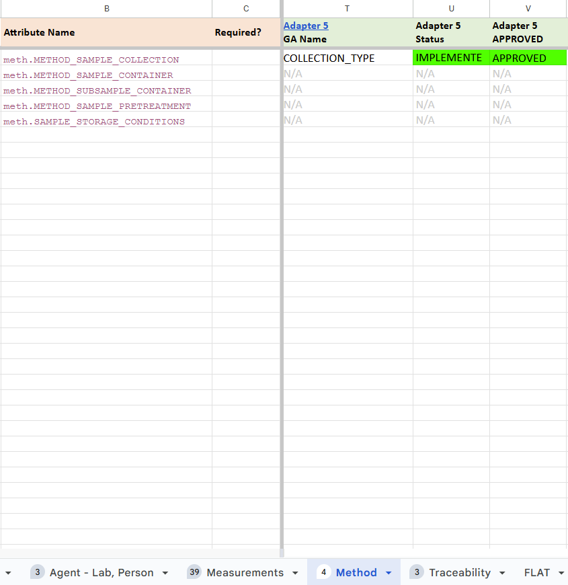

Adapter 6

Adapter 6 Specification
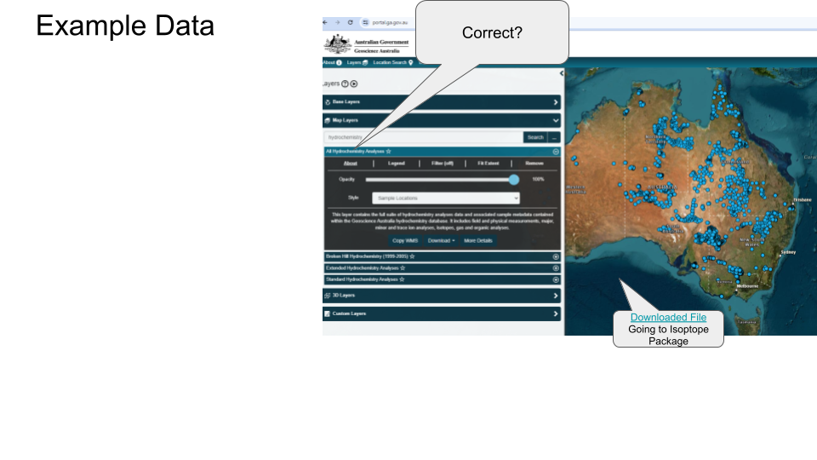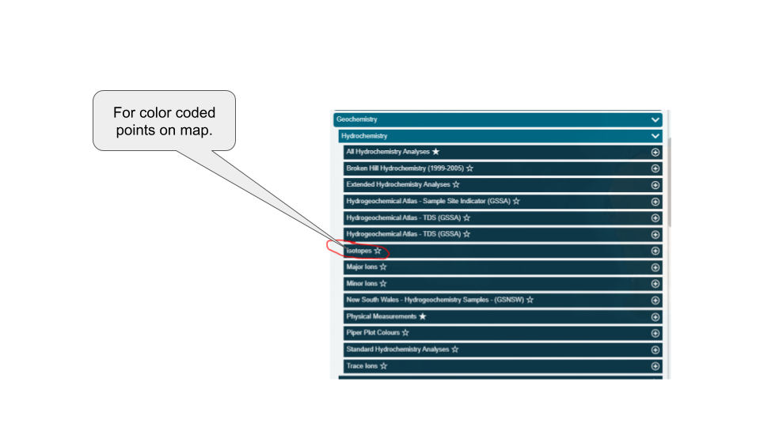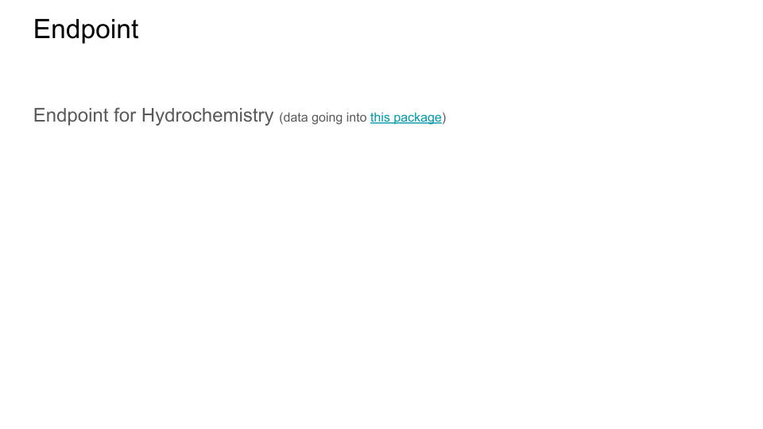

Adapter 6 Environment
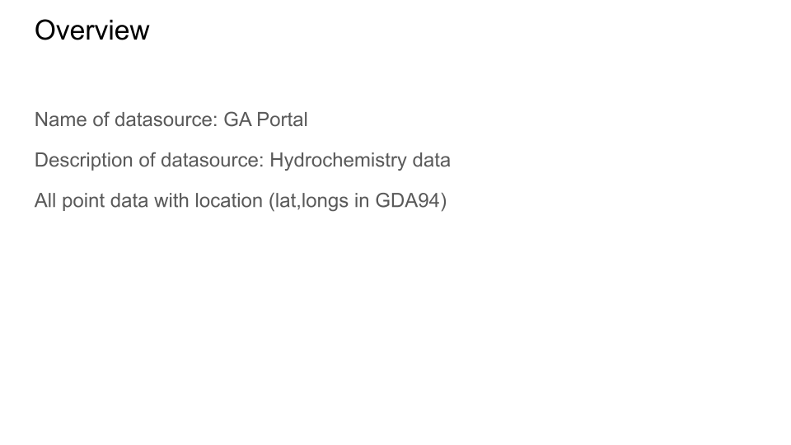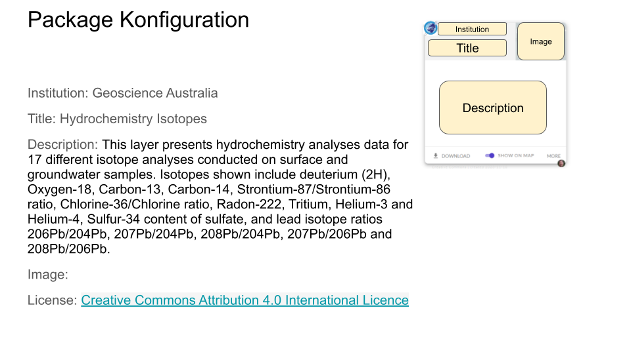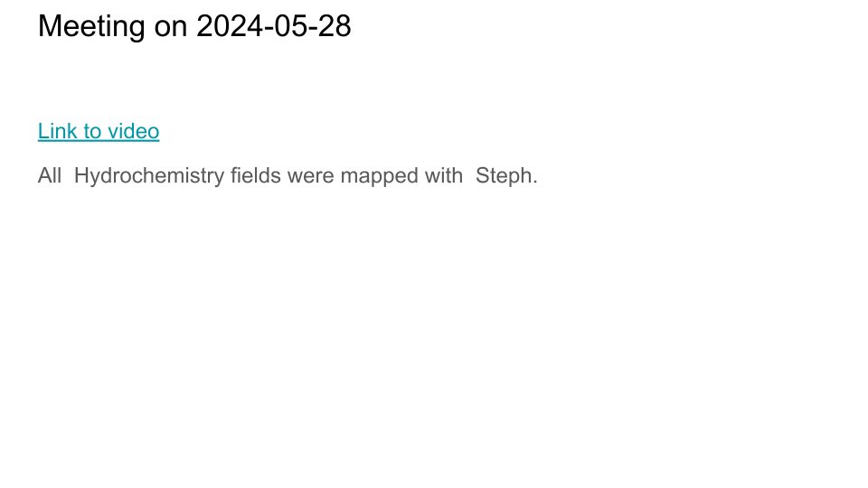

Adapter 6 Mappings

Sample
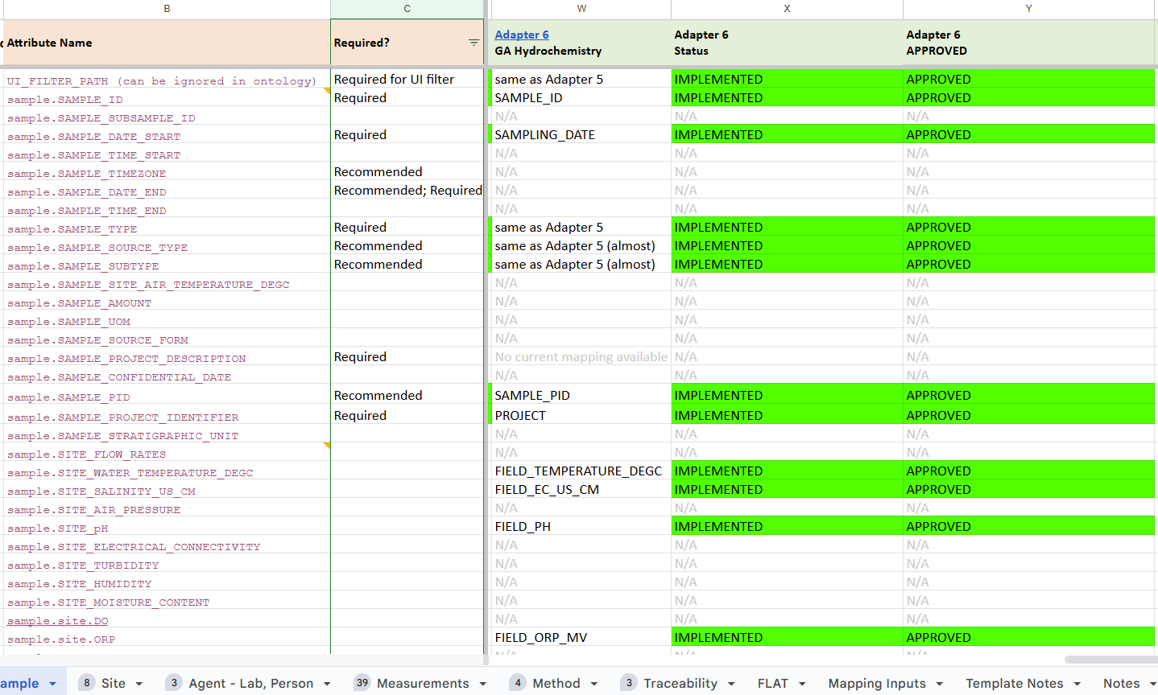

Site
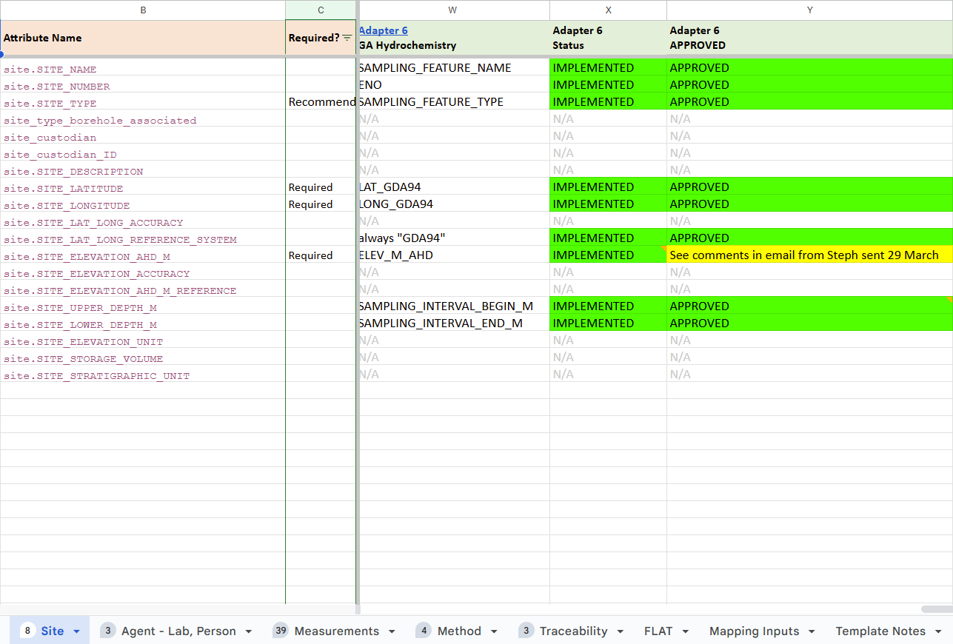

Agent - Lab, Persons
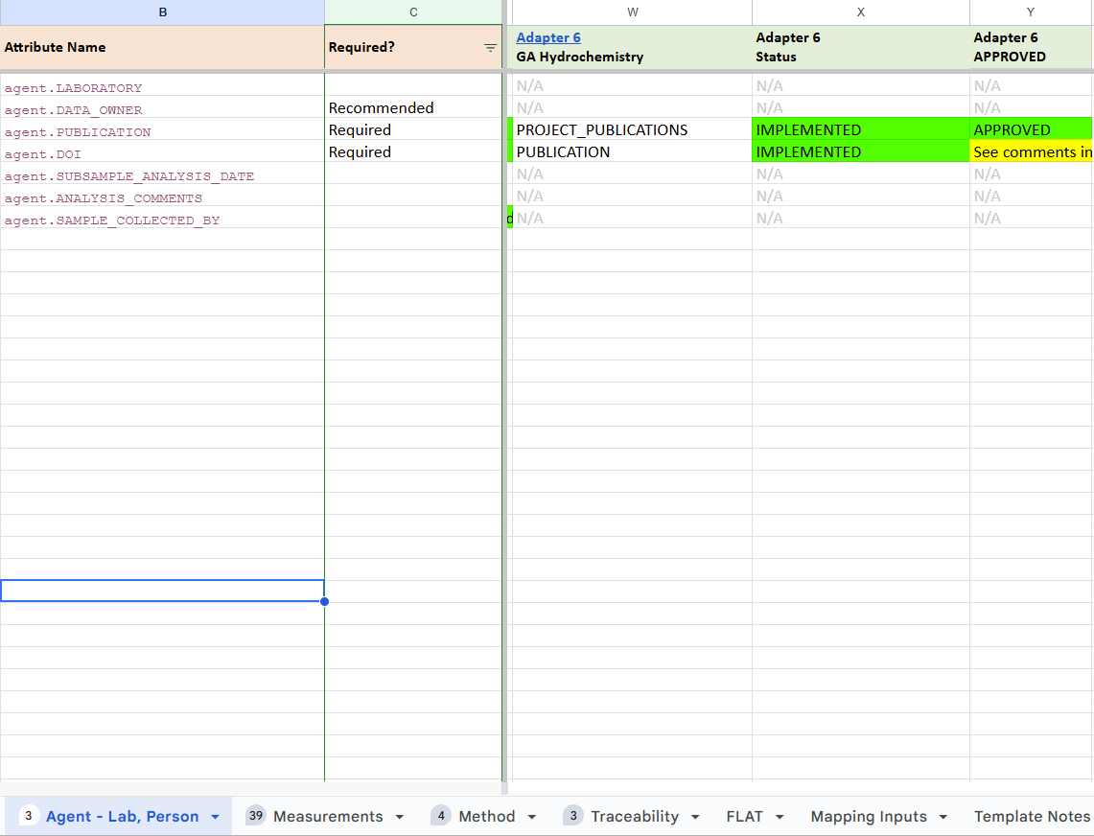

Measurements
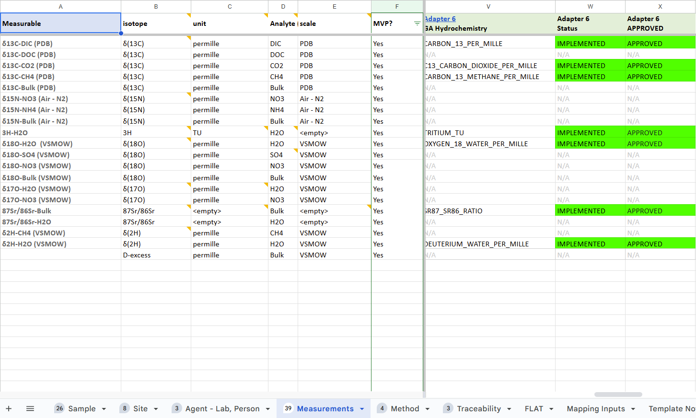

Method
